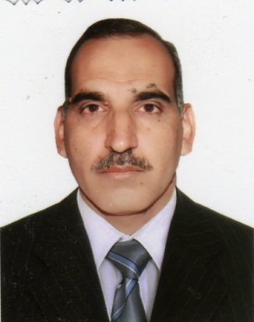

Curriculum Vitae

Name: MOHAMMED SELMAN SALEH

Date of Birth: 12-12-1966

Nationality: Iraqi

Marital Status: Married

Language: Arabic and English

Email: [mohselman09@yahoo.com](mailto:mohselman09@yahoo.com)

Education

|  |  |  |  |  |
| --- | --- | --- | --- | --- |
| University Name | Degree | Issue Date | Department | Country |
| MilitaryEngineeringCollege | B.Sc | 1989 | Electronic Department | Iraq |
| MilitaryEngineeringCollege | M.Sc | 1998 | Control Department | Iraq |
| University of Technology | PhD | 2012 | Control Eng. Dept. | Iraq |

Experience

|  |  |  |  |  |
| --- | --- | --- | --- | --- |
| Date |  | University | Department | Country |
| 1999-2000 | Lecturer | Uni. Of Technology | Electronic Dep. | Iraq |
| 1999-2006 | Lecturer | Diyala University | Electronic Dep.  Computer Dep. | Iraq |
| 2007- 2010 | Lecturer | Al-yarmuke Uni. | Computer Dep. | Iraq |
| 2008-2012 | Lecturer | Diyala University | Electronic Dep. | Iraq |
| 2012- up | Head of Electronic Dep. | Diyala University | Electronic Dep. | Iraq |

Training Courses

|  |  |  |  |  |
| --- | --- | --- | --- | --- |
| Date | Period (month) | Position | Subject | Country |
| 1990 | One | Ministry of Industry | Computer application | Iraq |
| 1991 | One | Ministry of Industry | Operating system (DOS) | Iraq |
| 1995 | One | Baghdad Uni. | serial communication with pc computer RS232 | Iraq |
| 1999 | One | Babel Company | Visual Basic | Iraq |
| 2008 | Two | Diyala Uni. | Computer application | Iraq |
| 2008 | Two | Diyala Uni. | Teaching methods | Iraq |
| 2010 | One | Salah addin Eribl Uni. | DASYLab Software | Iraq |
| 2011 | One | Salah addin Eribl Uni. | DASYLab Software | Iraq |

Membership of professional Institutions

1. Member of Iraqi Engineering Society.
2. Member of Iraqi Teachers Union.
3. Member of Institute of Electrical and Electronic Engineers (IEEE)

Academic Experiences

I taught many subjects (1999-2010) such as:-

Electronic, Digital Electronic, Power Electronic, Program with Basic, Program with C++, Real Time System, Control System, Micro-Processor, Computer Control System, Artificial Intelligent.

Engineering Experiences

I have been involved in the following practical engineering works:-

- Design and Implementation for several governmental engineering project

* + Many projects for microprocessor-based dc motor speed control, position control via parallel port, ISA bus
  + Rehabilitation of Control Unit for Al-Hartha Power Station(Basrah)
  + Construct Educational Package for Students Training at the field of Computer and electronics.
  + Training board for analog electronic, digital electronic, computer control
  + IR remote for many channels
  + Ultrasonic Range finder system
  + Neural network controller for Speed control of DC motor
  + Condition monitoring system

Publications

1. Osama Y.AL-Rawi and AbidaounH.shallal and Mohammad S.Saleh, “Switching Angle Optimization Based Genetic Genetic Algorithms For Harmonic Reduction In Three-Phase *PWM* Strategy”
2. M. Z. Al-Faiz and Mohammad S. Saleh, “Inverse Kinematics Analysis for Manipulator Robot with Wrist Offset Based On the Closed-Form Algorithm”, International Journal of Robotics and Automation (IJRA), Volume (2) : Issue (3), 2011
3. M. Z. Al-Faiz, MIEEE, M. S, Saleh, Ahmed A. Oglah, “Type-2 Fuzzy Logic Controllers Based Genetic Algorithm for the Position Control of DC Motor”, ***Intelligent Control and Automation*, 2013, 4,** Published Online February 2013 (http://www.scirp.org/journal/ica