1.1 INTRODUTION

The construction of dams ranks with the earliest and most fundamental of civil engineering activities. All great civilizations have been identified with the construction of storage reservoirs appropriate to their needs, in the earliest instances to satisfy irrigation demands arising through the development and expansion of organized agriculture.
Operating within constraints imposed by local circumstance, notably climate and terrain, the economic power of successive civilizations was related to proficiency in water engineering. Prosperity, health and material progress became increasingly linked to the ability to store and direct water.
In an international context, the proper and timely utilization of water resources remains one of the most vital contributions made to society by the civil engineer. Dam construction represents a major investment in basic infrastructure within all nations. The annual completion rate for dams of all sizes continues at a very high level in many countries, e.g. China, Turkey and India, and to a lesser degree in some more heavily industrialized nations including the United States. Dams are individually unique structures. Irrespective of size and type they demonstrate great complexity in their load response and in their interactive relationship with site hydrology and geology. In recognition of this, and reflecting the relatively indeterminate nature of many major design inputs, dam engineering is not a
stylized and formal science. As practised, it is a highly specialist activity which draws upon many scientific disciplines and balances them with a large element of engineering judgement; dam engineering is thus a uniquely challenging and stimulating field of endeavour The primary purpose of a dam may be defined as to provide for the safe retention and storage of water. As a corollary to this every dam must represent a design solution specific to its site circumstances. The design therefore also represents an optimum balance of local technical and economic considerations at the time of construction. Reservoirs are readily classified in accordance with their primary purpose, e.g. irrigation, water supply, hydroelectric power generation, river regulation, flood control, etc. Dams are of numerous types, and type classification is sometimes less clearly defined. An initial broad classification into two generic groups can be made in terms of the principal construction material employed.

- Embankment dams are constructed of earthfill and/or rockfill upstream and downstream face slopes are similar and of moderate angle, giving a wide section and a high construction volume relative to height.
- Concrete dams are constructed of mass concrete. Face slopes are dissimilar,
Generally steep downstream and near vertical upstream, and dams have relatively slender profiles dependent upon the type.

1.2 Embankment dams
Which are constructed of earth and rock materials, are generally referred to as embankment dams or fill-type dams.
The history of construction of embankment dams is much older than that of concrete dams. It is evident that some earth dams were constructed about 3,000 years ago in the cradles of ancient cultures such as east countries. According to the standard manual provided by the International commission on Large Dams (ICOLD), in which about 63 member countries are now associated, dams with the height of more than 15m are referred to as "high dams". About 14,000 high dams have been registered up to the present, and more than 70 percent of them are embankment dams. A recent report on the construction of high dams has also noted that among about 1,000 of high dams constructed in recent two years, just about 20 percent are concrete dams and remaining 80 percent are embankment dams.
It is thus readily recognized that construction of embankment dams is a recent world-wide trend in place of concrete dams. Two major distinct features and advantages are noticed for the construction of embankment dams.
- Rigorous conditions are not required for the dam foundation, while hard and sound rock foundation is necessary for concrete dams. Embankment dams can be constructed even on the alluvial deposit and pervious foundations.
- Construction of embankment dams has an economical advantage; i.e., the dam project can be planned in the outskirts of city area because of the merit mentioned above, and construction materials are principally to be supplied near the dam site.
In this brief note, several important issues associated with the design and construction of embankment dams, which engineers often encounter in the dam project, are summarized, and some discussions are given on them by introducing recent development of design procedures and construction technology.

1.3 Types of Embankment Dams

Embankment dams are classified into two main categories by
types of soil mainly used as construction materials, such as earthfill dams and rockfill dams. The latter ones further can be classified into a few groups by configurations of dam sections, as one with a centrally located core, one with an inclined core and one with a facing, as shown in Fig.1.1.The main body of rockfill dams, which should have a structural resistance against failure, consists of rockfill shell and transition zones, and core and facing zones have a role to minimize leakage through embankment. Filter zone should be provided in any type of rockfill dams to prevent loss of soil particles by erosion due to seepage flow through embankment. In earthfill dams, on the other hand, the dam body is the only one which should have both structural and seepage resistance against failure with a provided drainage facilities. The dam type in a project is determined by considering various factors associated with topography and geology of the dam site, and quality and quantity of construction materials available. The inclined core is adopted instead of the center core, for instance, in cases where the dam foundation has a steep inclination along the river, where a blanket zone is provided in the previous foundation to be
connected with the impervious core zone, and where different construction processes are available for the placement of core and rockfill materials.

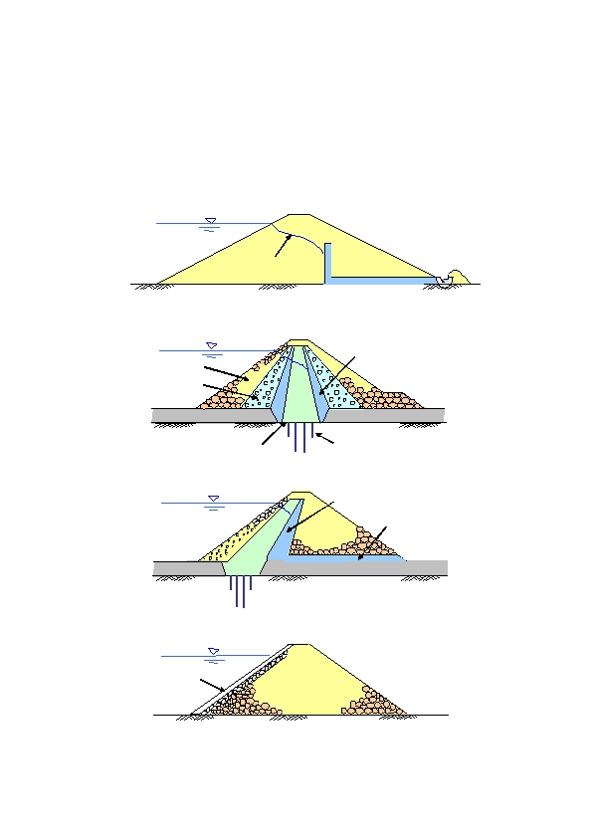
Key Words: rockfill, transition ......... pervious zone, to have structural strength
core, facing ................... impervious zone, to keep water tight
filter .............................. to prevent loss of soil particles
drain .............................. to pass water from upstream to downstream
(to dissipate pore water pressure)
core trench, grouting .... to keep water tight in the foundation
(a) Homogeneous Earth Dam
Phreatic surface
Drain
(b) Rockfill Dam with a C entrally Located Core

Filter
Outer Shell

Inner Shell
(Transition)
Core
Core Trench

(c) Rockfill Dam with an Inclined Core
Curtain Grouting
Filter

Random
Shell
Drain
Core
Curtain Grouting

(d) Rockfill Dam with a Facing
Facing
Shell
Fig.1.1 Earth and Rockfill Dams

1.4 Objective
The objective of this study is to obtain the discharge by using rational method by taking the average monthly rate in millimeters for the period (1971-2000) is recorded by Kirkuk meteorological station. The rainy seasons start in October and ends in April. Analysis is done to obtain the maximum amount of rainfall for a different return periods. The analysis included using Gumbel distribution.

2.1 Hydrology Analysis
For hydrological studies, data from the historical series of maximum monthly rainfall obtained from a pluviometric Kirkuk station were used. They were made available by the ministry of water resources. The unavailability of pluviograph data is very common in hydro-meteorology networks. In the hydrological evaluation, only the extreme event series of the years without omissions were considered. For our study, the years considered without omissions were those that presented a complete record sequence of the period between October and April. In the end, a sample of rainfalls with 37 extreme events was obtained from the record presented in table (2.1) from years of 1971 to 2000. Considering that the sample is representative of the genesis of the intense rainfalls of the studied region and that the probability of the events follows distribution of extremes Type I (Gumbel distribution).

2.2 Frequency Analysis
For the analysis of the maximum annual rainfall, the asymptotic extreme distribution type I (Gumbel distribution) was adopted as theoretical model. Equation (1) and (2) show the mathematical relation and characteristic parameters of the adopted model (TUCCI, 1993).
$P\left(x_{o }≥x\right)=1-e^{{-e}^{-y}} ……………(1)$
$$y=\frac{(x-μ)}{α}……………………..…….(2)$$
In which: $P\left(x_{o }≥x\right)$ = probability that rainfall x is under or equal to a generic x_{o}; and $α$ and $μ$ = characteristic parameters of the distribution. The parameters of the distribution are estimated by the Moment method using the mean $\overline{x}$ and the standard deviations of the maximum annual rain fall sample values as shown in equations (3) and (4).
$$α=0.78 s ………………………(3)$$
$$μ=\overline{x}-0.5772α……………...(4)$$

2.3 Precipitation
The average annually precipitation varies considerably in the Lower-Zab river area. In the mountainous region, it fluctuates between 800 mm and 1600 mm, where in the lower parts of the Lower-Zab river catchment area it varies between 400 mm and 500 mm, the average monthly rate in millimeters for the period (1971-2000) is recorded by Kirkuk meteorological station. The rainy seasons start in October and ends in April... Table (2.1) gives monthly rainfall at Kirkuk meteorological station in mm for period (1971 – 2000).

year | Jan | feb | mar | apr | may | jun | jul | aug | sep | oct | nov | des | total
1971 | 1.3 | 42.3 | 100.1 | 144.4 | 0.7 | 0.0 | 0.0 | 0.0 | 0.0 | Tr | 13.5 | 58.8 | 361.1
1972 | 87.8 | 84.7 | 87.9 | 59.6 | 48.7 | Tr | Tr | 0.0 | Tr | Tr | 30.1 | 56.6 | 455.4
1973 | 66.3 | 64.1 | 33.4 | 39.8 | 9.1 | 0.0 | 0.0 | 0.0 | 0.0 | Tr | 5.6 | 42.6 | 260.9
1974 | 142.7 | 98.5 | 286.6 | 73.5 | Tr | 0.0 | 0.0 | 0.0 | 0.0 | Tr | 26.2 | 68.4 | 695.9
1975 | 37.0 | 155.8 | 13.9 | 56.6 | 16.6 | Tr | 0.0 | 0.0 | 0.0 | Tr | 23.0 | 117.9 | 420.8
1976 | 54.6 | 72.9 | 72.2 | 59.9 | 29.2 | Tr | 0.0 | 0.0 | Tr | 14.5 | 2.2 | 48.5 | 351
1977 | 82.5 | 40.4 | 33.9 | 67.1 | 13.2 | 0.3 | 0.0 | 0.0 | 0.0 | 2.7 | 22.6 | 83.3 | 346
1978 | 47.4 | 48.2 | 54.5 | 12.2 | 0.5 | Tr | 0.0 | 0.0 | 0.0 | 5.2 | 11.4 | 63.6 | 243
1979 | 84 | 22.3 | 42.3 | 2.6 | 23.1 | Tr | 0.0 | 0.0 | Tr | 37.5 | 28.3 | 51.9 | 292
1980 | 20.4 | 88.7 | 49.8 | 47.5 | 12.7 | 0.0 | 0.0 | 0.0 | 0.0 | 8.5 | 71.7 | 16.3 | 360.6
1981 | 86.3 | 92.5 | 87.6 | 21.6 | 13.9 | 1.2 | Tr | Tr | 0.0 | 11 | 70.9 | 104.4 | 489.4
1982 | 125.1 | 42.6 | 40 | 120.4 | 37 | 0.0 | Tr | 0.0 | 8.2 | 76.9 | 58.1 | 23.7 | 532
1983 | 36.7 | 38.7 | 26.7 | 37 | 28.5 | 0.0 | 0.0 | 0.0 | 0.0 | Tr | 13.5 | 20.6 | 201.7
1984 | 8.9 | 12.3 | 41 | 25.9 | 0.6 | 0.0 | 0.0 | 0.0 | 0.0 | 21.6 | 136 | 25.3 | 271.6
1985 | 63.9 | 101.1 | 36.8 | 29.4 | 0.0 | 0.0 | 0.0 | 0.0 | 0.0 | 0.0 | 41.1 | 71.3 | 343.6
1986 | 15.2 | 117.4 | 12.3 | 65.8 | 13.7 | 0.0 | 0.0 | 0.0 | 1.6 | 6.9 | 59.7 | 20.6 | 313.2
1987 | 17.2 | 57.7 | 70.8 | 6.1 | 3 | 0.0 | 0.0 | 0.0 | 0.0 | 22.4 | 5.3 | 123.5 | 306
1988 | 100.9 | 81.4 | 103.7 | 57.8 | Tr | 0.0 | 0.0 | 0.0 | 0.0 | 4.5 | 10.1 | 99.7 | 458.1
1989 | 20 | 41.5 | 116.8 | Tr | 1.2 | 0.0 | 0.0 | 1.6 | 0.0 | 10.8 | 116 | 38.9 | 346.8
1990 | 26.7 | 107.7 | 41 | 39.6 | Tr | 0.0 | 0.0 | 0.0 | 0.0 | 3.2 | 6.8 | 19.4 | 244.4
1991 | 68.3 | 106.4 | M | M | M | M | 0.0 | 0.0 | 0.0 | 35.1 | 75.3 | 110.4 | 395.5
1992 | 130.8 | 147.6 | 55 | 21.5 | 32.8 | 1 | 0.0 | 0.0 | Tr | 0.0 | 157.9 | 122.8 | 669.4
1993 | 68.2 | 53.4 | 83 | 122.5 | 36.3 | 0.0 | 0.0 | 0.0 | 0.0 | 66 | 54.2 | 61.1 | 594.7
1994 | 94 | 33 | 47.2 | 29.3 | 11.1 | 0.0 | 0.0 | 0.0 | Tr | 13.8 | 75.7 | 61.2 | 365.3
1995 | 38.8 | 115.7 | 38.1 | 58.6 | 5.7 | 1.1 | 0.0 | 0.0 | 8.2 | 0.0 | 4 | 51.3 | 285.5
1996 | 048.8 | 14.2 | 95.4 | 24.9 | 6.2 | 0.0 | Tr | 0.0 | 0.8 | 4.8 | 83.5 | 64.9 | 398.5
1997 | 72.9 | 45.6 | 78.4 | 42 | 12.8 | 0.2 | 0.0 | 0.0 | 0.0 | 33.5 | 119.7 | 90.2 | 495.3
1998 | 119 | 41 | 49.5 | 60.7 | 5.4 | 1.6 | 8.1 | 0.0 | 0.0 | 0.0 | 0.0 | 2.4 | 287.7
1999 | 93.3 | 72.9 | 4 | 5.9 | 0.1 | 0.0 | 0.0 | 0.0 | 0.0 | 4.5 | 7.5 | 41.6 | 229.8
2000 | 85.4 | 14.7 | 11.4 | 6.4 | 5.6 | 0.0 | 0.0 | 0.0 | Tr | 10.3 | 28.8 | 71.6 | 234.2
Table (2.1) monthly rainfall recorded at Kirkuk metrological station in mm for period (1971-2000)

We take the maximum rainfall for period (1971-2000) as shown in table (2.2)
Table (2.2) Maximum monthly rainfall recorded for period (1971-2000)
year | Max.oct – mar.
1971 | 100.1
1972 | 87.9
1973 | 66.3
1974 | 286.6
1975 | 155.8
1976 | 72.9
1977 | 83.3
1978 | 63.6
1979 | 84
1980 | 88.7
1981 | 104.4
1982 | 125.1
1983 | 38.7
1984 | 136
1985 | 101.1
1986 | 117.4
1987 | 123.5
1988 | 103.9
1989 | 116.8
1990 | 107.7
1991 | 110.4
1992 | 157.9
1993 | 83
1994 | 94
1995 | 115.7
1996 | 148.8
1997 | 119.7
1998 | 119
1999 | 93.3
2000 | 85.4

Table (2.3) shows the exceedance probability and the parameters obtained with the adjustment of theoretical distribution. Values of maximum daily rainfall that correspond to different recurrence times- calculated using the adjusted probability theoretical distribution (Gumbel distribution)
Gumbel distribution included the following equation:
$$y=\frac{(x-μ)}{α}$$
$$P\left(x_{o }≥x\right)=1-e^{{-e}^{-y}}$$
$$α=0.78 s$$
$$μ=\overline{x}-0.5772α$$
Where
α,µ are characteristic parameters of the distribution

Table (2.3) shows the exceedance probability, parameters and time period
rank | Rainfall(x) |  | y | p | Tr (1/p)
1 | 286.6 |  | 5.829 | 0.00293 | 341.29
2 | 157.9 |  | 2.009 | 0.125 | 8
3 | 155.8 |  | 1.947 | 0.132 | 7.5
4 | 148.8 |  | 1.739 | 0.161 | 6.2
5 | 136 |  | 1.359 | 0.226 | 4.42
6 | 125.1 |  | 1.036 | 0.289 | 3.35
7 | 123.5 |  | 0.988 | 0.31 | 3.22
8 | 119.7 |  | 0.876 | 0.34 | 2.94
9 | 119 |  | 0.855 | 0.346 | 2.89
10 | 117.4 |  | 0.807 | 0.359 | 2.78
11 | 116.8 |  | 0.789 | 0.355 | 2.73
12 | 115.7 |  | 0.757 | 0.374 | 2.673
13 | 110.4 |  | 0.599 | 0.422 | 2.36
14 | 107.7 |  | 0.519 | 0.448 | 2.23
15 | 104.4 |  | 0.421 | 0.481 | 2.07
16 | 103.9 |  | 0.407 | 0.486 | 2.057
17 | 101.1 |  | 0.323 | 0.515 | 2
18 | 100.1 |  | 0.294 | 0.525 | 1.9
19 | 94 |  | 0.113 | 0.59 | 1.69
20 | 93.3 |  | 0.092 | 0.598 | 1.67
21 | 88.7 |  | -0.044 | 0.648 | 1.54
22 | 87.9 |  | -0.067 | 0.656 | 1.52
23 | 85.4 |  | -0.157 | 0.689 | 1.45
24 | 84 |  | -0.183 | 0.699 | 1.43
25 | 83.3 |  | -0.207 | 0.7066 | 1.41
26 | 83 |  | -0.213 | 0.709 | 1.41
27 | 72.9 |  | -0.513 | 0.811 | 1.23
28 | 66.3 |  | -0.708 | 0.868 | 1.15
29 | 63.6 |  | -0.789 | 0.889 | 1.12
30 | 38.7 |  | -1.528 | 0.99 | 1.01
parameters |  | α =33.692 |  | $\overline{x}$=109.633
 |  | µ=90.185 |  | S=42.921
 |  | N=30

From figure(2.1) we find rainfall depth in mm for 5,10,25,50,100,1000 in years as shown below in table (2.4 )

rainfall and time period

Fig (2.1) Relationship between rainfall and time period

Table (2.4) return period and rainfall depth
RETURN PERIOD(T) | RAINFALL DEPTH(mm)
5 | 140
10 | 168
25 | 195
50 | 223
100 | 245
1000 | 325

2.4 Relation between rainfalls of different durations
The study area is situated in a semiarid region, where rainfall regimen is characterized by low frequency short term heavy storms. These characteristics indicate the adoption of ( $\frac{P_{24hrs} }{P_{1 day} }$ =1 ) where p_{24 hrs} represents the maximum 24-hours rainfall and P_{1 day} represents the maximum one day rainfall. For conservative estimation the relation between maximum 24-hours rainfall and maximum one day rainfall was taken to be 1.1 according to the recommendation by Taborga (Matos, 2006). A number of publications about studies performed in regions with different climate features have shown that the relations between different rainfalls do not show significant variations as shown in table (2.5). Table (2.5) represents disaggregation coefficients obtained from different sources such as (U.S. Weather Bureau, Denver (North America), Bahia (South America) ). CETESB method used equation (5) and (6) to calculate the rainfall disaggregation coefficients. The evaluation of rainfalls with durations not listed in table (2.5) was performed using rainfall disaggregation coefficients calculated from relation presented in equation (5) and (6).
$$\frac{P_{24hrs} }{P_{1 day} }=1.0………………………………………….…(5)$$
$$C_{24}\left(d\right)=\frac{P_{24hrs} }{P_{1 day} } exp\left\{1.5 ln\left[\frac{ln\left(d\right)}{7.3}\right]\right\}…………….………(6)$$
Where:
$C_{24}\left(d\right)$ is 24- hour rainfall disaggregation coefficient.
d is rainfall duration in minutes.
For semiarid region use ( $\frac{P_{24hrs} }{P_{1 day} }$ =1 ) and equation (6) one can calculate the disaggregation coefficient:
For example : for (1 hr/ 24 hr)relation: $C_{24}\left(60\right)=$ 1.0 (exp ( 1.5 ln (lin (60)/7.3)= 0.42 and for(30 min/24hr)relation:$C_{24}\left(30\right)=$ 1.0 (exp ( 1.5 ln (lin (30)/7.3)= 0.31 which is = (0.74* 0.42) calculated from column CETESB in table (2.5) and so on for any other duration such as 20min, 10 min and 5 min.
Table (2.5) Relation between different rainfall durations(Matos, 2006)
 | Relation between rainfall durations | Values
 |  | Bahia | Adopted in Denver | U.S. Weather Bureau | CETESB  Equations  (5,6)
 | 5 min/ 30 min | 0.3 | 0.42 | 0.37 | 0.34
 | 10 min/ 30 min | 0.5 | 0.63 | 0.57 | 0.54
 | 15 min/ 30 min | 0.67 | 0.75 | 0.72 | 0.7
 | 20 min/ 30 min | 0.8 | 0.84 |  | 0.81
 | 25 min/ 30 min |  | 0.92 |  | 0.91
 | 30 min/1 hr | 0.73 |  | 0.79 | 0.74
 | 1 hr/ 24 hr | 0.57 |  |  | 0.42
 | 6hr/24hr | 0.85 |  |  | 0.72
 | 8hr/24hr |  |  |  | 0.78
 | 10hr/24hr | 0.89 |  |  | 0.82
 | 12hr/24hr | 0.91 |  |  | 0.85

2.5 Intensity duration frequency curves
Rainfall depths of different duration rainfalls based on maximum one day rainfall, resulting from the extreme event frequency analysis and the use of one day disaggregation coefficients C(d) determined by equation 5 and 6 is given in table (2.6). For example the rainfall depth for the 30 min duration and for 100 years return period can be calculated using the following procedure:
- From table (2.4) rainfall depth in mm for 100 yrs return period= 245mm
- From table (2.5) estimate disaggregation coefficients:
C(30 min)= C(24 hr/1hr) * C(1hr/30 min)
= 0.42*0.74=0.31 (using CETESB column)
- Rainfall depth for 30 min duration and for 100 yrs return period=
245 mm * 0.31 = 76 mm (as shown in table 2.6)
- Rainfall intensity = 7.6 cm /(0.5hr) = 10.29 cm/hr (as shown in table 2.6) Other values are shown in table (2.6).
Graphical representation of intensity duration frequency curves to be used in the hydrologic dimensioning of Al- Arkhama dam is shown in figure (2.2).

Table (2.6) Rainfall depth and intensities corresponding to different durations and return periods.
 |  |  |  | Depth in mm for given return period
time |  |  | units |  | 5 yrs | 10 yrs | 25 yrs | 50 yers | 100 yrs |  | 1000 yrs
5 |  |  | min |  | 14.8 | 17.7 | 20.6 | 23.5 | 25.8 |  | 34.3
10 |  |  | min |  | 23.5 | 28.1 | 32.7 | 37.4 | 41.1 |  | 54.5
15 |  |  | min |  | 30.4 | 36.5 | 42.4 | 48.5 | 53.3 |  | 70.7
20 |  |  | min |  | 35.2 | 42.2 | 49. | 56. | 61.6 |  | 81.8
25 |  |  | min |  | 39.6 | 47.5 | 55. | 63. | 69.2 |  | 91.9
30 |  |  | min |  | 43.5 | 52.2 | 60.6 | 69.3 | 76.1 |  | 101.
60 |  |  | min |  | 58.8 | 70.5 | 81.9 | 93.6 | 102.9 |  | 136.5
360 |  |  | min |  | 100.8 | 120.9 | 140.4 | 160.5 | 176.4 |  | 234
480 |  |  | min |  | 109.2 | 131. | 152.1 | 173.9 | 191.1 |  | 253.5
600 |  |  | min |  | 114.8 | 137.7 | 159.9 | 182.8 | 200.9 |  | 266.5
720 |  |  | min |  | 119 | 142.8 | 165.7 | 189.5 | 208.2 |  | 276.2

Intensity of rainfall in cm/hr for given return period
5 yrs | 10 yrs | 25 yrs | 50 yers | 100 yrs | 1000 yrs
17.8 | 21.3 | 24.7 | 28.2 | 31. | 41.2
14.1 | 16.9 | 19.6 | 22.4 | 24.6 | 32.7
12.1 | 14.6 | 16.9 | 19.4 | 21.3 | 28.2
10.5 | 12.6 | 14.7 | 16.8 | 18.5 | 24.5
9.5 | 11.4 | 13.2 | 15.1 | 16.6 | 22.
8.7 | 10.4 | 12.1 | 13.8 | 15.2 | 20.2
5.8 | 7. | 8.1 | 9.3 | 10.2 | 13.6
1.6 | 2. | 2.3 | 2.6 | 2.9 | 3.9
1.3 | 1.6 | 1.9 | 2.1 | 2.3 | 3.1
1.1 | 1.3 | 1.5 | 1.8 | 2. | 2.6
0.99 | 1.1 | 1.3 | 1.5 | 1.7 | 2.3

Figure (2.2) a Rainfall duration intensity curve for different return period

Figure (2.2)b Rainfall duration intensity curve for 100 yrs return period

CHAPTER THREE
ESTIMATION OF PEAK RUNOFF RATE

3.1 Introduction
For hydraulic designs on very small watersheds, a complete hydrograph of runoff is not always required. The maximum, or peak, of the hydrograph is sufficient for design of the structure in question. Therefore, the design discharge is the maximum value of the flood runoff hydrograph. A number of methods for estimating a design discharge have been developed. One such method was developed by Kuichling (1889) for estimating design discharge for small urban watersheds.
During the time since Kuichling's original development, the rational method became the basis for design of many small structures. In this context, small watershed refers to a watershed with a drainage area of a few tens of acres. The rational method is described in most standard textbook.

3.2 Basics
The rational method is based on a simple formula that relates runoff producing potential of the watershed, the average intensity of rainfall for a particular length of time (the time of concentration), and the watershed drainage area. The formula
Q = CuCiA ………………………………….equation (7)
Where:
Q = design discharge (L3/T),
Cu = units conversion coefficient,
C = runoff coefficient (dimensionless),
i = design rainfall intensity (L/T), and
A = watershed drainage area (L2).
The unit conversion coefficient Cu, is necessary because the iA product, while it has units of L³/T, is not a standard unit in the traditional units system.

3.3 Runoff Coefficient
The runoff coefficient, C, is a dimensionless ratio intended to indicate the amount of runoff generated by a watershed given a average intensity of precipitation for a storm. While it is implied by the rational method, equation 1, that intensity of runoff is proportional to intensity of rainfall, calibration of the runoff coefficient has almost always depended on comparing the total depth of runoff with the total depth of precipitation,
C=R/P…………………………………………equation (8)
Where:
R = Total depth of runoff (L), and
P = Total depth of precipitation (L).
The runoff coefficient represents the fraction of rainfall converted to runoff. Standard values are listed in table (3.1)

Table(3. 1): General runoff coefficients for the rational method. After Viessman and Lewis (2003)
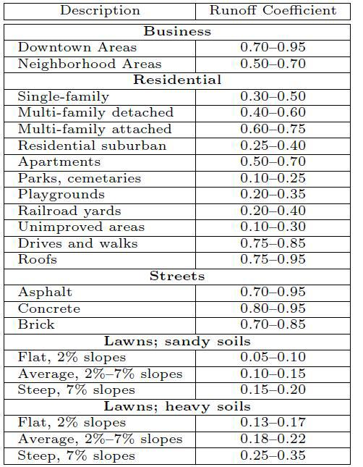

3.4 Storm Intensity
Storm intensity, i, is a function of geographic location, design exceedence frequency (or return interval), and storm duration. It is true that the greater the return interval (hence, the lower the exceedence frequency), the greater the precipitation intensity for a given storm duration. Furthermore, as storm duration increases average precipitation intensity decreases. The relation between these three components, storm duration, storm intensity, and storm return interval, is represented by a family of curves called the intensity-duration- frequency curves, or IDF curves. The IDF curves can be determined by analysis of storms for a particular site or by the use of standard meteorological atlase.
3.5 Time of Concentration
The time of concentration, tc, of a watershed is often defined to be the time required for a parcel of runoff to travel from the most hydraulically distant part of a watershed to the outlet. It is not possible to point to a particular point on a watershed and say, "The time of concentration is measured from this point." Neither is it possible to measure the time of concentration. Instead, the concept of tc is useful for describing the time response of a watershed to a driving impulse, namely that of watershed runoff. In the context of the rational method, tc represents the time at which all areas of the watershed that will contribute runoff to the watershed outlet are just contributing runoff to the outlet. That is, at tc, the watershed is fully contributing. We choose to use this time to select the rainfall intensity for application of the rational method. To elaborate, if storm duration is chosen to exceed tc, then the rainfall intensity will be less than that at tc. Therefore, the peak discharge estimated using the rational method will be less than the optimal value. Furthermore, if storm duration is chosen to be less than tc, then the watershed is not fully contributing runoff to the outlet for that storm length, and the optimal value will not be realized, although a value for peak discharge will be computed that exceeds the value from the first case. Therefore,
we choose the storm duration to be equal to tc to estimate peak discharges using the rational method
3.5.1 Estimating Time of Concentration
There are many methods for estimating tc. In fact, just about every hydrologist or engineer has a favorite method. All methods for estimating tc are empirical, that is, each is based on the analysis of one or more datasets. The methods in common use are not based on theoretical fluid mechanics.
For application of the rational method, TxDOT recommends that tc be less than 300 minutes (5 hours) and greater than 10 minutes. Other agencies require tc to be greater than 5 minutes. The reason is that estimates of i become unacceptably large for durations less than 5 or 10 minutes. For long durations (such as longer than 300 min- utes), the assumption of a relatively steady rainfall rate is less valid. A number of methods are in common use for estimating time of concentration. For urban environment, Morgali and Linsley (1965) is sometimes used for planar flows. For rural environments, Kerby (1959) and Kirpich (1940) are useful for overland flow and channel flow, respectively. The Natural Resources Conservation Service (NRCS) developed a method (U.S. Department of Agriculture, Natural Resources Conservation Service, 1986) that treats time of concentration (travel time) as having components related to overland flow (termed sheet flow), shallow-concentrated flow, and channel flow that are combined to produce an estimate of the time of concentration of a watershed. These methods are developed below:

- Kirpich Method

For small drainage basins that are dominated by channel ow, Kirpich (1940) equation can be used. The Kirpich equation is

tc= 0.0195 L^{0.77} S^{-0.385} ........................................equation (9)
tc=time of concentration (min)
L = length of main channel(km)
S= average slope

- Kerby-Hatheway Method

For small watersheds where overland flow is an important component, but the assumptions inherent in the Morgali and Linsley approach are not appropriate, then the Kerby 1959 method can be used. The Kerby-Hatheway equation is
Tc = [ 0.67NL/S^{1/2}]……………………………………..equation (10)
tc=time of concentration (min)
N=kerby roughness parameter (dimensionless), and
S=over land flow slope (dimensionless).
Where N is taken from the table (3.2)

Table (3.2) value of N (kerby roughness parameter)
Description | N
Pavement | 0.02
Smooth, bare packed soil | 0.10
Poor grass, cultivated row  crops or moderately rough  bare surfaces | 0.20
Pasture, average grass | 0.40
Deciduous forest | 0.60
Dense grass, coniferous forest,  or deciduous forest with deep  litter | 0.80

3.6 Conservatism
This author has direct experience with over-conservatism. A natural tendency of de- signers is to work estimates always on the high (or conservative) side. This process is taught in engineering curricula either explicitly or implicitly and reinforced during the internship period of engineers. However, the drawback of such standard practice is that
designs so created do not meet the risk level (exceedence probability) appropriate for the structure, but instead will pass events substantially greater than those required by local design codes.
There are several problems with this situation. First, the client (whether private or public) is paying for structures that are larger than required. Second, structures down- stream not so designed may be impacted by flows exceeding their design flows. Third, problems that would be evidenced at the site may be moved downstream to other locations. The risk level for a structure should be selected based on the outcome of structure failure. For a small culvert in a bar-ditch, the impact of an event that exceeds the capacity of the culvert is limited. However, failure of a similar culvert in another location might cause flooding of important structures and result in significant problems for a community.
It is this author's opinion that conservatism should not be applied at each step in the design process, but a rational (pun intended) decision be made by the designer to make the best estimate of the design discharge for an appropriate level of risk. Then, once the design discharge is estimated, a factor of safety can be applied during the structure- sizing process to ensure that errors (not blunders) in the design-discharge estimate are accommodated.
This approach must be taught by more experienced analysts to interns. It also must be implemented broadly throughout the design community. The intent is
not to produce less expansive designs although that is a spin-off of the process, the intent is to produce designs appropriate for the level of risk applied to a structure and agreed to by all parties - designers, owners, and regulators .
3.7 Design Flood Discharge
Rational formed
Q =0.0028 C A I ………………………………….(11)
Where
C is runoff coefficient and equal to 0.2.
A is the catchment area equal 785.760 km2.
I is the rainfall intensity.
First we find the time of concentration to find (I) intensity of rainfall
tc= 0.0195 L^{0.77} S^{-0.385} …………………………(12)
Where L and S is found in case steady
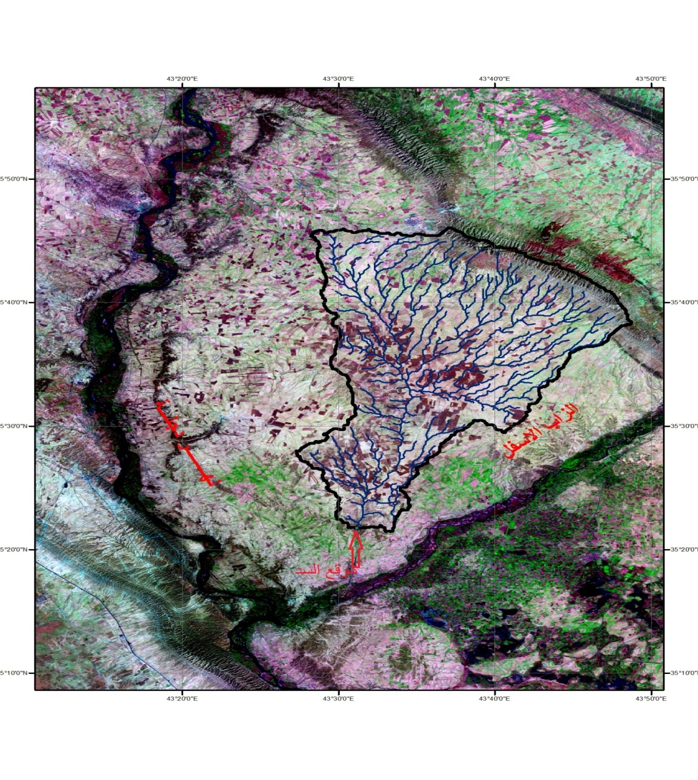

Figure (3.1) Case Study Catchment Area

Case steady. Table (3.3)
unit | value | Parameter
Km² | 785.760 | Area
km | 15 | The longest distance traveled by water from the most remote point to the dam site
(%) | 0.37 | Average slope

L=15 km
S=0.37%
TC= 277 min =4.6 hours
When we found tc we can found I from the figure between time and intensity (2.2)b
Then
I= 4cm/hr
The discharge will be in unit m3/sec and I in mm/hr and A in hectares
Then
Q=0.0028*C* I*A
Q= 0.0028*0.2*40*785.760*1000000/10000
=1760.1 m³/sec

Conclusions.
The discharge was 1760.1 m³/sec and the max rainfall intensity between (1971-2000) was used for return period equal to 100 years. In our calculation we used rational method for estimation of the runoff discharge , the rational method is valid for small catchment areas . In our result the time of concentration was 277 min ,that make our calculation is valid. CETESB method used equation (5) and (6) to calculate the rainfall disaggregation coefficients is applicable and give good results.

Recommendations
1.Rational formula is applicable for small catchment area. We recommended to use another method such as s.c. s method.
2. Disaggregation method using table suggested it is a good method for establishing rainfall intensity curve.

References

Ben-Zvi, A.; Peeling Two Misleading Concepts off the Rational Method; Channel
Flow and Catchment Runoff, Proc. Int. Conf. for Centennial of Mannings Formula
and Kuichling's Rational Formula, Yen, B. C. (ed.), Univ. of Virginia 22 - 26 May
pp. 45 - 50; 1989
Eliasson, J., Arnalds, S., Johannsson, S., Kjaran, S.P.; Ground water models with
parallel linear reservoirs; Institute of Hydrodynamics and Hydraulic Engineering,
Technical University of Denmark, Ser. Paper No.1; 1973
Gilman, C. S.; Rainfall; Handbook of Applied Hydrology, Chow, V. T. (ed.) pp. 9.1 -
9.6; Mac-Graw
Kuichling, E.; The Relation between Rainfall and the Discharge in Sewers in
Populous Districts; Trans. ASCE No 20; 1889
Novotny, V., Imhoff, K. R., Olthof, M., Krenkel, P.A.; Karl Imhoff's Handbook of
Urban Drainage and Wastewater Disposal; J. Wiley & sons, N.Y.; 1989 ; ;
Rossmiller, R. L.; The Runoff Coefficient in the Rational Formula; Eng. Res. Inst.
Iowa State University; 1981 ; ;
Singh, V. P. ; Hydrologic Systems, Vol. 1, Rainfall-runoff Modelling; Prentice Hall,
Englewood Cliffs; 1988
Singh, V. P. and Cruise, J. F.; A Note on the Rational Method; Proc. Int. Conf. on
Channel Flow and Catchment Runoff: Centennial of Mannings Formula and
Kuichling's Rational Formula, Yen, B. C. (ed.), Univ. of Virginia 22 - 26 May pp. 78
- 86; 1989
Singh, V. P. ; Elementary Hydrology; Prentice Hall, Englewood Cliffs; 1992
Engman, E. T. (1986). Roughness coe_cients for routing surface runo_. Journal of
Irrigation and Drainage Engineering 112 (1), 39{53.
Kerby, W. S. (1959). Time of concentration for overland ow. Civil Engineering 29 (3),
60.
Kirpich, Z. P. (1940). Time of concentration of small agricultural watersheds. Civil
Engineering 10 (6), 362. The original source for the Kirpich equation. (In PDF).
Kuichling, E. (1889). The relation between the rainfall and the discharge of sewers in
populous districts. Transactions, American Society of Civil Engineers 20, 1{56.
Morgali, J. R. and R. K. Linsley (1965). Computer analysis of overland ow. Journal
of the Hydraulics Division 91 (HY3), 81{101.
National Oceanic and Atmospheric Administration (1977, June). Five- to 60-minute
precipitation frequency for the eastern and central united states. Hydro-35. (In PDF).
Overton, D. E. and M. E. Meadows (1977). Stormwater modeling. Academic Press.
U.S. Department of Agriculture, Natural Resources Conservation Service (1986). Urban
hydrology for small watersheds. Technical Release 55, U.S. Department of Agriculture.
U.S. Weather Bureau (1963). Rainfall frequency atlas of the united states for durations
of 30 minutes to 24 hours and return periods from 1 to 100 years. Technical Report 40,
U. S. Weather Bureau.

