**Abstract :**

Salty soil is one of the many types of collapsible soils and in turn is one of the many types of problematic soils. This soil totally has good engineering properties when dry ,i.e., moderate bearing capacity with low settlement. But once is wetted it loses its entire structure (collapse) and undergoes very large instantaneous settlement. A laboratory model test consists of a cylindrical steel container of 250mm diameter and 270mm height, the soil is brought from Diyala discrete. The density of soil is controlled by placing the required weight inside the container of known volume, to the required height. A square footing 60mmx60mm makes from steel is used. The stress is applied from a fixed loading system designed especially for model tests. The salty soil used in study is only rich in sodium chloride and in percentages of 15 % and 20 % by weight of dry soil . This type of salt is unlike others such as gypsum or calcareous soil and it is fast in the dissolution resulting in large instantaneous collapse settlement . The results of this study are showed that the degree of improvement of salty soil changes with increasing lime content. The best percent of lime added to salty soil which gives good improvement is 3%.The addition of 3% lime to salty soil reduces the collapsibility to 60.6% for sample 15% salt content and 27.81% for sample 20% salt content. The degree of improvement of salty soil by adding lime decreases with increase salt content.

**Chapter One**

**1.Introduction**

**1.1 General :**

The distinguished features of sabkha soil are the presence of shallow and highly concentrated brines and variety of its geotechnical characteristics in both the horizontal and vertical directions. These features cause several engineering problems in road and building constructed on the sabkha soil.Sabkha is an Arabic expression to describe recent coastal sediments with a high salt content and are characterized by very low bearing capacities and low SPT values .

Salt flats or sabkha are salt bearing arid climate sediments covering vast areas of coasts of middle Eastern and North African countries . The development of this material is due to low wave energy allowing the settlement of silt and clay particles to take place and then be loosely cemented by soluble. Sabkha sediments are characterized by high void ratios and low dry densities. Accordingly ,upon wetting sabkha soil is renowned for being highly compressible material with low bearing resistance and hence considered among the poorest of foundation material.

Several field stabilization techniques have been implemented to improve the interior saline soil properties including soil reinforcement with geotextile ,soil replacement, vibratory compaction ,deep soil densification and stabilization with lime and cement.

The CBR test shows in saline soil that the most ideal percent of lime for stabilization is 2% and 3% silica fume.

Saline soils are associated with many geotechnical problems ,due to presence of digenetic salts of different sizes ,shapes and compositions ;and shallow saline ground waters . Therefore ; saline soil is considered to be an inferior constriction material . Because of these characteristics ,some of pavement located on saline flats have exhibited various type of deterioration in form of reveling ,cracking ,rutting and formation of landslides in recently built roads .The susceptibility of these soil to strength loss and collapse upon wetting makes their use in construction very risky and hazardous .Saline soil present high rigidity and high shear strength in natural condition ,but they change radically in front of water action triggering huge localized settlement in civil works.

Many studies are performed about geotechnical of saline soil in civil projects in different countries .Saline soil posses a high collapse potential attributable primarily to dissolution of sodium chlorides ,leaching of calcium ions and soil grain adjustment .

Sabkha soils are widely distributed in the Arabian Peninsula. Sabkha soils are not only found in the Middle East but are also widely distributed over the world, like in India, Australia, USA and Southern Africa where sabkha soil have different expressions .The geotechnical problems caused by sabkha are now well defined and although several standard soil improvement techniques are still extensively used, more economical and long-lasting soil improvement methods are playing an increasing role in foundation work of road and highways. One of the most economical soil improvement solution is the use of geosynthetics.Not only are geosynthetics used as a reinforcement or as a separators ,they more and more using in combinations with other foundation technologies. This paper presents several standared possible stabilization methods used in sabkha soils with geosynthetic systems and reveals the benefits of using geosynthetics.

Prediction of the settlements of structures in the field is primarily based on a method of extrapolating laboratory test results. The laboratory tests commonly used are almost solely based on the one-dimensional Terzaghi theory of consolidation, irrespective the validity of the assumptions that this theory is based on (Lambe, 1952). Such a predication is typically established using two types of oedometers ; the floating-ring oedometer and the fixedringoedometer. Typical consolidation tests are usually conducted on undisturbed samples in accordance with ASTM D 2435 (ASTM, 1988), where samples are initially loaded with a prescribed pressure until the change in volume is ceased then they are flooded with water . This is essential to study the collapse and/or swell potential as well as to determine the consolidation parameters that include the compression index , swelling index , over consolidation ratio, etc.

Collapsible soils are generally characterized by a sudden and rather large volume decrease at usually a constant stress when exposed to water (Lutenegger and Saber, 1988). In other words, the volume decreases accompanying the increases in water content at essentially constant total stresses in loose, partly saturated soils are termed collapse, hydrocompaction or hydro-consolidation(Lawton et al., 1989). Accordingly, the collapse potential can be detected at the flooding stage when the prescribed pressure is sustained in the consolidation.

Conventional analysis based on laboratory data gave misleading predictions concerning both the magnitude and the rate of settlement. In effect, the predictions considerably overestimated the measured field settlements and showed a very slow rate of settlement as compared to the observed settlement-time response.

It is evident that the process of soil consolidation is a coupled problem, where settlement of a compressible layer is the result of pore water dissipation as well as the deformation of the soil skeleton. The complexity of this problem dictates that the method of analysis be numerical in nature. The finite element is considered the best established numerical method available today for solving boundary value problems. However, to obtain accurate and reliable predictions from this highly efficient and economical method, a realistic three-dimensional constitutive model of soil stress-strain-time behavior is essential. The theory of viscoplasticity, which provides simultaneous description of both rheological and plastic effects, offers the best viable approach for modeling long-term behavior of cohesive soils. Therefore, in finite element analysis if the flow of pore fluid is considered and the deformation of the deformation of soil skeleton is characterized with an appropriate elasto-viscoplasticmultiaxial constitutive law, both primary and secondary compression can be estimated. More recently, analysis that use elasto-viscoplastic model have become a subject of special interest with the progress of the studies on the constitutive law for cohesive soils.

**1.2 Distribution of salty soils in the world:**

Hot and arid climates, with much more evaporation than precipitation, are conducive to saline "evaporitic" soils. A review of the global distribution of sabkhaindicates its extensive presence in the Middle East, including Egypt, Sudan,Libya, Tunisia, Algeria and Ethiopia. Sabkha also exists in India , Australia and southern Africa (Ellis, 1973; Renfro, 1974). Contrary to expectations, sabkha and sabkha-like sediments occur also in relatively cold cli-mates, such as in Mexico, California, Utah and Texas in the U.S.A. Aridity , therefore, seems to play a more fundamental role than hot weather in the formation of sabkha. The active and potential (i.e. in the process of formation) locations of sabkha around the world are shown in fig.(1-1) , where the potential locations include some sitesin North and South America as well as in what was previously the Soviet Union (Al-Amoudi, 1994a).

Along the western and southwestern shores of the Arabian Gulf, these soil are generally viewed as unconsolidated, heterogeneous, layered or unlayered sediments, that are bathed in highly concentrated brines (Al***-***Amoudietal***.,*** 1992).

Their outer surface are generally composed of hygroscopic salts which, when dampened, can render the normally stable surface crust impassable (Ellis, 1973;Johnson et al., 1978). These characteristics make the sabkha susceptible to collapse upon flooding.

Surficial undisturbed sabkha sample from the Ras Al-Ghar vicinity in eastern Saudi Arabia were retrieved and used in this investigation. This soil has recently been subjected to an extensive laboratory program. Based on their results, Al- Amoudi et al. (1992).

characterized this sabkha as cohesionless, non-plastic and classified it as A-2-4 and SW-SP according to the AASHTO and USCS system, respectively. Its specific gravity was found to be 2.73 and the permeability of its undisturbed specimens ranged from 1.24×10-6 to 3.2×10-5 m/s. the natural water content of the surficial layers ranged from 16 to 22%, and the ground water table was observed at a depth of 0.8 m (Al-Amoudi, 1994b). fig. 2 shows an X-ray diffractogram for the sabkha used in this investigation. Sime quantitative analysis (Al-Amoudi, 1992) indicates that the following mineral phases are present: quartz (44.2%), halite (15.3%), orthoclase (11.9%), aragonite (11.1%), calcite (9.1%), gypsum (6.5%) and traces of anhydrite. The presence of a significant quantity (about 42%) of diagenetic minerals (i.e. halite, aragonite, calcite, gypsum and anhydrite) indicates that there is an active genesis in this sabkha system whereby the formation of these and other minerals seems to be going onز. This is also evidenced by the chemistry of the sabkha brine; the concentrated nature of the brine is reflected by a total dissolved solids of as much as four to five time that present in a typical sea water (Al-Amoudi et al., 1992).

Despite the "salt-full" and cemented matrix of sabkha, a recent investigation (Al-Amoudi et al., 1992) indicates that typical consolidation tests conducted on such soils using the conventional oedometers showed a negligible reduction in void ratio upon flooding with either distilled water or sabkha brine. The main reasons for such an unexpected behavior were attributed to the profound desiccation, aging and cementation in these surficial samples which could not be disrupted or destroyed (Abduljauwad and Al-Amoudi, 1995). This reasoning was supported by the high overcosolidation ratio exhibited by these surficial soils (Hossain and Ali, 1988; Al-Amoudi et al., 1992; Ismael and Al-Sanad, 1993). Another contributing factor is that distilled water only wets the sabkha but cannot flow continuously through the consolidating specimens, unlike, for example, the constant and variable head permeability tests (Al-Amoudi and Ab-duljauwad, 1994b). therefore, the evaporitic and cemented matrix of such soils was marginally affected by the soaking process in the conventional oedometers and, consequently, the collapse potential could not be properly evaluated. It is argued, therefore, that water has to percolate through the consolidation specimen in order to accurately assess the collapse potential of sabkha. This is essential to facilitate the dissolution of the soluble, cementing salts, thereby enhancing the reduction in void ratio (Al-amoudi and Abduljauwad, 1994a).

**1.3 Purpose of this project**

The main purpose of this project is to study :

1-Behavior of salty soil during soaking under loadin

2-Improvement of settlement salty soil by adding different percentages (1.5%, 3%, 4.5%) of lime.

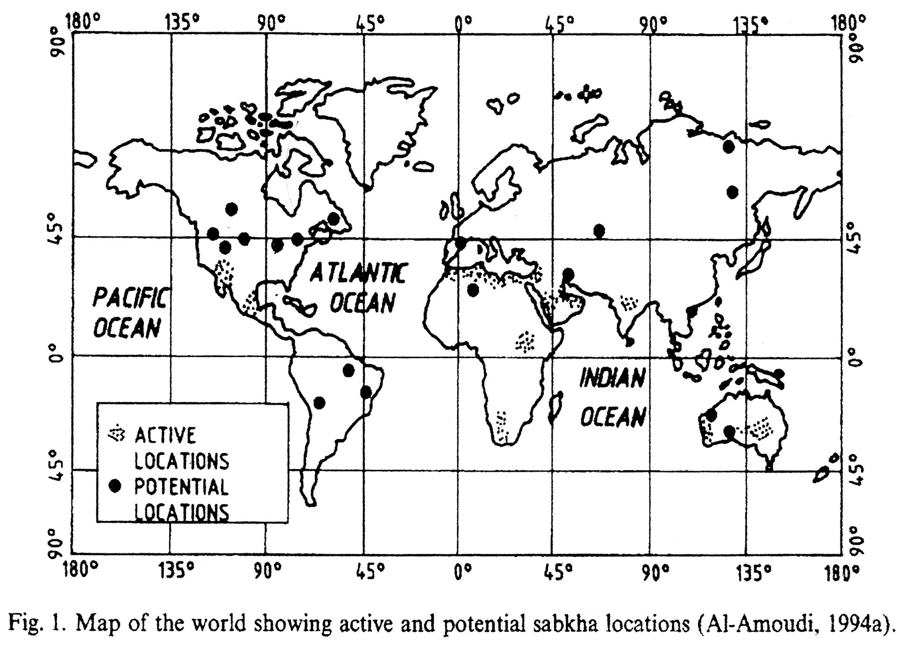**Chapter Two**

**2.1 Introduction:**

Collapsible soil is defined as soil that is susceptible to a large and sudden reduction in volume upon wetting.Collapsibles soil deposits share two main features:

1-They are loose, cemented deposits

2-They are naturally quite dry

Collapsible soil can with stand a large applied vertical pressure with small compression, but then show much larger settlement upon wetting with no increase in vertical stress. This behavior can yelied disastrous consequences for structure unwittingly built on such deposits. The process of their collapsing is often called any of “hydroconsolidation”, “hydrocompression” or “hydrocollapse”

**2.2Sabkha soil :**

The expression “sabkha”is originally an Arabic name for saline flats that are underlain by sand silt and clay and often encrusted with salt . These soil are products of the evaporative environment. There are essentially two types of sabkhas, coastal and continental which are both equilibrium geomorphic surfaces. The coastal sabkhas are the result of depositional off-lap of marine sediments of subtidal, intertidal and supratidalfacies, while continental sabkhas are landward and comprise earlier cycle marine sediments . It differs from a salt pan (or an evaporite basin ) in that its depositional interface is subaeral, whereas that of a salt pan is subaqueous (AL-Amoudi 1992). Sabkha soils have loose, permeable sandy to gritty textures. The encrusted surface is composed usually of hygroscopic salts (Abduljawad 1994). Sabkha’ssurface is usually hard enough to support a medium –weight vehicle and become so impassible when wetted that aperson would sink in direction is related to its proximity to the shoreline, while the vertical variations represent stages of development of the sabkha cycle (Akili 1981).nearly to knee depth (Al-Amoudi 1995). The variability of sabkha soil in the horizontal

**2.2.1Coastal sabkhas:**

Coastal sabkhas are the normal end product of nearshore marine sedimentional where by the sediments are laid down just above the high-water mark and the shoreline gradually moves seaward. Acoastal sabkha is typically bordered on the seaward side by asemi-restricted lagoon, and on the land ward side by adesert or rock outcrops.This sabkha is usually strak, salt-encrusted and virtually flat except for possible scattered strom tide channels and small isolated sand dunes. Its surface dips very gently seaward at imperceptible rates, and does not normally exceed a few centimeters to one or two meters elevation above the mean high-water level as depicted. Since virtually the whole spectrum of sedimentation in the Arabian gulf is carbonates, the major constituents of these types of sabkhas are aragonite and calcite and by virtue of their proximity to the coasts the carbonate content decreases as the sabkha grades landward (Al-Amoudi 1995). The formation of coastal sabkha is believed to be related to the regressive sedimentation which occuerd during the past 4,000 to 5,000 years . The sabkha is awedge of marine sediments of facies similar to those accumulating in the present marine and intertidal areas, capped by a thin supratidalfacies which is overline by a thin eolianfacies. In addition to their primary marine sedimentological characteristics the coastal sabkhas have many other features, particularly the early diagenetic minerals. The new minerals are formed in response to the chemical and physical conditions of the sabkha environment. The minerals of the marine carbonate sediments represent a relatively stable marine assemblage, even though aragonite the dominant mineral is metastable at earth-surface temperatures and pressure . Coastal sabkhas may also evolve into continental sabkhas as the coastal plain progrades and marine-derived brines are replaced by continental waters. where as the change can be occurred without noticeable change in surface morphology.

**2.2.2 Continental Sabkhas :**

These types of sabkha are originally much order than coastal sabkhas, and their formation was linked to the transgression of sea water 300,000 years ago, when its level was well above its present one, and about that time started to regress leaving behind salt flats which formed these deposits . They are often interpreted as deflation surfaces, from which the wind removes the dry small particles, parallel to the water table at a level controlled by the dampness of the sediments . The groundwater table has to be higher than the bedrock surface, and the base level of deflation has to lie just above the capillary fringe in the sediments. The rate of evaporation in these sabkhas is supposedly higher than that in the coastal ones due to the more arid conditions consequently, the ground-water table plays asubstantial role in the development of continental sabkhas, which are usually less developed than coastal sabkha flats and are predominantly tectonically and or topographically controlled (El-Naggar 1988). The sediments of these sabkhas consist predominantly of gypsum (desert roses), quartz and calcite, with halite always existing at the curst .

**2.3 Geology of sabkha :**

In order to study the geology of the sabkha soils in the region, the sequence of major palaeogeographic events in the Arabian gulf is presented first with reference to. At the end of the Pliocene periods (about 400,000 Y.B.P)the Arabian gulf water was about 150m higher than its present day mean and submerged most of the present coastal areas. Sabkhas terrains were formed along the ancient coasts of the gulf (now inland sabkhas) in the same manner of formation of the present sabkhas . During the Pleistocene glaciations ( shortly before 100,000 Y.B.P ) the gulf water were lowered to a level of about 120m below its present level. The gulf basin dried out completely except for a small arm at the Hormuz strait. During maximum regression the basin was a very large river valley carrying Tigris-Euphrates waters directly into the gulf of Oman. This stage was reached at about 700,000 to 17,000 Y.B.P . The during out of the gulf basin was followed by a gradual rising of the sea level and the re-filling of the basin with waters from the Indian ocean during the postglacial transgression between 20,000 and about 17,000 Y.B.P . In the early and middle Holocene (7,000 – 4,000 Y.B.P ) oscillations in the eustatic sea level brought in the local marine transgressions, during which the water level was slightly higher than the present level (El- Naggar 1988).

**2.4Factors Influencing The Sabkha Formation**

The factors that play a role in the formation of sabkha are following :

1. Climatic factors
2. Geochemical factors
3. Geomorphological factors
4. Hydrological factors
5. Biological factors

**2.4.1 Climatic Factors**

The Arabian gulf sabkha lie within the northern sub-tropical zone and are surrounded mostly by vast deserts with generally arid climate. The major climatic factors that control the formation of the sabkha are :

**1.Rain fall :**

Its is one of the three main water sources that feed the sabkha system . quotes an a verage annual rainfall for the Arabian gulf sabkhas of less than 5cm however, it is probably mainly between 3 to 4 cm; compared to un average annual evaporation rate of approximately 124 cm/ year. Rain waters tend to bissolve the precipitated salts within the sabkha strata, particularly intorrentialdownpours,when the temperature is relatively low and evaporation loss would be minimum. Rainfall might also temporarily would dilute the sabkha brine and might raise the water table level (Al-Amoudi 1992).

**2.Temperature :**

Its is the principal driving factor for the evaporative mechanism. The climate of Arabian littoral area is hot and humid with a daily average temperature range of 16˚C to 44˚C, and asummer range of 40˚C to 50˚C. The inland margins of the sabkha have awiderrangr of temperature reaching up to 50˚C during summer days and droping down to almost 0˚C during winter nights. The average temperature of the sabkha water table surface is 34˚C. while just below the sediment surface of the sabkha, the daily temperature ranges from 18˚C to 53˚C.

**3.Relative humidity :**

It is proposed as constraint on the final salinity of the sabkha brine and hence the ultimate evaporative mineral faciesfor arid coastal evaporative areas, the relative mean humidity ranging from 70 to 80% , which is mainly suitable for sulfate minerals precipitation(Al- Amoudi 1992).

**4.The persistence of the prevailing winds:**

Their seasonability and direction play an important role in the genesis of sabkha in the Arabian gulf. The shamal winds, being north to northwest winds accompanied byhazyconditions, as aresultof suspended dust can transport huge quantities of aeolian sands into and across the sabkha flats. The sand adheres to both the damp surfaces and the algal mats often, entire sand dune fields can migrate across the sabkha in an offshore conditions and this is the main reason for producing are naceous (siliciclastic) sabkhas (called deflation basins) (Al- Amoudi 1992 ). The shamal seasonal strong offshore winds in the southeast direction can cause flooding of sabkha surfaces providing critical replenishment of its water . Such wave-driven sabkhas are mostly calcareous in composition with minor amounts of quartzose sand (Al- Amoudi 1992 ) .

**2.4.2 Geochemical factors :**

The high salinity of the Arabain gulf waters and its sabkhas as compared with other open seas, is dictated by the excessive rate of evaporation and the restrictive nature of the gulf basin. The geochemical factors influencing the formation of the sabkha can be categorized as follows :

**1.lagoon and sabkha Brine chemistry** :

**A.lagoon chemistry**:

Due to the low precipitation and high evaporation rates coupled with the restricted nature of the gulf the salinity ranges from 37 to 40 % in the outer shelf areas and from 40 to 50 % in the inner shelf areas to the range of 60 to 70 % in very restricted lagoons. lagoon waters are recorded as having PH values of about 8.3, interstitial algal flat waters of 7.5, while in mid and inner sabkhas, the PH values fall to 6.0 to 6.4 (Butler 1969 ).The overall acidity of the brines in the sabkha sediments as reflected by the PH measurements, has probably been caused by the decomposition of organic matters releasing carbon dioxide and hydrogen sulfide . The variation of the PH values is also in the vertical direction .

**B.Brine chemistry:**

**i.chlorinity :**

from the lagoon across the sabkha brine chlorinity rises to a maximum and decreases again towards the inland margin(Butler 1969). Chlorinities across the sabkha excluding the high supratidal zone are consistent with the process of flood recharge .During and immediately following flooding the sea water concentrates by dissolution of solube salts from the surface and within the sediments(Butler 1969). Between flooding brines concentrate by evaporation. Chlorinity increases with depth across the 2 to 3mile wide belt of sabkha just inland from the lagoon margin. On the other hand , it decreases with depth across the outer flood recharge zone . the brines in the outer flood recharge zone are saturated with respect to sodium chloride (Butler 1969).

**ii.Sulfate :**

The lateral and vertical distribution of the sulfate in the brines across the sabkha is similar to that of the chlorinity. Sulfate increases from 3.2 to 3.9 mg/kg in the lagoon to a maximum of about 16mg/kg at the land ward margin of the inner flood recharge zone and then decreases rapidly to less than 1 mg/kg in the outer flood recharge zone(Butler 1969) .across alarge potion of this zone sulfate remains constant within values of about 0.5 mg /kg .sulfate concentration increases to more than 2 mg/kg across the high supraidal zone and probably reaches values in excess of 4.4 gm/kg (Butler 1969).

**iii.Magnesium to Calcium Ratio :**

This ratio increases from about 5.3 in the lagoon to a maximum of approximately 35 at the landward margin of the inner flood recharge zone and decreases rapidly to about 10 across the intermediate flood recharge zone. Across the outer flood recharge zone the ratio remains constant between3 and 4. The brines from the high supratidal zone have ratios that very 1.4 and 4, with an average of 3.5. vertically within the sediment, seaward of the high supratidal zone, the ratio decreases in value downward from the surface. The ratio balance of evaporite brines is controlled partially by evaporation leading to precipitation of calcium carbonate any gypsum, and partially by the concomitant dolomitization causing precipitation of gypsum(Butler 1969) .

**2.5Problems associated with sabkha soil :**

Due to the concentrated nature of sabkha brine and its proximity from the ground surface, several geotechnical and constructional problems may emerge. These problems are further exacerbated by the fact that sabkha terrains do prevail in several major cities in Saudi Arabia . These problems can be divided into the following two parts (Al-Amoudi 1992) :

**2.5.1 Problems Associated with sabkha as a construction Material**

1. A potential variation in compressibility of sabkha sediments will lead to excessive differential settlements. This is ascribed to the fact that sabkha deposits, in general, are know to vary from very loose or loose to dense conditions with a relatively short distance of five to ten meters. As a sequence, sabkha possesses a high collapse potential mainly as a result of dissolution of sodium chloride, leaching of calcium ions and soil grain adjustment(Al- Amoudi and Abduljawad 1995) .
2. The surfacialsabkha layers have low strength in their natural state , leading to as low as an average unconfined compressive strength of about 20 kpa (Abduljawad 1994). Strength will significantly further reduce in the surficial sabkha layers due to rainfall, flash floods , strom tides, or merely as a result of absorption of water from the humid environments.
3. Alternate volumetric change due to alternate hydration and dehydration of unstable gypsum will damage the construction above the sabkha soil(Akili 1981) .
4. The highly concentrated chloride and sulfate salts present in sabkha sediments and its brines, lead to corrosion of the steel reinforcement and deterioration of the concrete itself (Akili 1981 ;Al- Amoudi 1995).
5. Frequent rise of subsurface water due to the evaporative pumping mechanism moves soluble salts from the water table towards the surface where in they precipitate. The salt crystals thus formed may from salt blisters and initiate surface cracking below structures (Akili 1981 ).
6. Densification of the upper layers of sabkha by conventional means, to improve its bearing capacity and reduce its settlement characteristic, may break up the cementation bonds in the underlying layers and lower their bearing capacity(Akili and Torrance 1981) .
7. Interaction of sabkha with fresh water could dissolve some of the cementing materials and decrease the strength.
8. Difficulties associated with the accessibility to sabkha sites due to saturation and loss of strength may delay the construction operations and increase the cost.
9. The used of distilled water to determine the geotechnical properties of sabkha, as recommended by ASTM, BS, DIN,ect.. seems to be inappropriate(Al- Amoudi and Abduljawad 1994 ) . This is because distilled water tend to dissolve the salts, which are considered as apart of the soil.

**2.5.2 Foundation Problems in sabkha soil :**

1. Problems due to the periodic changes in moisture content, will lead large changes in density, consistency, strength and volumetric changes. These excsssive volumetric changes may cause serious damage to foundations as well as to the constructions above the sabkha soil (Al- Amoudi 1992).
2. Problems due to excessive differential settlements may take place due to the inhomogeneity of sabkha soil profile, the looseness of certain layers within the soil profile and the highly variable compressibility of the various components of the soil. This may lead to severe differential settlements and to serious cracks and tilting in the structures on the sabkha soil (Al-Amoudi 1992 ; Al-Shamrani and Dhowian 1997 ) .
3. Problems due to the presence of highly corrosive salts and brines due to excavation and refilling will induce capillary rise which brings with it additional soluble salts to the new foundations. The sulfate and chloride ions present with high concentrations are highly corrosive to both concrete and reinforcement, respectively. Moreover , salt crystallization usually occurs in the concrete pores above the water table leading to slow disintegration of concrete due to the high crystallization pressure that is enhanced by evaporation (Al- Amoudi 1995 ) .
4. Problems due to the proximty of the ground water table due to the fluctuations in the ground water level can cause serious problems of settlements for structures built on such a soil. These settlements occure due to the wetting of dry, loose sands or due to the compressibility of dewatered, loose, sandy soils. In addition, the susceptibility of the sabkha soil to flooding due to the low elevation of sabkha surface may cause several problems (Al- Amoudi 1992 ; Aiban 1994 ).

**2.6 Geotechnical properties of Sabkha soil :**

Although several papers have been published about the sabkha characteristics , a rough distinction between muddy and sandy sabkhas can be made

1. ***Muddy sabkhas:*** These soils are generally found between +2m and -6m related to present sea level and are all near the coast . These sabkha soils are relatively young .

2.***Sandysabkhas :*** Sandy sabkhas are often sandy layers interbedded with sandy mud . These ancient soils can be found as far as 50 km inland

Table 1 highlights the physical characteristics of both sabkha types . Clearly , the muddy sabkhas are the worst construct your road on . This paper will continue with these muddy sabkhas since these are the most critical of two

Table (2-1) Typical soil properties of muddy and sandy sabkhas (JUILLIE and SHERWOOD):

|  |  |  |
| --- | --- | --- |
| Properties | Muddy sabkhas | Sandy sabkhas |
| Percentage fine | 25 to 95 | 5 to 25 |
| Salt content (%) | 2 to 18 | 2 to 15 |
| Water content (%) | 25 to 90 | 4 to 40 |
| In –situ density | 1.0 to 1.35 | 1.3 to 1.85 |
| Internal friction | 0°to 22° | 20°to 35° |
| Percentage of CaCo3 | 20 to 90 | >30 |
| Plasticity index | 0 to 40 | Non plastic |
| Cohesion (KN/m²) | 0 to 55 | Zero |
| Compression index | 0.4 to o.95 | Zero |
| S.P.T value (blows) | 0 to 4 | 2 to 10 |
| Static cone resistance (MN/m²) | 0.2 to 2 | 1 to 6 |
| Bearing capacity | 15 to 30 | 30 to 60 |

**CHAPTER THREE**

**EXPERIMENTAL WORK**

**3.1 INTRODUCTION**

The experimental work consists of perform laboratory model tests, to investigation the behavior of salty soil with adding different percentages of salt (15% , 20%) content at soaking only and fix all other parameters (feasibility of rewetting of salty soil as a method to improve its collapsibility .the testing program is shown in figure (3-1). Details of the material and experiments used are given in the sections below:

Fig (3-1): flow chart of experimental work

**3.2 Physical Test**

**3.2.1 Grain size distribution:**

The grain size distribution is carried out on washed samples and the results are shown in fig. (3-2). It is noticed from this curve that the percent of gravel is 6% and sand 85% and silt with clay 8.6%

Cu =D60 ∕ D10 =0.4/0.09 =4.4

Cc=(D30)² / D60 *D10=(0.3)²/0.4*0.09 =2.5

Where:

Cu = coefficient of uniformity

Cc= coefficient of curvature

Must Cu > 6

1< Cc< 3

.˙.The soil SP

L.L = 0

P.L =0

P.I = L.L – P.L =0

.˙. The soil SM

.˙. The type of soil (SP- SM)

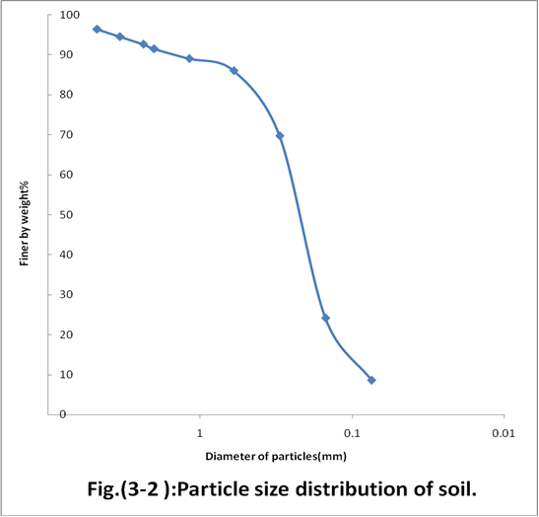

|  |  |  |  |  |  |  |
| --- | --- | --- | --- | --- | --- | --- |
| Sieve no. | Sieve dia. | Sieve weight empty | Retaind weight | Retaind  Weight  (%) | Cumulative  Retained  Weight (%) | Passing (%) |
| 4 | 4.75 | 770.2 | 70.2 | 3.59 | 3.59 | 96.4 |
| 6 | 3.35 | 725.4 | 37.7 | 1.93 | 5.52 | 94.48 |
| 8 | 2.36 | 704.9 | 37 | 1.89 | 7.41 | 92.59 |
| 10 | 2.00 | 692.5 | 22 | 1.124 | 8.534 | 91.47 |
| 16 | 1.18 | 647.9 | 49.4 | 2.52 | 11.054 | 88.95 |
| 30 | 0.60 | 600 | 56.9 | 2.91 | 13.964 | 86.1 |
| 50 | 0.30 | 542.2 | 320 | 16.36 | 30.324 | 69.7 |
| 100 | 015 | 521.9 | 890.6 | 45.53 | 75.854 | 24.2 |
| 200 | 0.075 | 500.2 | 304.9 | 15.58 | 91.43 | 8.67 |
| pan |  | 481.3 | 158.8 | 8.12 | 99.56 | 0 |

Table (3-1) sieve analysis for soil

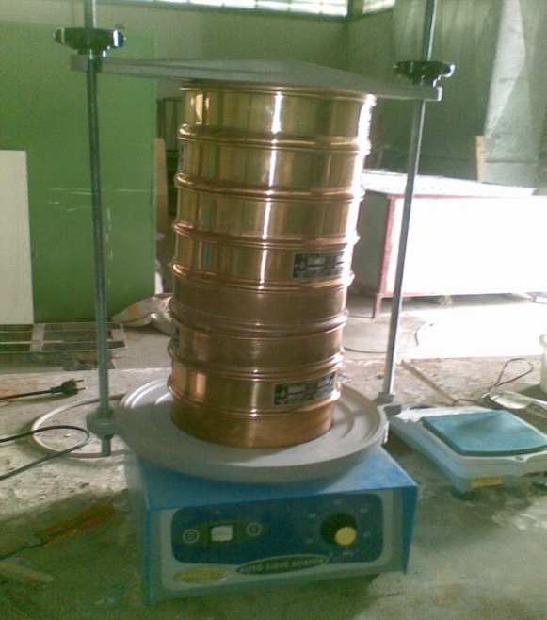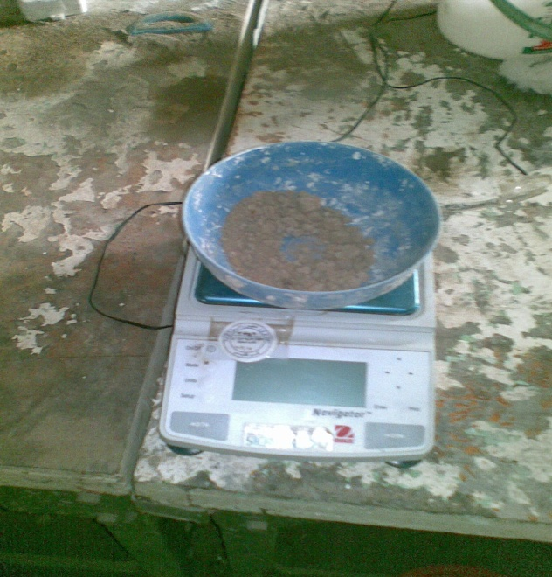

Fig (3-3) The Grain size distribution test

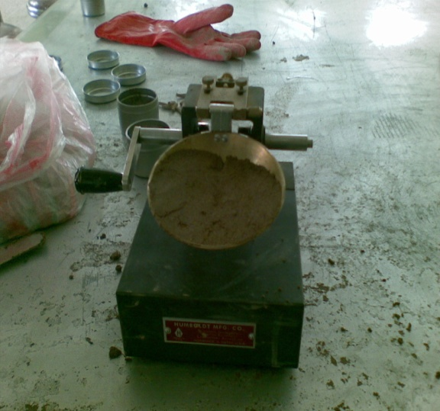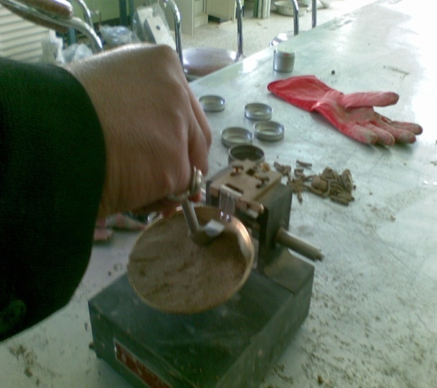

Fig (3-4): Atterberg Limits test

**3.2.2 Soil Used**

The soil used was artificially made in laboratory (salty soil) to make good category about the behavior of this soil using this new device,by mixing soil with 15% ,20% pure salt to ensure fix boundary conditions for all samples. The physical tests of the soil are shown in the table(3-2):

Table ( 3-2) Average results for physical tests for artificial salty soil used.

|  |  |  |  |  |  |  |
| --- | --- | --- | --- | --- | --- | --- |
| Dry Density KN/m3 | Wet Density KN/m3 | Plasticity Index% | Plastic limit% | Liquid limit% | Soil type | Moisture  Content % |
| 13.7 | 15 | 0 | 0 | 0 | SM-SP | 9.5 |

**3.3.1 Laboratory model preparation:**

The model used consists of 28 cm diameter and 34 cm height, plastic cylindrical container. The loading system consists of fix weights had 32 KN/m2 as a stress applied directly over steel footing (60*60)mm shown in fig (3-5) which placed over the soil, the load transferred by 10 mm diameter of steel bar, a stainless steel bar was designed and constructed vertically with the assistance of professional. The container was opened from the top, to ensure feeding the sample with water. The model was braced at the upper side with steel loading frame, manufactured specially for this test to prevent tilting or movement of footing of fix weight along the test stages. Finally the of dial

gauge was instilled beside the mold to read settlement of the soil. The dial gauge reading is continuously taken with time from the first soaking period, which takes about 5 days and the dial reading was recorded after applying stress as shown in figure (3-6)

. 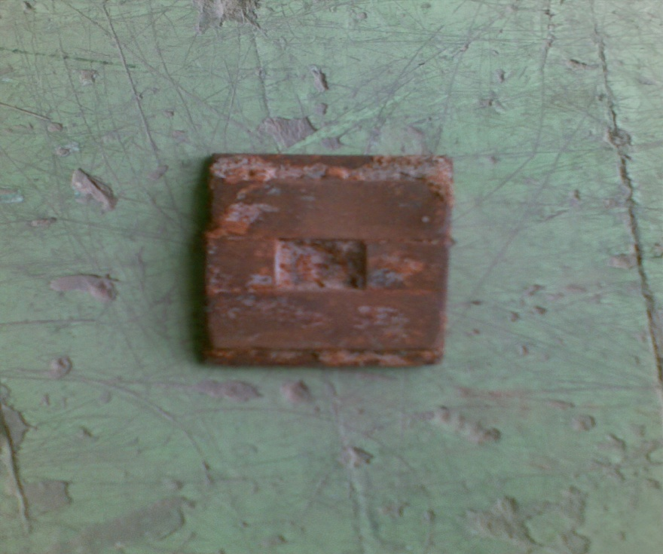

Fig (3-5) small steel plate make as a footing

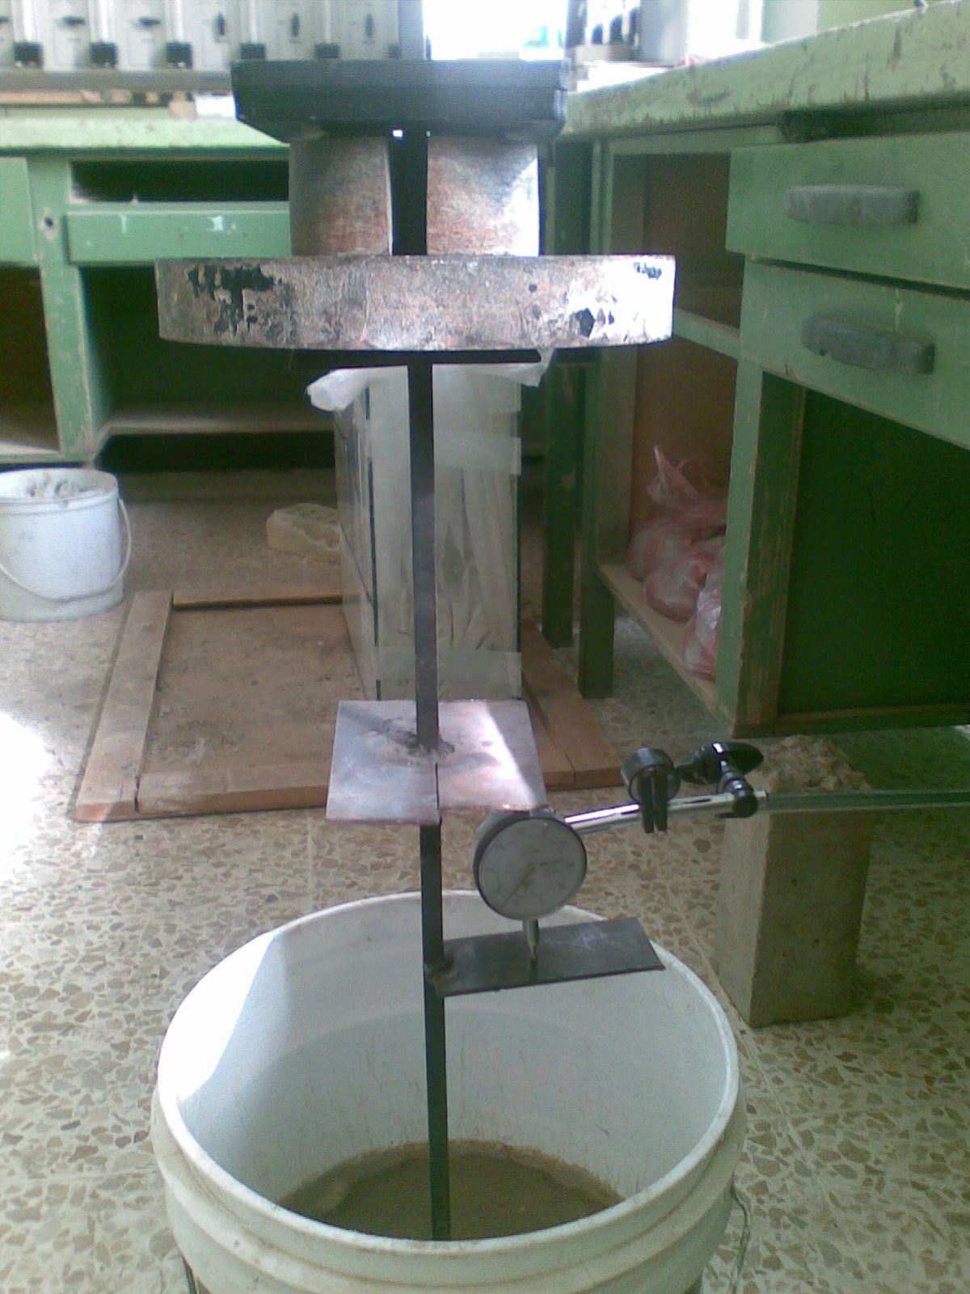

Fig(3-6) : Installing the model with the dial gage to read the settlement of the sample soil

**3.3.2 Soil preparation:**

The salty soil was sieved by No.4 sieve, mix thoroughly with water by 5% as a percentage by weight and the various percentages of the salt (15% ,20%) by weight, were added to the mixture of the samples. The cylindrical model was fitted at its position, the soil consisted one patch and putted into container in three layer of 7 cm thickness sub layer, the layer was soaked with water .

The procedure was proceed until the final reading. Soil density was calculated within all the samples. The dial gauge readings were recorded with time 5 days. After 5 minutes from the beginning of load application, the dial gage reading was recorded, which represent the immediate settlement of footing, as in the dry test for laboratory model.and after 20 minutes from the beginning the water was added to the container

**3.3.3 Preparation of lime:**

Lime is preparation by dried (3 hours) in oven at degree 600 C˚. Lime formed from calcium carbonates after dried it as shown in this chemical equation:

CaCo3 Cao +Co2

**3.3.4 The site of the soil use:**

The soil used was taken from the location near situ of Diyala river in diyala city. The depth of samples is (0.5-1)m as shown in fig.(3-7)

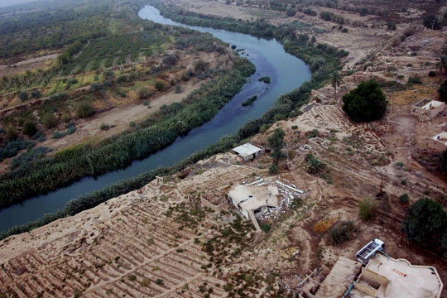

Diyala River

Depth 1 m

Location of soilFig(3-7)

Also, it is used natural sabkha soil in this study brought from diyala discrete from (1-2)m depth of handmade borehole. The chemical properties of sabkha soil are shown in table(3-3). These tests are worked in national center for construction laboratories and research.

Table(3-3): chemical properties of sabkha soil

|  |  |  |  |  |
| --- | --- | --- | --- | --- |
| Chlorides content (%) | Organic content (%) | PH value | T.S.S.(%) | SO3 (%) |
| 14.20 | 0.71 | 8.10 | 22.4 | 0.65 |

**Chapter four**

**Results and Discussion :**

Salty soil ,not a lot of promising future if exists in landscape, as known is one of the many types of collapsible soils and in turn the later is one of the many type of problem soils .These soil ,as mentioned earlier, are totally having good engineering properties when dry , i.e. , moderate bearing capacity with low settlement and almost very little creep. But once are wetted they loose their entire structure (collapse and undergo very large instantaneous settlement called potential collapse even if there is no or very little applied stress . Bad policy one follows in building an engineering facility over such soils without any counter measures taken in both the foundation soil and the structure itself.

In this study it is not intended to focus or the collapsibility of such soils, instead it is intended to make use of such soils for engineering purposes . Using these soil directly without any mean to improve their engineering strength properties is not an engineering wisdom, but authors tend to add some additives(which should be available in local market and rather cheap) to get some improvement on their behavior.

As mentioned earlier in chapter three that two percentages of salt prepared are (15%,20%) .The results of first sample are shown in figures(4-1,4-2,4-3,4-4&4-5).These curves show the time_ settlement/width of footing relationship for samples 15% salt content, the soil tested at stress level of 32 kPa and soil density 15 kN/m3 .The settlement of case of no treatment is continued and does not stop until leveled off at measured quantity of 10 mm ,that is S/B ratio of 0.17 , that is a very high settlement and author believe that there is no such domestic building that can withstand such numerical value. This type of settlement is collapse and not long term one like consolidation settlement. It is noticed that after adding lime with different percentages (1.5%,3%,4.5%), the settlement is decreased and S/B became (0.12,0.067,0.15) respectively . The percentages of improvement are approximately 29.4%,60.6% and 11.8% .

Figures (4-6.4-7,4-8,4-9&4-10) show the results of second sample with salt content 20% . It is noticed that the settlement of case no settlement is increased until reached 11.2mm,that is S/B 0.187 .When adding lime with different percentages (1.5%,3%,4.5%) ,the settlement is decreased and S/B became (0.183,0.135,0.166) respectively .Figure(4-11) shows the relationship between percent lime added to salty soil versus S/B recorded for two samples 15%&20% salt content .It is noticed that the best percent of lime which gives good improvement is 3% for both samples. Also, that the degree of improvement decreased with increased salt content.

Fig.(4-12) shows the time_ settlement/width of footing curves for natural soil without treatment and treatment with 3% lime at the same conditions mentioned above .It is noticed that S/B is 0.19 for case no treatment ,when added 3% lime , the ratio S/B reduced to 0.06 .The solubility of sodium chloride is high ,therefore; the settlement of salty soil increases during soaking .

Table (4-1):Time –Settlement **∕** width of footing for salty soil (15% NaCl) without treatment

|  |  |
| --- | --- |
| Time (min.) | Without treatement |
| 0.01 | 0.0013 |
| 1440 | 0.0017 |
| 1460 | 0.0057 |
| 1520 | 0.025 |
| 2960 | 0.045 |
| 4400 | 0.16 |
| 5840 | 0.165 |
| 7280 | 0.17 |

Table (4-2):Time –Settlement **∕** width of footing for salty soil (15%NaCl) treatment with 1.5 % lime

|  |  |
| --- | --- |
| Time (min.) | Added 1.5% lime |
| 0.01 | 0.0002 |
| 1440 | 0.0002 |
| 1460 | 0.0033 |
| 1520 | 0.0183 |
| 2960 | 0.0317 |
| 4400 | 0.1183 |
| 5840 | 0.119 |
| 7280 | 0.12 |

Table (4-3):Time-Settlement **/** width of footing for salty soil (15%NaCl)treatment with 3% lime

|  |  |
| --- | --- |
| Time (min.) | Added 3% lime |
| 0.01 | 0.0002 |
| 1440 | 0.0002 |
| 1460 | 0.00125 |
| 1520 | 0.0126 |
| 2960 | 0.0195 |
| 4400 | 0.057 |
| 5840 | 0.06 |
| 7280 | 0.067 |

Table (4-4):Time-Settlement **/** width of footing for salty soil(15%NaCl) treatment with 4.5% lime

|  |  |
| --- | --- |
| Time (min.) | Added 4.5 % lime |
| 0.01 | 0 |
| 1440 | 0.0002 |
| 1460 | 0.025 |
| 1520 | 0.028 |
| 2960 | 0.042 |
| 4400 | 0.05 |
| 5840 | 0.14 |
| 7280 | 0.15 |

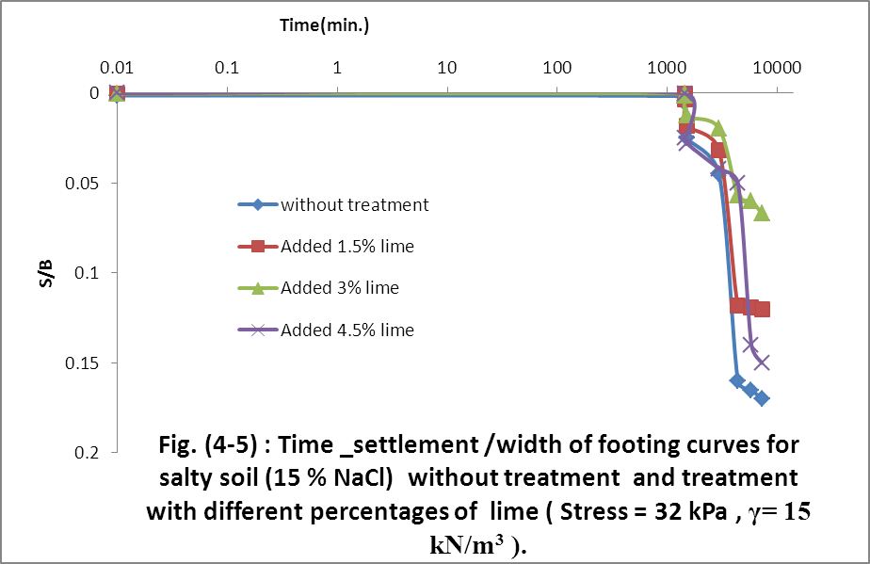

Table (4-5):Time –Settlement **/** width of footing for salty soil (15%NaCl) without treatement and treatment with different percentages of lime

|  |  |  |  |  |
| --- | --- | --- | --- | --- |
| Time (min.) | Without treatment | Added 1.5 % lime | Added 3 % lime | Added 4.5 % lime |
| 0.01 | 0.0013 | 0.0002 | 0.0002 | 0 |
| 1440 | 0.0017 | 0.0002 | 0.0002 | 0.0002 |
| 1460 | 0.0057 | 0.0033 | 0.00125 | 0.025 |
| 1520 | 0.025 | 0.0183 | 0.0126 | 0.028 |
| 2960 | 0.045 | 0.0317 | 0.0195 | 0.042 |
| 4400 | 0.16 | 0.1183 | 0.057 | 0.05 |
| 5840 | 0.165 | 0.119 | 0.06 | 0.14 |
| 7280 | 0.17 | 0.12 | 0.067 | 0.15 |

Table (4-6):Time –Settlement **/**width of footing for salty soil (20%NaCl) without treatment

|  |  |
| --- | --- |
| Time (min.) | Without treatment |
| 0.01 | 0.001 |
| 1440 | 0.0017 |
| 1460 | 0.0067 |
| 1520 | 0.03 |
| 2960 | 0.05 |
| 4400 | 0.167 |
| 5840 | 0.183 |
| 7280 | 0.187 |

Table (4-7):Time –Settlement **/** width of footing for salty soil (20%NaCl) treatment with 1.5% lime

|  |  |
| --- | --- |
| Time (min) | Added 1.5 % lime |
| 0.01 | 0.001 |
| 1440 | 0.0018 |
| 1460 | 0.01 |
| 1520 | 0.033 |
| 2960 | 0.047 |
| 4400 | 0.162 |
| 5840 | 0.18 |
| 7280 | 0.183 |

Table (4-8):Time –Settlement **/** width of footing for salty soil (20%NaCl) treatment with 3% lime

|  |  |
| --- | --- |
| Time (min.) | Added 3 % lime |
| 0.01 | 0.0005 |
| 1440 | 0.0033 |
| 1460 | 0.0052 |
| 1520 | 0.03 |
| 2960 | 0.035 |
| 4400 | 0.09 |
| 5840 | 0.132 |
| 7280 | 0.135 |

Table (4-9):Time –Settlement **/** width of footing for salty soil (20%NaCl) treatment with 4.5 % lime

|  |  |
| --- | --- |
| Time (min.) | Added 4.5 % lime |
| 0.01 | 0.0007 |
| 1440 | 0.0042 |
| 1460 | 0.0068 |
| 1520 | 0.032 |
| 2960 | 0.043 |
| 4400 | 0.075 |
| 5840 | 0.165 |
| 7280 | 0.166 |

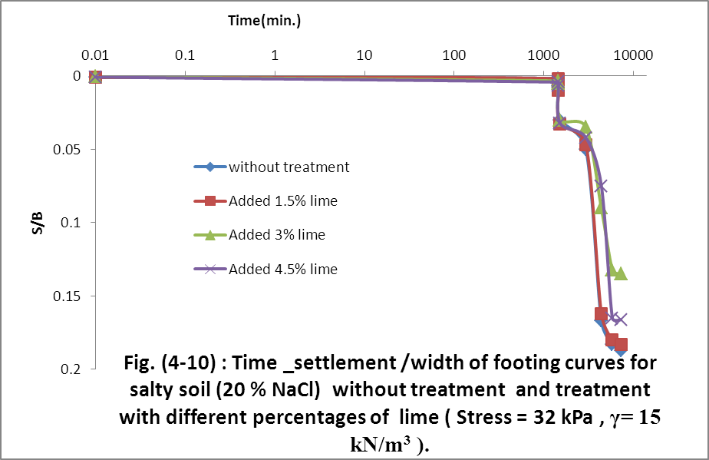

Table (4-10):Time – Settlement / width of footing for salty soil (20%NaCl) without treatment and treatment with defferent percentage of lime

|  |  |  |  |  |
| --- | --- | --- | --- | --- |
| Time (min) | Without treatment | Added 1.5 % lime | Added 3 % lime | Added 4.5 % lime |
| 0.01 | 0.001 | 0.001 | 0.0005 | 0.0007 |
| 1440 | 0.0017 | 0.0018 | 0.0033 | 0.0042 |
| 1460 | 0.0067 | 0.01 | 0.0052 | 0.0068 |
| 1520 | 0.03 | 0.033 | 0.03 | 0.032 |
| 2960 | 0.05 | 0.047 | 0.035 | 0.042 |
| 4400 | 0.167 | 0.162 | 0.09 | 0.075 |
| 5840 | 0.183 | 0.18 | 0.132 | 0.165 |
| 7280 | 0.187 | 0.183 | 0.135 | 0.166 |

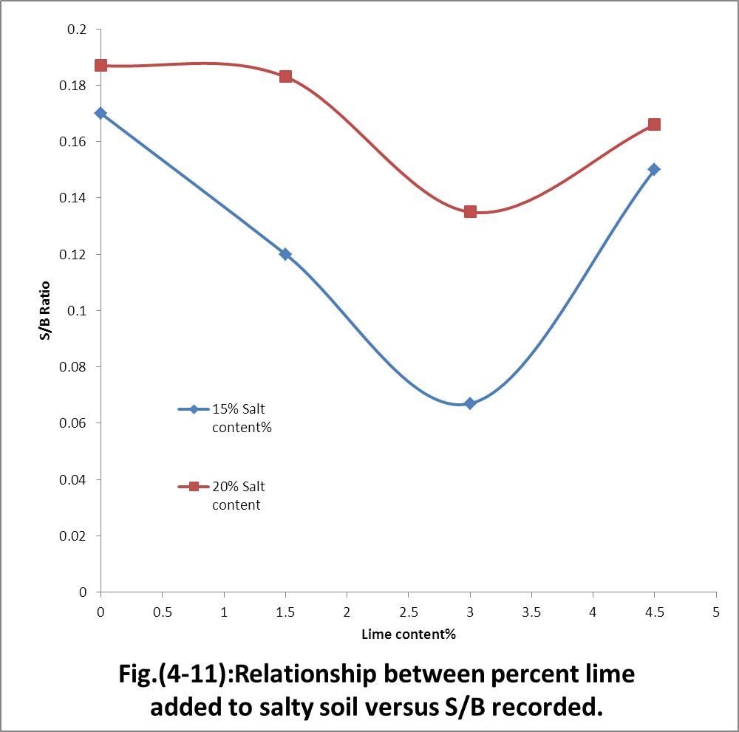

Table ( 4-11) :Relationship between percent lime added to salty soil versus S / B recorded

|  |  |  |
| --- | --- | --- |
| Lime content | 15 % salt content | 20 % salt content |
| 0 | 0.17 | 0.187 |
| 1.5 | 0.12 | 0.183 |
| 3 | 0.067 | 0.135 |
| 4.5 | 0.15 | 0.166 |

Table (4 -11) :Time – settlement / width of footing for natural salty soil without treatment with added 3 % lime

|  |  |  |
| --- | --- | --- |
| Time (min.) | Without treatment | Added 3% lime |
| 0.01 | 0.0015 | 0.0008 |
| 1440 | 0.0025 | 0.0017 |
| 1460 | 0.007 | 0.0032 |
| 1520 | 0.044 | 0.019 |
| 2960 | 0.064 | 0.035 |
| 4400 | 0.179 | 0.053 |
| 5840 | 0.187 | 0.058 |
| 7280 | 0.19 | 0.06 |

**Chapter Five**

**Conclusions :**

The following points are drawn from this study :

1.The degree of improvement of salty soil changes with increasing lime content.

2.The best percent of lime added to salty soil which gives good improvement is 3%.

3.The addition of 3% lime to salty soil reduces the collapsibility to 60.6% for sample 15% salt content and 27.81% for sample 20% salt content.

4.The degree of improvement of salty soil by adding lime decreases with increase salt content.

5.It is a best policy not to use salty soil in any engineering construction or to build on unless they receive some sort of treatment.

6.In using 3% of lime by weight of natural salty soil, the collapse settlement is reduced from S/B=0.19 to S/B=0.06.

7.The stress level used in the laboratory models is about 32kPa..This may represent the average and actual bearing stress in most domestic buildings. Higher stresses will of course cause higher settlement collapse

**Recommendations for future works:**

1-Study the leaching process for all samples used in this study.

2-Apply pressure stress larger that used in this study.

3-It is necessary to used another salt content samples and used the same procedure test in this study.

4-Study the shear strength parameters for all samples used in this study.

5-Study another improvement methods for salty soil.

**: References**

**1.**AL-Amoudi, O.S.B., (1994 )., "A state – of – the art report on the geotechnical problems associated with sabkha soils and method of treatment ." Proceedings, ASCE – SAS First Regional Conference and Exhibition , Bahrain, PP. 53 -77

**2.**AL-Amoudi , O.S.B., (1992) ., "Studies on soil – foundation Interaction in the sabkha Environment of the Eastern province of Saudi Arabia ." Ph.D. Dissertation , Department of civil Engineering , King fahd university of petroleum and minerals, Dhahran ,Saudi Arabia ,vols I and II.

**3.** AL-Amoudi , O.S.B.,(1995) ., "A Review of the Geotechnical and Construction problems in sabkha Environments and method of treatment." The Arabian Journal for Science and Engineering , vol.20 No.3 .

**4.**AL-Amoudi ,O.S.B. and Abdulijauwad ,S.N., (1994) . "Modified Oedometer for arid saline soil."ASCE Journal of Geotechnical . Engineering., 120(10) . PP. 1892- 1897 .

**5.**AL-Amoudi ,O.S.B. and Abduljauwad, S.N.,(1994)., "Discussion contribution of the paper laboratory and field leaching tests on coastal salt- Bearing soils." ASCE Journal of Geotechnical Engineering , vol.120, NO.10, PP. 1900-1902 .

**6.**AL-Amoudi,O.S.B., Abduljauwad, S.N., EL-Naggar, Z.R.andRasheeduzzafar, (1992). "Response of sabkha to laboratory Tests :Acase study." Engineering Geology , vol. 33, No.2 ,PP. 111-125 .

**7.**AL-Amoudi, O.S.B., and Abdujauwad, S.N., (1995)., "Strength Characteristics of sabkha soils ." Geotechnical Engineering Journal .

**8.**AL-Shamrani ,M.A., (1998)., "Application of the Cα / Cc concept to secondary compression of sabkha soils." Canadian Geotechnical Journal National Research Council, Ottawa , Canada , vol. 35 , PP. 15- 26

**9.**AL-Shamrani, M.A. and Dhowian , A.W., (1997). "Preloading for reduction of compressibility characteristics of sabkha soil profiles." Engineering Geology , Amsterdam, The Netherlands,48, PP.19-41.

**10.**Abduljauwad , S.N.,Bayomy, F.M.,AL-Shaikh.A.M. and AL-Amoudi,O.S.B., (1994). "Influence of Geotextiles on the performance of saline sabkha soils." ASCE Journal of Geotechnical Engineering ,vol .120 , No.11, PP. 1939-1960 .

**11.**Aklili, W.,Torrance, J.K., (1981)." The development and Geotechnical problems of sabkha with preliminary experiments on the static penetration resistance of cemented sand " Quartery Journal of Engineering . Geology ,vol . 14 , PP. 59-73 .

**12.**Akili , W.(1983) ." The sabkhas of Eastern Saudi Arabia Geotechnical considerations ."Proceedings , first Saudi Engineers conference , king Abdul – Aziz University , Jeddah , vol. 11 , PP. 300-322 .

**13.**Aiban , S.A., AL-Abdul Wahhab , H.I .and AL-Amoudi , O.S.B., (1994) ."Identification Evaluation and Improvement of Eastern Saudi soils for constructional purpose ." project No. AR-14.61, First Report, King Abdulaziz City for Science and Technology (KACST) , Riyadh ,Saudi Arabia .

**14.** ASTM (1988) ."Standard test method for one – dimensional consolidation properties of soils ."Am .Soc Testing and materials, Philadelphia, part 19 ,vol. 4.08 , PP. 278-282 .

**15.**Butler , G.P., (1969) ."Modern Evaporite Deposition and Geochemistry of Coexisting Brines , the sabkha , Trucial Arabian Gulf." Journal of sedimentary petrology , vol. 39 , No. 1 ,PP. 70-89 .

**16.**Dhowian, A.W.,Erol , A.O., and Sultan, S., (1987) ."Settlement prediction in complex sabkha soil profiles Bulletin of the International Association of Engineering Geology ." Paris , No. 36 , PP. 11-21 .

**17.**Ellis , G.I . (1973) ." Arabian salt – bearing soil (sabkha) as an engineering material ." TRLL Rep .LR 523 ,Crowthorne , Berkshire .

**18.** EL-Naggar ,Z.R (1988)." Foundation problems in sabkha deposits.In short course on foundation Engineering for practicing Engineer ." Department of civil Engineering., King Fahd University petroleum and Minerals , Dhahran , SD1- SD54 .

**19.** JUILLIE Y. and SHERWOOD D.E., " Improvement of sabkha soil of the Gulf Coast" Eighth European Conference on soil Mechanics and Foundation Engineering , Helsinki , 1983 .

**20.**Lambe , T.W.,(1951)." Soil Testing for Engineers."Wiley ,Newyork, N.Y.

**21.** Lawton, E.C.,Fragaszy ,R.J. and Hardcastle , J.H.,(1989)." Collapse of compacted clayey sand ." ASCE Journal Geotechnical Engineering., 115(9) .PP . 1252- 1267 .

**22.**Lutenegger . A.J. and Saber, R.T., (1988) ."Determination of Collapse potential of soils ." ASCE Geotech . Test. Journal ., 111(3) . PP. 13-16 .

**23.**Zienkiewicz , O.C. and Cormeau ,I.C. (1974) ."Visco- plasticity – plasticity and creep inelastic solids –aunified Numerical solution approach International Journal for Numerical method in Engineering , vol.8 , PP.821-845 .

**.**