The Ministry of
Higher Education and Scientific Research

University of Diyala
Engineering of College
Civil Department

Assessment The Quality of Ground Water in Agricultural Area For Irrigation

By

Hayder A. Farhan
Mouge M. Bilal

Supervisor: Nahida H. Hamza

2012 - 2011

بســــــــــــــــــــــــم الله الرحمن الرحيم

وَمَا أُوتِيتُمْ مِنْ الْعِلْمِ إِلاَّ قَلِيلاً

صدق الله العظيم

SUPERVISORS CERTIFICATION

We certify that this project " Assessment The Quality of Ground Water in Agricultural Area For Irrigation" was prepared under our supervisors at the civil engineering department /college of engineering by: (Hayder A. Farhan and Mouge M. Bilal) as a partial fulfillment of the requirements for the degree of B.Sc. Civil Engineering.

Signature:
Name:
Title:
Date:

In view of available recommendations, forward this project for debate by the examining committee.

Signature:
Name:
Title:
(Head of the department)
Date:

Certification of the Examination Committee

We certify that we have read this project entitled " Assessment The Quality of Ground Water in Agricultural Area For Irrigation" and as examination committee examined the students (Hayder A. Farhan and Mouge M. Bilal) in its contents and that in our opinion it meets the standards of a project for the degree of B.Sc. in Civil Engineering.
Signature: Signature:
Name: Name:
Title: Title:
(Member) (Member)
Date: Date:
Signature:
Name:
Title:
(Chairman)
Date:
Approved For Civil Engineering Department
Signature:
Name:
Title:
Date: (Head of the department)

Acknowledgments

This dissertation would not have been completed without the help of many people. I would like to thank everyone who has contributed directly and indirectly to this work. My sincere gratitude is due to my supervisor Nahida H. Hamza for her guidance and support throughout my research. More thanks must go to My cousin Laith K. Farhan.. A special word of thanks and deep appreciation must go to my father, my mother, and my brothers for their encouragement, help, support and patience.

Dedication

To my parents,

My brothers,

My friends,

And to my country Iraq

ABSTRACT

The study contained suitability Quality of Ground Water in agricultural Area in Al Muqudadia City for irrigation uses, thirteen wells were selected from Al Muqudadia City are Hamza and Kasha Well, New AL-Muqudadia/1 Well, New AL-Muqudadia/2 Well, Old AL-Muqudadia /1 Well, Old Al Muqudadia /2 Well, Shakrak Well, Hambes Well, Zherat Well, Al Awashiq Well, Theaba Well, AL-Aly well, Al Abara Well and Nawfal well. Water samples were collected and analyzed for pH, electric conductivity (EC), TDS, Na⁺, K⁺, Ca²⁺, Mg²⁺, HCO₃⁻, CO₃²⁻, SO₄²⁻, Cl⁻ and NO₃⁻ from these Wells . In addition, to classify water quality and to evaluate its suitability for irrigation purposes, Sodium Adsorption Ratio (SAR), Soluble Sodium Percentage (SSP) and Residual Sodium Carbonate (RSC) were calculated following standard equations and found experimentally as (63), (71.5), (-1.79) respectively. According to the EC and SAR plotted on the US salinity diagram. It is illustrated that water samples of New Al Mouqdadia/1, New AL-Mouqdadia/2, Old Al Mouqdadia/1, Old Al Mouqdadia/2, Shakrak, Hembes, AL-Aly, Theaba, and A l Abara fall in the class of C3-S1 indicating high salinity with low sodium water, which can be used for irrigation on almost all types of soil, with only a minimum risk of exchangeable sodium, while water samples of other stations fall in the class of C2-S1 indicating medium salinity with low sodium water, which can be suitable to salt tolerant plants with probability develop permeability problem of soil when Lime is not existing. RSC values are negative at all sampling sites, indicating that there is no complete precipitation of calcium and magnesium. Also all other parameters were in standard levels. The results of the study revealed that most of the Al Mouqdadia City Wells water can be classified as suitable for irrigation with few exceptions.

Table of Contents

ACKNOWLEDGMENT ………………………………………..…………I
DEDICATION…………………………………………………………….II
ABSTRACT……………………………………………………….………III
TABLE OF CONTENTS………………..……………………………...…IV
LISTS OF TABLES……………………………………………………..…VI
LIST OF FIGURES……………………………………………………...…VI
GLOSSARY ABBREVIATIO………………………………………..…..VII
- CHAPTER ONE INTRODUCTION ……………………………..….…1
  - Introduction……………………………..…………………………..…1
  - Objective of the Study…………………………………………….…..4
- CHAPTER TWO LITERATURE SURVEY………………….…….…5
  - Water Quality Problems……………………………………….……....5
    - Salinity Hazard………………………….………………….…..6
    - Hydrogen Ion Activity (pH) …………………………..……….8
    - Sodium Hazard………………….……………………..…....….8
    - Soluble Sodium percentage (SSP) ……………..…………..….11
    - Residual Sodium Carbonate (RSC) …………....………..…….11
    - Magnesium Hazard………………………..…....………….….12
    - Chloride Hazard………………….………..…....………….….12
    - Sulfate………………….…………………..…....………….….13
    - Nitrate………………….…………………..…....………….….13
  - Previous Works………………….………………..…....…………..….15

- CHAPTER THREE RESULTS AND DISCUSSION……………...….21
  - Introduction………………………………………………….…….....16
  - Results and Discussion………………………………………………..17
    - Salinity Hazard……………..………………………………….17
    - Sodium Hazard………..………..……………………………...18
    - Soluble Sodium Percentage (SSP) …………………………….19
    - pH Affect…………………………………..…………………..19
    - Residual Sodium Carbonate ……………..………………...….19
    - Chloride Hazard…………………………..………………...….20
    - Magnesium Hazard……………….………..……………….….20
    - Sulfate……………………………………….……………...….20
    - Nitrate……………………………………….………………….21

- CHAPTER FOUR CONCLUSION AND RECOMMENDATION…...22
  - Conclusion……………………………………….……………..…..….24
  - Recommendation.………………………………………………..…….24
- REFRENCES .…………………………….…………………………..….25

LISTS OF TABLES

Table 2.1: Salinization of soils on Irrigated Lands............................................................7
Table 2.2: Water quality classes for agricultural irrigation...............................................14
Table 3.1: The Results of analytical Chemical of Al-Mouqdadyia Well (mg/l)……..…21
Table 3.2: Summary Statistics of the analytical data........................................................22
Table 3.3: Calculated Irrigation Quality Characteristics...................................................23

LISTS OF FIGURES

Figure 1.1: The groundwater source..............................................................................1
Figure 1.2: Using groundwater in the cities..................................................................2
Figure 1.3: Groundwater use for irrigation...................................................................3
Figure 1.4: Top Ten countries by groundwater withdrawal, 2000 to 2010….........….4
Figure 3.1: Rating of water samples in relation
to salinity and sodium hazard……………………………………….……………….23

GLOSSARY ABBREVIATIO

- TDS: Total Dissolve Solid
- EC: Electric Conductivity
- PH: Hydrogen Ion Activity
- SAR: Sodium Adsorption Ratio
- SSP: Soluble Sodium percentage
- RSC: Residual Sodium Carbonate

CHAPTER ONE
INTRoduction
1.1 Introduction:
Groundwater is water that exists in the pore spaces and fractures in rock and sediment beneath the Earth's surface. It originates as rainfall or snow, and then moves through the soil into the groundwater system, where it eventually makes its way back to surface streams, lakes, or oceans. Groundwater is stored in the ground in materials like gravel or sand. It's kind of like the earth is a big sponge holding all that water. Water can also move through rock formations like sandstone or through cracks in rocks [1]. As shown in the (figure1-1).
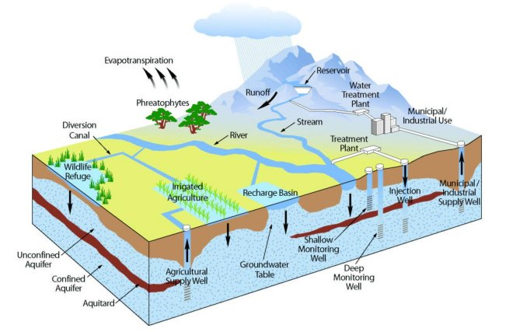
Groundwater makes up about 1% of the water on Earth (most water is in oceans). But, groundwater makes up about 35 times the amount of water in lakes and streams. Groundwater occurs everywhere beneath the Earth's surface, but is usually restricted to depths less that about 750 meters. The volume of groundwater is a equivalent to a 55 meter thick layer spread out over the entire surface of the Earth [2].

Figure1-1: The groundwater source
An area that holds a lot of water, which can be pumped up with a well, is called an aquifer. Wells pump groundwater from the aquifer and then pipes deliver the water to cities, houses in the country, or to crops. As illustrated in (figure 1-2).

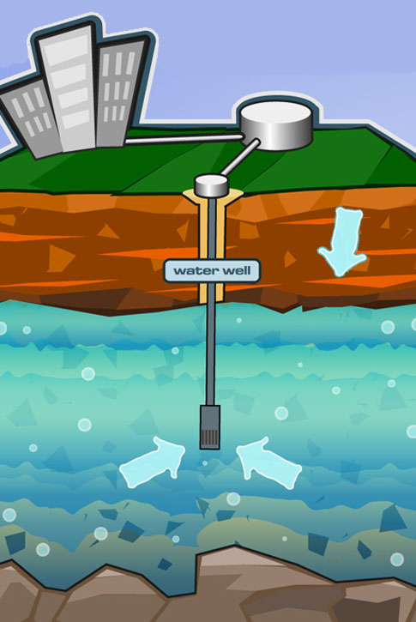

Figure 1-2: Using groundwater in the cities [3].

Groundwater is the main source of irrigation water supply for many settlements. Hence, it is necessary to evaluate the ground water quality for irrigation [4]. As shown in figure 1-3.
For many important agricultural production areas, groundwater will remain the ultimate source of freshwater when surface water sources have been depleted. The aquifers that host groundwater are the primary buffers against drought for both human requirements, and crop production. In many concentrations of intensive agriculture, groundwater offers reliability and flexibility in access to water that irrigation canals can hardly match. Additionally, groundwater is generally less prone to pollution than surface water [4].
Most groundwater is clean, but groundwater can become polluted, or contaminate. It can become polluted from leaky underground tanks that store gasoline, leaky landfills, or when people apply too much fertilizer or pesticides on their fields or lawns. When pollutants leak, spill, or are carelessly dumped on the ground they can move through the soil.

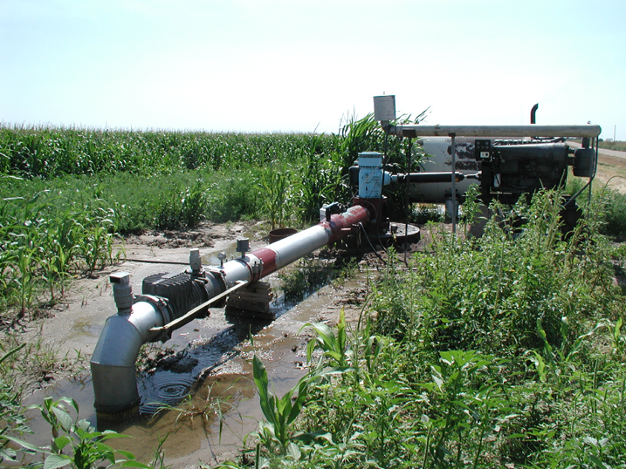

Figure 1-3: Groundwater use for irrigation

Because it is deep in the ground, groundwater pollution is generally difficult and expensive to clean up. Sometimes people have to find new places to dig a well because their own became polluted [4].
The chart below (figure 1-4) has explained the top ten countries in the world using groundwater from 2000 to 2010.

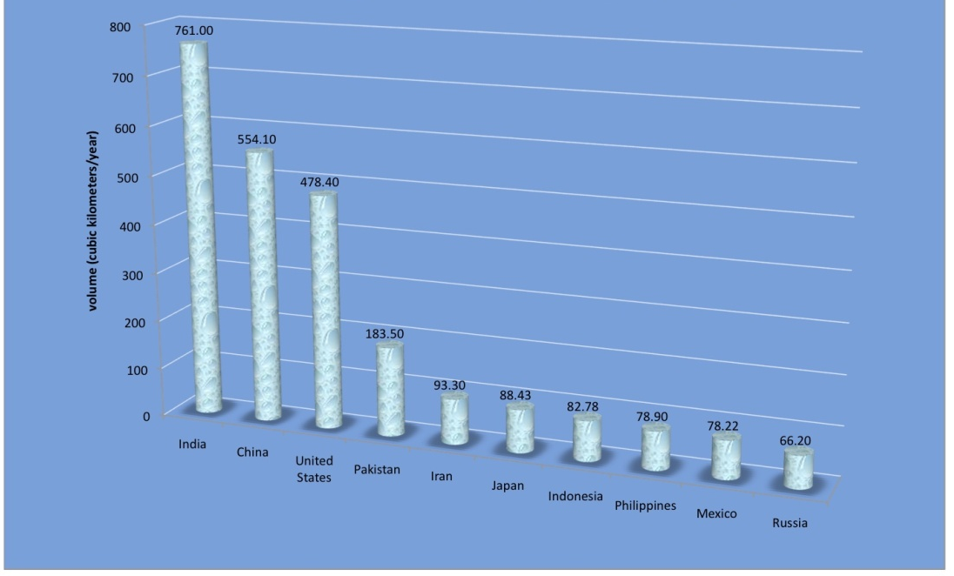

Figure 1-4: Top Ten countries by groundwater withdrawal, 2000 to 2010 [5]

1.2 Objective of the Study
The present of study is mainly conducted to measure and analyze the irrigation ground water quality in Al- Mouqdadayia Well City such as EC and TDS Sodium adsorption ratio, percentage sodium, magnesium and chloride hazard ,ph, residual sodium carbonate that could potentially Import of irrigation crop

CHAPTER TWO
LITERATURE SURVEY
2-1 Water Quality Problems
Water quality is the physical, chemical and biological characteristics of water. It is a measure of the condition of water relative to the requirements of one or more biotic species and or to any human need or purpose. It is most frequently used by reference to a set of standards against which compliance can be assessed [6].
Water used for irrigation can vary greatly in quality depending upon type and quantity of dissolved salts. Salts are present in irrigation water in relatively small but significant amounts. They originate from dissolution or weathering of the rocks and soil, including dissolution of lime, gypsum and other slowly dissolved soil minerals. These salts are carried with the water to wherever it is used. In the case of irrigation, the salts are applied with the water and remain behind in the soil as water evaporates or is used by the crop [6].
The suitability of a water for irrigation is determined not only by the total amount of salt present but also by the kind of salt. Various soil and cropping problems develop as the total salt content increases, and special management practices may be required to maintain acceptable crop yields. Water quality or suitability for use is judged on the potential severity of problems that can be expected to develop during long-term use [7].
The problems that result vary both in kind and degree, and are modified by soil, climate and crop, as well as by the skill and knowledge of the water user. As a result, there is no set limit on water quality; rather, its suitability for use is determined by the conditions of use which affect the accumulation of the water constituents and which may restrict crop yield. The soil problems most commonly encountered and used as a basis to evaluate water quality are those related to salinity, water infiltration rate, toxicity and a group of other miscellaneous problems [7].

2-1-1 Salinity Hazard
The excess of salts content is one of the major concerns with water used for irrigation. A high salt concentration present in the water and soil will negatively affect the crop yields, degrade the land and pollute groundwater [8].
The suitability of water reuse for irrigation with high salt content depends on the following factors:
- Salt tolerance of the type of crop
- Characteristics of the soil under irrigation
- Climate conditions. The quality of the irrigation water plays an essential role in arid areas affected by high evaporation rates and cause high concentrations of salt accumulating in the soil
- Soil and water management practices Real hazard, a percentage of 21% of total irrigated land is estimated to be damaged by salt (as shown in table 2-1).

Table 2-1: Salinization of soils on Irrigated Lands [8]
Country | Irrigated Land Damaged by Salt  (million Ha) | Total irrigated Land Damaged by Salt  (percent)
India  China  Pakistan  USA  Uzbekistan  Iran  Turkmenistan  Egypt  Subtotal  World Estimate | 7.0  6.7  4.2  4.2  2.4  1.7  1.0  0.9  28.1  47.7 | 17  15  26  23  60  30  80  33  21  21

In irrigated agriculture, many salinity problems are associated with or strongly influenced by a shallow water table (within 2 metres of the surface). Salts accumulate in this water table and frequently become an important additional source of salt that moves upward into the crop root zone. Control of an existing shallow water table is thus essential to salinity control and to successful long-term irrigated agriculture. Higher salinity water requires appreciable extra water for leaching, which adds greatly to a potential water table (drainage) problem and makes long-term irrigated agriculture nearly impossible to achieve without adequate drainage. If drainage is adequate, salinity control becomes simply good management to ensure that the crop is adequately supplied with water at all times and that enough leaching water is applied to control salts within the tolerance of the crop(8).
Salinity hazard is the most influential water quality guideline on crop productivity as measured by electrical conductivity, it reflects the total dissolved solid (TDS) in water [9,10]. The amount of water transpired through a crop is directly related to yield; therefore, irrigation water with high EC reduces yield potential and can result in a physiological drought condition. That is, even though the field appears to have plenty of moisture, the plants wilt because the roots are unable to absorb the water [11, 12].
2-1-2 Hydrogen Ion Activity (pH)
pH is a way of expressing the hydrogen ion concentration in water. It is related to the acidic or alkaline nature of water. Consideration of hydrogen ion concentration is important in almost all uses of water. In particular, pH balance is important in maintaining desirable aquatic ecological conditions in natural waters [13]. The pH of most natural waters lies between 6.5 and 8.4. Where low pH may cause accelerated irrigation system corrosion where they occur. While high pH above 8.5 are often caused by high carbonate (CO₃²⁻) and bicarbonate (HCO³⁻) concentrations [9, 14, 15].
2-1-3 Sodium Hazard
Although plant growth is primarily limited by the salinity EC level of the irrigation water, the application of water with a sodium imbalance can further reduce yield under certain soil texture conditions. Toxicity of sodium occurs with the accumulation sodium in the plant tissues and exceeds the tolerance limit of crop. Reductions in water infiltration can occur when irrigation water contains high sodium relative to the calcium and magnesium contents, this causes swelling and dispersion of soil clays, surface crusting and pore plugging, almost impermeable to rain or irrigation water and decrease in the downward movement of water into and through the soil, and actively growing plants roots may not get adequate water, despite pooling of water on the soil surface after irrigation[14].
As sodium ions increase in the soil ,they adsorb to the cation exchange sites and displace elements needed for plant growth. The net effect of the sodium ion buildup is a dispersion of soil aggregates, resulting in a soil that has a structure more like that of talcum powder than of a normal soil [16].
Sodium hazard is usually expressed in terms of the Sodium Adsorption Ratio (SAR) which can be calculated from the ratio of sodium to calcium and magnesium [9,17]. The equation is expressed as follows:
SAR = $\frac{Na^{+}}{\sqrt{\frac{Ca^{+2}+Mg^{+2}}{2}}}$
(1)

where: Na⁺, Ca²⁺ and Mg²⁺ are in meq/L.
For waters containing significant amounts of bicarbonate, Bower and Maasland [18] proposed a modification in the old SAR procedure to include changes in soil water composition that are expected to result due to dissolution/ precipitation of lime in the soil upon irrigation. Therefore, the adjusted sodium adsorption ratio (adj SAR) is sometimes used , and it is an SAR value corrected to account for the removal of Ca²⁺ and Mg²⁺ by their precipitation with CO₃²⁻ and HCO₃⁻ ions in the water added . It can be calculated as in reference by using the following formula[9, 19]:
adj SAR = SAR [1 + ( 8.4 - pHc)] (2)
where 8.4 is the approximate of a nonsodic saline soil in equilibrium with CaCO3 and is substituted for the pH of water. This substitution reflects the high buffering capacity of calcareous soils. pHc is defined by:
pHc = (pK₂ + pK_{c} ) + p (Ca²⁺ + Mg²⁺) + pAlk (3)
where p refers to the negative logarithm, K₂ is the second dissociation equilibrium constant of carbonic acid, K_{c} is solubility equilibrium constant for calcite. Concentrations of Ca²⁺, Mg²⁺, CO₃²⁻ and HCO₃⁻ in meq/L.
The pHc can be calculated using the standard table given by reference [9] which related to the concentration values from water analysis. This concept has been found very useful for predicting the effect of sodium hazard of irrigation water on soil properties. Values of pHc above 8.4 indicate tendency to dissolve lime from soil through which the water moves; values below 8.4 indicate tendency to precipitate lime from waters applied [19].
A new adj SAR method [9, 19] is derived which adjusts the calcium concentration of the irrigation water to the expected equilibrium value and includes the effects of carbon dioxide CO2, carbonate (HCO3-) and of salinity (EC) upon the calcium originally present in the applied water but now a part of the soil water. The new adjusted SAR is termed widely as adj RNa, and the equation is as follows:
adj RNa = $\frac{Na}{\sqrt{\frac{Cax +Mg}{2}}}$ (4)
where Na, Mg are sodium and magnesium in the irrigation water in (meq/l), Ca_{x} is a modified calcium value (meq/l) expected to remain in near surface soil water following irrigation with water of given HCO₃ ⁻/Ca²⁺ ratio and EC available from the standard Tables ( 2-2).

2-1-4 Soluble Sodium percentage (SSP)
Soluble Sodium Percent (SSP) is also used to evaluate sodium hazard. SSP is defined as the ration of sodium to the total cation. Water with a SSP greater than 60% may result in sodium accumulations that will cause a breakdown in the soil’s physical properties. SSP is expressed as follows:
SSP = $\frac{Na}{Ca+Mg+Na+K}*100$ (5)
where all the ions are expressed in meq/L.
The ratio of the exchangeable Na+ to total exchangeable cations (Exchangeable Sodium Percentage, ESP) is a good indicator for soil structure deterioration. Although, the ESP of 10-15% is generally accepted as a critical level, an ESP of 25% may have little effect on soil structure in a sandy soil, whereas an ESP of 5% is considered high particularly in soils containing 2:1 clay minerals like montmorillonite [12]. The ESP of soils can be predicted quite well from the following the empirical relationship [20]:
ESP = $\frac{100(-0.0126+0.01475*SAR)}{1+(-0.0126+0.01475*SAR)}$ (6)
2-1-5 Residual Sodium Carbonate (RSC)
RSC represents the amount of sodium carbonate and sodium bicarbonate in water when total carbonate and bicarbonate levels exceed total amount of calcium and magnesium. It is usually expressed as meq/l of sodium carbonate. Residual carbonate levels less than 1.25 meq/l are considered safe. Waters with RSC of 1.25-2.50 meq/l are within the marginal range. These waters should be used with good irrigation management techniques and soil salinity monitored by laboratory analysis. RSC values of 2.50 meq/l or greater are considered too high making the water unsuitable for irrigation use. RSC is determined by [10, 12, 14]:
RSC= (CO₃²⁻ + HCO₃⁻) - (Ca²⁺ + Mg²⁺) (7)
All ion concentrations are expressed in meq/l.
2-1-6 Magnesium Hazard
Generally, Ca²⁺ and Mg²⁺ maintain a state of equilibrium in most waters. Both Ca²⁺ and Mg²⁺ ions are associated soil aggregation and friability, but they are also essential plant nutrients. High concentration of Ca²⁺ and Mg²⁺ ions in irrigation water can increase soil pH, resulting in reducing of the availability of phosphorous [21]. Water containing Ca²⁺ and Mg²⁺ higher than 10 meq/L (200 mg/L) cannot be used in agriculture [11]. Another indicator that can be used to specify the magnesium hazard (MH) is proposed by reference [22] for irrigation water as in the following formula:
MH = $\frac{Mg}{Mg+Ca}*100$ (8)
where Ca and Mg ions are expressed in meq/l [11, 17, 23].
If the value of MH is less than 50, then the water is safe and suitable for irrigation [11].
2-1-7 Chloride Hazard
The most common toxicity is from chloride (Cl-) in the irrigation water. Cl- is not adsorbed or held back by soils, therefore it moves readily with the soil-water, is taken up by the crop, moves in the transpiration stream, and accumulates in the leaves. If the Cl- concentration in the leaves exceeds the tolerance of the crop, injury symptoms develop such as leaf burn or drying of leaf tissue. Normally, plant injury occurs first at the leaf tips (which is common for chloride toxicity), and progresses from the tip back along the edges as severity increases. Excessive necrosis (dead tissue) is often accompanied by early leaf drop or defoliation [24].
Chemical analysis of plant tissue is commonly used to confirm chloride toxicity. The part of the plant generally used for analysis varies with the crop, depending upon which of the available interpretative values is being followed. However, for irrigated areas, the chloride uptake depends not only on the water quality but also on the soil chloride, controlled by the amount of leaching that has taken place and the ability
of the crop to exclude chloride. Crop tolerances to chloride are not nearly so well documented as crop tolerances to salinity [9].
2-1-8 Sulfate
Sulfate (SO₄) is relatively common in water and has no major effect on the soil other than contributing to the total salt content. Irrigation water high in sulfate ions reduces phosphorus availability to plants. SO₄ less than 400 mg/l is desired range but higher than 400mg/l will acidify the soil [25].
2-1-9 Nitrate
Waters high in N can cause quality problems in crops such as barley and sugar beets and excessive vegetative growth in some vegetables. However, these problems can usually be overcome by good fertilizer and irrigation management. Regardless of the crop, nitrate should be credited toward the fertilizer rate especially when the concentration of NO₃ exceeds 45 mg/l [26].

Table 2-2. Water quality classes for agricultural irrigation[9, 20].
Salinity Hazard
Irrigation water classification |  |  |  |  |  |  |  |  |  |  |  |  |  |  |  |  |  |  |  |  |  | Degree of restriction on use
Parameter |  |  | Excellent |  |  |  | Good |  |  |  |  | Permissible |  |  |  | Unsuitable |  |  |  |  |  | None |  |  |  |  | Slight to Moderate |  |  | Severe
EC (dS/m) |  |  | < 0.25 |  |  |  | 0.25-0.75 |  |  |  |  | 0.75-2.25 |  |  |  | 2.25-5.0 |  |  |  |  |  | < 0.7 |  |  |  |  | 0.7-3.0 |  |  | > 3.0
TDS (mg/L) |  |  | < 200 |  |  |  | 200-500 |  |  |  |  | 500-1500 |  |  |  | 1500-3000 |  |  |  |  |  | < 450 |  |  |  |  | 450-2000 |  |  | > 2000
Effect on plants |  |  | No detrimental effects |  |  |  | Sensitive plants show salt stress |  |  |  |  | Salt tolerant plants only |  |  |  | Very salt tolerant plants only |  |  |  |  |  | -
Soil water Infiltration (Evaluate using EC and SAR together)
EC(dS/m) | SAR |  |  |  | Degree of  restriction |  |  |  | Remarks |  |  |  |  |  |  |  |  | Degree of restriction on use
< 0.25 | <10 |  |  |  | Low |  |  |  | Satisfactory for all crops |  |  |  |  |  |  |  |  | EC (dS/m)  & SAR |  |  | None |  |  |  |  | Slight to  Moderate |  | Severe
0.25-0.75 | 10-18 |  |  |  | Medium |  |  |  | Satisfactory, some salt sensitive crops will  be affected |  |  |  |  |  |  |  |  | SAR 0-3 &EC |  |  | > 0.7 |  |  |  |  | 0.7-0.2 |  | < 0.2
0.75-2.25 | 18-26 |  |  |  | High |  |  |  | Satisfactory for most crops, salinity condition  will be develop unless leaching and  drainage are adequate |  |  |  |  |  |  |  |  | If SAR 3-6  & EC  If SAR6-12 &EC |  |  | > 0.2  > 1.9 |  |  |  |  | 0.2-0.3  1.9-0.5 |  | < 0.3  < 0.5
2.25-5 | >26 |  |  |  | Very high |  |  |  | Suitable for most salt tolerant plants, leaching  and drainage are imperative |  |  |  |  |  |  |  |  | If SAR  12-20  &EC  If SAR  20-40 &  EC |  |  | > 2.9  > 5.0 |  |  |  |  | 2.9-1.3  5.0-2.9 |  | < 1.3  < 2.9
Specific Ion Toxicity
Degree of restriction on use |  |  |  |  |  |  |  |  |  |  |  |  |  |  | Degree of restriction on use
- |  | Low |  |  |  | Medium |  |  |  | High | Very high |  |  |  | None |  |  |  | Slight to Moderate |  |  |  |  |  |  |  |  |  | Severe
Na(mg/l) |  | - |  |  |  | - |  |  |  | - | - |  |  |  | < 100 |  |  |  | > 100 |  |  |  |  |  |  |  |  |  | > 100
Na⁺ (SAR) |  | < 10.0 |  |  |  | 10-18 |  |  |  | 18-26 | > 26.0 |  |  |  | < 3.0 |  |  |  | 3-9 |  |  |  |  |  |  |  |  |  | > 9.0
Na⁺ (SSP) |  | < 20.0 |  |  |  | 20-40 |  |  |  | 40-80 | > 80 |  |  |  | - |  |  |  | - |  |  |  |  |  |  |  |  |  | -
Irrigation Water Classification
- |  | Safe |  |  | Sensitive plants |  |  |  |  | Moderately to  tolerant plants |  |  |  | Unsuitable or  tolerant plants |  |  |  |  |  | No  problem |  |  |  |  | Increasing  problem |  |  | Sever problem
Cl⁻(meq/L) |  | < 2 |  |  | 2-4 |  |  |  |  | 4-10 |  |  |  | > 10 |  |  |  |  |  | < 4 |  |  |  | 4-10 |  |  |  | > 10
Miscellaneous Effects
Irrigation water classification |  |  |  |  |  |  |  |  |  |  |  |  |  |  |  |  | Degree of restriction on use
- |  |  |  | Safe |  |  |  | Permissible |  |  |  |  | Unsuitable |  |  |  | None |  |  |  |  |  | Slight to  Moderate |  |  |  |  |  | Severe
RSC (meq/L) |  |  |  | < 1.25 |  |  |  | 1.25-2.5 |  |  |  |  | > 2.5 |  |  |  | - |  |  |  |  |  | - |  |  |  |  |  | -
HCO3 (meq/L) |  |  |  | - |  |  |  | - |  |  |  |  | - |  |  |  | < 1.5 |  |  |  |  |  | 1.5-8.5 |  |  |  |  |  | > 8.5
Guidelines for interpretation of irrigation water quality of other parameters
Water parameters |  |  |  |  |  |  |  |  |  |  |  |  |  | Normal ranking in irrigation water
Calcium Ca²⁺ (meq/l) |  |  |  |  |  |  |  |  |  |  |  |  |  | 0-20
Magnesium Mg²⁺( meq/l) |  |  |  |  |  |  |  |  |  |  |  |  |  | 0-5
Carbonate CO₃²⁻( meq/l) |  |  |  |  |  |  |  |  |  |  |  |  |  | 0-1
Bicarbonate HCO₃⁻ (meq/l) |  |  |  |  |  |  |  |  |  |  |  |  |  | 0-10
Sulfate SO₄²⁻ (meq/l) |  |  |  |  |  |  |  |  |  |  |  |  |  | 0-20
Potassium K⁺ mg/l |  |  |  |  |  |  |  |  |  |  |  |  |  | 0-2
Acid/Basic pH 1-14 |  |  |  |  |  |  |  |  |  |  |  |  |  | 6.0-8.5

2-2 Previous Works
There have been numerous studies and reports on assessment of surface water, ground water and treated wastewater quality for irrigation in various states of the country. Jain and Chaurasia [27]. found the surface and subsurface water in upper Urmil river basin suitable and hazard-free for the crops grown. Issac et al [28]. investigated the water available from all the sources in the Chaka block can be used for irrigation purpose without any harm. Haritash et al (North India villages) [17], Khodapanah et al (Eshtehard District ,Iran) [11] and Kacmaz and Nakoman (Koprubasi, Turkey) [23] found that most of the ground water samples are not suitable for irrigation uses. Anwar [29] found the wastewater qualities from both Karak and Mutah wastewater treatment plant are suitable for irrigation purposes in term of salinity and its high sodium content. Naseem et al [30] found the pH, TDS and other major ions are within the specified limit for irrigation purpose except Na, which is at the margin. Important parameters such as RSC, SAR, PI(permeability index) and KR (Kelley ̓s Ratio) reveal as good quality water for irrigation purposes, while MAR (Magnesium Absorption Ratio) is slightly higher for crops.

CHAPTER THREE
RESULTS AND DISCUSSION
3-1 Introduction
The study area is located within agricultural fields in Diyala governorate, thirteen wells were selected from Al Muqudadia City are Hamza and Kasha Well, New AL-Muqudadia/1 Well, New AL-Muqudadia/2 Well, Old AL-Muqudadia/1 Well, Old AL-Muqudadia/2 Well, Shakrak Well, Hambes Well, Zherat Well, AL-Awashiq Well, Theaba Well, AL-Alee well, AL-Abara Well and Nawfal well. Various tests were conducted according to the Standard Methods for examination of water [20] in the laboratory of Environmental Department in Diyala city. Water quality parameters which were studied are as follows: total dissolved solids (TDS), electrical conductivity (EC), PH, Calcium (Ca), Magnesium (Mg), Sodium (Na), Potassium (K), Carbonate (CO₃), Bicarbonate (HCO₃), Nitrate (NO₃), Sulfate (SO₄) and Chloride (Cl) As Shown in Table (3-1). These parameters mainly consist of certain physical and chemical characteristics of water that are used in the evaluation of agricultural water quality. Numerous water quality guidelines have been developed by many researchers for using water in irrigation under different condition. However, the classification of US Salinity Laboratory (USSL) is most commonly used (3,6,13). Parameters such as EC, TDS, pH, Sodium Adsorption Ratio (SAR), adjusted SAR (adj SAR) and the Exchangeable Sodium Percentage (ESP), Soluble Sodium Percentage (SSP) and Residual Sodium Carbonate (RSC) were used to assess the suitability of water for irrigation purposes. The criteria used to evaluate quality of water for use in agriculture are listed in Table (2-2).
3.2 Results and Discussion
Statistical analysis (mean, maximum, minimum values and standard deviation ) of parameters values for physical and chemical characterization of the thirteen wells samples calculated using Microsoft Excel Program 2007,they are listed in (Table 3-2). The characteristics of water for irrigation which are important in determining its quality are:
3.2.1 Salinity Hazard
It was observed from table (3-2) that electrical conductivity of water for all wells ranged from (464 to 1558 ) μS/cm . Maximum EC was observed in New Al Mouqdadia/2 Well was equal to (1558) μS/cm and was found minimum in Zherat Well was equal to (464) µs/cm with a mean value of (1011 μS/cm), while TDS for all wells ranged from (350 to 1051) mg/l. Maximum was found in New Al Mouqdadia/1 Well was equal to (1051) mg/l and minimum in Zherat Well was equal to (350) mg/l with a mean value of (700.5 mg/l). Plants with moderate salt tolerance can be grown in most cases without special practices for salinity control[27]. However, water samples of Wells New Al Mouqdadia/1, New Al Mouqdadia/2, Old Al Mouqdadia/1, Old Al Mouqdadia/2, Shakrak, Hembes, A l Aly, Theaba, and A l Abara fall in the high salinity hazard class (C3) may detrimental effects on sensitive crops and adverse effects on many plants requires selection of salt-tolerant plants, careful irrigation, good drainage and leaching, while water samples of other Wells fall in the medium salinity hazard class (C2) can be used in most cases without special practices for salinity control. Irrigation water with conductivity in the range of (750-2250 μS/cm) is permissible for irrigation and widely used. It is clear that most water used for irrigation is of good to excellent quality and is unlikely to present serious salinity constraints. Salinity control, however, becomes more difficult as water quality becomes poorer. As water salinity increases, greater care must be taken to leach salts out of the root zone before their accumulation reaches a concentration which might affect yields [9, 11].
3.2.2 Sodium Hazard:
Sodium concentrations in the samples of all Wells varied from (40 to 225) mg/l as shown in table (3-2). Maximum was in the Al Abara Well about (225 mg/l) and minimum was found in Well Hamza and Khashab about (40 mg/l) with a mean value of (132.5 mg/l), did not exceed the lower limit, indicating none restriction on use . In addition there is a different indicator, as SAR, SSP, adjSAR and ESP, can be used to measure the sodium hazard.
Sodium hazard is expressed in terms of SAR (Sodium Adsorption Ratio), it is a measure of the suitability of water for use in agricultural .
SAR in the all Wells ranged from 3.3 to 9.3. Maximum was in the Al Abara Well (9.3) and minimum was found in Hamza and Khashab well about (3.3) ,while adj SAR and adjRNa values range from ((5.28 to 29.76), (2.4 t0 12.6) and the mean value (17.52) , (7.5)) respectively (Table 3-3). The comparison between SAR, adj SAR and adjRNa values and their standard values reflects water is suitable for irrigation. The potential soil infiltration and permeability problems created from applications of irrigation cannot be adequately assessed on the basis of the SAR alone; therefore, the best measure of a water likely effect on soil permeability is the waters SAR considered together with its EC. In this respect, the US salinity diagram (Figure 3-1) which is based on the integrated effect of EC (salinity hazard) and SAR (alkalinity hazard), has been used to assess the water suitability for irrigation [17, 21]. When the analytical data of EC and SAR plotted on the US salinity diagram, it is illustrated that water samples of New Al Mouqdadia/1, New Al Mouqdadia/2, Old Al Mouqdadia/1, Old Al Mouqdadia/2, Shakrak, Hembes, A l Aly, Theaba, and A l Abara fall in the class of C3-S1 indicating high salinity with low sodium water, which can be used for irrigation on almost all types of soil, with only a minimum risk of exchangeable sodium. This type of water can be suitable for plants having good salt tolerance but restricts its suitability for irrigation, especially in soils with restricted drainage [20], while water samples of other Wells fall in the class of C2-S1 indicating medium salinity with low sodium water, which can be suitable to salt tolerant plants with probability develop permeability problem of soil when Lime is not existing.
3.2.3 Soluble Sodium Percentage (SSP)
The values for the SSP of the collected water samples ranged from 56 to 87 with a mean 71.5 as min value in the Shakrak and Hembes Wells and max value in the New Al Mouqdadia/1 Well, indicating unsuitable for irrigation water quality, Where Water with a SSP greater than 60% may result in sodium accumulations that will cause a breakdown in the soil’s physical properties [31].
water samples in all Wells have an ESP value of less than 5 (Table 3-3), which is a desired value for irrigation.
3.2.4 pH Affect
The Maximum value of PH was found (8.13) in A l Abara Well, while the minimum value was equal (7.00) in New Al Mouqdadia/1 with the mean value (7.565). As shown in table (3-2). which indicates that pH is within normal range (Table 2-2).
3.2.5 Residual Sodium Carbonate
Residual carbonate levels less than 1.25 meq/l are considered safe. Waters with RSC of 1.25-2.50 meq/l are within the marginal range. These waters should be used with good irrigation management techniques and soil salinity monitored by laboratory analysis. RSC values of 2.50 meq/l or greater are considered too high making the water unsuitable for irrigation use. The Table (3-3) clearly shows that all the samples have RSC less than zero and are good for irrigation purposes.
3.2.6 Chloride Hazard
Cl⁻ in the all Wells ranged from (33 to 323) mg/l. Maximum was in the well New Al Mouqdadia/2 with a mean value of (178 mg/l), indicating slight to moderate degree of restriction on the use with injury to sensitive plants and minimum was found in well Theaba.
3.2.7 Magnesium Hazard
Water contains calcium and magnesium concentration higher than 10 meq/l (200mg/l) cannot be used in agriculture [11].The concentration of calcium and magnesium in the studied water samples, as shown in the (Table 3-3), indicating that not expected to cause any problem for irrigation purpose. Magnesium ion concentration also plays an important role in productivity of soil. It has been noted that if magnesium hazard is less than 50, the water is safe and suitable for irrigation.It can be calculated by this formula:

MH = $\frac{Mg}{Mg+Ca}*100$ (8)

3.2.8 Sulfate
As shown from Table (3-2) that all values of SO₄ less than 400mg/l, indicating no problem in irrigation.

3.2.9 Nitrate
The NO₃ values in the present study varied from 0.16 to 5 these less than 45 mg/l and are good suitable for irrigation purposes.

Table (3-1): The Results of analytical Chemical of Al-Mouqdadyia Well (mg/l)
Well name | Depth  (m) | No₃(mg/l) | Hco₃(mg/l) | So₄(mg/l) | Cl(mg/l) | Ca(mg/l)
Hamza and Khashab | 18 | 5 | 15 | 70 | 80 | 28
New Al Mouqdadia/1 | 24 | 0.4 | 122 | 288 | 304 | 86.1
New Al Mouqdadia/2 | 24 | 0.37 | 98 | 273.6 | 323 | 84.1
Old Al Mouqdadia/1 | 24 | 0.3 | 116.4 | 135 | 259.1 | 74.14
old Al Mouqdadia/2 | 24 | 0.3 | 79.3 | 115.22 | 178 | 54.1
Shakrak | 24 | 0.3 | 92 | 125 | 188 | 58.2
Hembes | 24 | 0.37 | 128 | 149 | 249 | 78.1
A l Ali | 24 | 2.21 | 110 | 125 | 178 | 66
Nawfal | 30 | 3.9 | 45 | 96 | 111 | 41
Zherat | 18 | 2.44 | 33 | 77 | 85 | 25
Al Awashiq | 18 | 1.9 | 75 | 99 | 60 | 30
Theaba | 20 | 2.5 | 62 | 110 | 33 | 44
A l Abara | 23 | 0.16 | 305 | 400 | 213 | 120.2

Table (3-1): The Results of analytical Chemical of Al-Mouqdadyia Well (mg/l).
Well name | Mg  (mg/l) | Na  (mg/l) | K  (mg/l) | CO3  (meq/l) | PH | TDS  (mg/l) | EC  (µs/cm)
Hamza and Khashab | 12 | 40 | 0.3 | 0.352 | 7.6 | 404 | 585
New Al Mouqdadia/1 | 43 | 198.4 | 0.23 | 0.322 | 7.00 | 1051 | 1070
New Al Mouqdadia/2 | 41.27 | 196.1 | 0.22 | 0.298 | 7.80 | 1039 | 1558
Old Al Mouqdadia/1 | 41.2 | 111 | 0.19 | 0.375 | 7.18 | 743 | 1065
Old Al Mouqdadia/2 | 29.1 | 80.7 | 0.2 | 0.327 | 7.20 | 630 | 918
Shakrak | 32 | 82 | 0.35 | 0.388 | 7.07 | 650 | 961
Hembes | 42.4 | 108.4 | 0.36 | 0.389 | 7.8 | 760 | 1093
A l Aly | 27 | 95 | 1.1 | 0.411 | 7.1 | 700 | 992
Nawfal | 13 | 66 | 0.99 | 0.415 | 7.62 | 510 | 694
Zherat | 11 | 55 | 0.11 | 0.521 | 7.8 | 350 | 464
Al Awashiq | 13 | 51 | 0.11 | 0.3 | 7.6 | 420 | 622
Theaba | 17 | 80 | 0.91 | 0.575 | 7.12 | 610 | 892
A l Abara | 44 | 225 | 1.11 | 0.437 | 8.13 | 460 | 1200

Table(3-2): Summary Statistics of the analytical data
Characteristics | Min | Max | Mean | Standard deviation
PH | 7.00 | 8.13 | 7.565 | 0.33
EC (µs/cm) | 464 | 1558 | 1011 | 38.7
TDS (mg/l) | 350 | 1051 | 700.5 | 50.76
Ca (mg/l) | 25 | 120.2 | 72.6 | 27.43
Mg (mg/l) | 11 | 44 | 27.5 | 13.78
K (mg/l) | 0.11 | 1.11 | 0.61 | 0.22
Na (mg/l) | 40 | 225 | 132.5 | 17.28
HCO3 (mg/l) | 15 | 305 | 160 | 44.07
CO3 (meq/l) | 0.298 | 0.575 | 0.44 | 0.12
CL (mg/l) | 33 | 323 | 178 | 16.76
SO4 (mg/l) | 70 | 400 | 235 | 38.37

Table (3-3): Calculated Irrigation Quality Characteristics
Characteristics | Min | Max | Mean | Standard deviation
SAR | 3.3 | 9.3 | 6.3 | 2.06
adj SAR | 5.28 | 29.76 | 17.52 | 5.52
adj RNA | 2.4 | 12.6 | 7.5 | 1.76
SSP | 56 | 87 | 71.5 | 13.43
RSC | - 4.102 | 0.527 | -1.79 | -0.58
ESP | -0.201 | 1.367 | 0.583 | 0.506
MH | 34.308 | 49.056 | 41.682 | 3.423

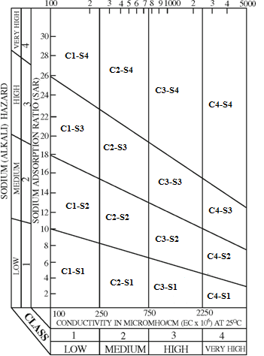

Figure (3.1): Rating of water samples in relation to salinity and sodium hazard [20].

CHAPTER FOUR
CONCLUSION AND RECOMMENDATION
4-1 Conclusion
The analysis revealed that most of the constituents in the water samples are within the prescribed limits. The US salinity diagram illustrates that water samples of New AL-Mouqdadia/1, New AL- Mouqdadia/2, Old AL-Mouqdadia/1, Old AL-Mouqdadia/2, Shakrak, Hembes, AL-Aly, Theaba, and AL-Abara fall in the class of C3-S1 indicating high salinity with low sodium water, which can be used for irrigation on almost all types of soil, with only a minimum risk of exchangeable sodium, while water samples of other stations fall in the class of C2-S1 indicating medium salinity with low sodium water, which can be suitable to salt tolerant plants with probability develop permeability problem of soil when Lime is not existing. Therefore, , we should emphasize that the some sites of water that we have analyzed in this study has a good performance for agriculture sector. And some of these water sites must not be used for irrigation purposes, because they have a negative impact in the soil as a result of causing salinity and infiltration problems and it requires the control of soil salinity at the field level.
4-2 Recommendation
1- An ongoing irrigation water quality monitoring program should be established in order to document changes over time.
2- Regardless of the approach used, a systems approach is recommended
that considers technical, environmental, and economic aspects at the
farm level and at the regional level.

REFERNCES

[1] Stephen A. N., (2012)," Earth & Environmental Sciences 1110
Physical Geology", Tulane University, USA.
[2] EENS 1110 ,"Groundwater " [online] ,[Accessed: 25 March 2012]. </http://www.tulane.edu/~sanelson/geol111/groundwater.htm/>.
[3] The Ground water foundation ," groundwater" [online], [Accessed: 1 April 2012]. </ http://www.groundwater.org/kc/whatis.html/>.
[4] Siebert , B. , Burke, L. , Frenken , J., Hoogeveen, G., and Portmann, E. , (2010), "Groundwater use for irrigation – a global inventory", Goethe University Frankfurt, Germany
[5] Stephen, A., ranking America, ( 2010), "The U.S. ranks 3rd in groundwater withdrawal",[online] </http://rankingamerica.wordpress.com/2010/10/>.
[6] wikipedia," Water quality",[online], [Accessed: 3 Feb 2012], </http://en.wikipedia.org/wiki/Water_quality/> .
[7] Bauder W., Bauder T., and Thomas F. ,(2011), "Assessing the Suitability of Water (Quality) forIrrigation - Salinity and Sodium".
[8] Lenntech, "Salinity Hazard", [online], [Accessed: 3 Feb 2012], </http://www.lenntech.com/applications/irrigation/salinity/salinity-hazard-irrigation.htm/>
[9] Ayers, R.S. and Westcot , D.W., (1985), “Water Quality for Agriculture,”Irrigation and Drainage Paper No. 29, FAO,Rome.
[10] Gordon, J., and Hailin, Z., "Classification of Irrigation Water Quality", OSU, Division of Agricultural Sciences and Natural Resources, Oklahoma State university, http:/www.osuextra.com.
[11] Khodapanah, L., Sulaiman, W.N.A. and Khodapanah, N., (2009), "Groundwater Quality Assessment for Different Purposes in Eshtehard District, Tehran, Iran", European Journal of Scientific Research, ISSN 1450-216X Vol.36, No.4, pp 543-553.
[12] Nishanthiny, S.C., Thushyanthy, M., Barathithasan, T. and Saravanan, S.,( 2010), "Irrigation Water Quality Based on Hydro Chemical Analysis, Jaffna, Sri Lanka", American-Eurasian J. Agric. & Environ. Sci., Vol7, No.1, pp100-102.
[13] "Measurement of hydrogen ion concentration", [online], [Accessed: 10Feb2012]. </http://www.rrcap.unep.org/male/manual/national/.pdf/>.
[14] Rachel, P.,(April 2010), "Effects of water quality on soil, plants and irrigation equipment", Primary Industries and fisheries.
[15] Søren P., and Lauritz S., (1968), "PH scale", [online], </http://www.jergym.hiedu.cz/~canovm/objevite/objev2/sorea.htm/> [Accessed: 15 Feb 2012].
[16] Christains, N.E., (June 1999), "Why Inject Acid into Irrigation Water", Golf Course Management, Iowa State University.
[17] ] Haritash, A. K., Kaushik, C.P. and kaushik, A., (2008), " Suitability assessment of groundwater for drinking,irrigation and industrial use in some North Indian villages", Environ Monit Assess, 145: pp 397–406.
[18] Bower, C. A. and Maasland, M. “Sodium Hazards of Punjab Groundwater,” West Pakistan Engineering Congress Proceeding, Vol. 50, 1963, pp. 49-61.
[19] Alobaidy, Ab.H. M. J.,Al-Sameraiy, M. A., Abass, J. K., Athmar, Ab. M.,( 2010)" Evaluation of Treated Municipal WastewaterQuality for Irrigation", Journal of Environmental Protection, 1, pp 216-225 .
[20] Richards, L. A. (1954),"Diagnosis and improvement of saline and alkali soils U.S. Salinity laboratory staff", USDA Handbook pp 60-160.
[21] Al-Shammiri, M., Al-Saffar, A., Bohamad, S. and Ahmed, M.,(2005), "Waste Water Quality and Reuse in Irrigation in Kuwait Using Microfiltration Technology in Treatment", Desalination, 185, pp213-225.
[22] Szabolcs, I. and Darab, C. “The Influence of Irrigation Water of High Sodium Carbonate Content of Soils,” Proceedings of 8th International Congress of ISSS, Vol. 2, 1964, pp. 803-812.
[23] Kacmaz, H. and Nakoman, M. E., (2010), "Evaluation of Shallow Groundwater Quality for Irrigation Purposes in the Koprubasi Uranium Area (Manisa, Turkey)", Scientific Research Project Division of Dokuz Eylul University, Turkey.
[24] Pescod, M. B. “Wastewater Treatment and Use in Agriculture,” FAO Irrigation and Drainage Paper No. 47, FAO, Rome, 1985.
[25] Khalil, A. A., and Arther, V. (2010) ," Irrigation Water Quality Guidelines", Reclaimed Water Project, Jordan Valley Authority and German Technical Cooperation.
[26] Bauder, T.A., Waskom, R.M, Sutherland, . P.L. and Davis, J.G., (2011), " Irrigation Water Quality Criteria", Revised 5/11, No.506.
[27] Jain, P. K. and Chaurasia, L. P. (1998),"Irrigation suitability of surface and sub-surface water in upper Urmil river basin, District-Chhatarpur Central India", Journal of India Water Resources Society, 18 (4), No.3, pp 57-62.
[28] Isaac, R. K., Khura, T. K. , Wurmbrand, J. R , (2009) " Surface and subsurface water quality appraisal for irrigation", Environ Monit Assess 159: pp 465–473.
[29] Anwar, G. J., (2001), "Chemical evaluation of treated sewage effluents in Karak Province and its suitability for irrigation purposes", Pakistan Journal of Biological Sciences, Vol.4, No.11, pp1400-1402.
[30] Naseem, S., Hamza, S. and Bashir, E., (2010), "Groundwater Geochemistry of Winder Agricultural Farms, Balochistan, Pakistan and Assessment for Irrigation Water Quality", European water, Vol. 31, pp21-32.
[31] Fipps, G. “Irrigation Water Quality Standards and Salinity Management,” The Texas A & M University System, 1998. http://www.extension.org/mediawiki/files/1/1e/Salinity
document.pdf

