Ministry of Higher Education
And Scientific Research
University of Diyala
College of Engineering
Civil Engineering Department

EFFECT OF BRACING TYPE IN MULTI-STORY STEEL BUILDING
A Project Submitted to the College of Engineering for the Fulfillment of the Requirements of the Degree of BSC of Science in Civil Engineering
Researched by
NOOR SABAH OMAR
NOOR MAHMMOD LATEF
Supervisor
DR. ALI L. ABAS
&
JINAN L. ABAS

2011 - ھ1432

بسم الله الرحمن الرحيم

﴿قل لو كان البحر مدادا لكلمات ربي لنفذ البحر قبل ان تنفذ كلمات ربي ولو جئنا بمثله مدادا﴾

صدق الله العظيم
سورة الكهف (109)

الاهداء
إلى معلمنا الاول...الى الاسوة الحسنة...إلى من تشتاق لرؤيته العيون وتهيم به الارواح...الى الرحمة المهداة...إلى صاحب الرسالة المحمدية...........اليك ياشفيعنا يارسول الله….
الى من اعطاني بدون مقابل واحبني بلا حدود...ودلني على الطريق وسلمني مفتاح النجاح.....
الى من افخر انه ابي...
الى من اسال الله ان يديمه ويحفظه ويرعاه ليبقى لنا السند والملجا وشاطئ الامان ...الى من ارجو رضاه على الدوام....
الى ابي الحبيب
الى من سكبت دموعها أياما وليالي لترى البسمة مرسومة على وجوهنا ...الى من نذرت حياتها لنا فنسيت بذلك نفسها ....
إلى من أتلمس خطواتي برضاها...إلى نور عيني وضياء حياتي....
إلى أمي الحبيبية
إلى من شاركوني الحلوة والمرة..... إلى من أجد الراحة والحب معهم....
إلى منت أدعو الله أن يحفظهم من كل سوء وان يجعل الأيام المقبلة تحمل لهم كل ما هو جميل ومفرح....
إلى إخوتي الأعزاء
إلى من سعدت بصحبتهم ونسيت برفقتهم طول المشوار وعناء الدراسة ......
إلى من عشت معهم أجمل الذكريات.......
إلى كل من أراد لي الخير والنجاح....
إلى كل من عرفت وأحببت
إلى زملائي

Table of content

1.Chapter one

……………………………………..1 1.1 Introduction
1.2 The Structural Scheme …………………………...2
3......................... ...…………………… . 1.2.1 Columns
3 .. ……………………………………. 1.2.2 Beams
1.2.3 Floor Structures………………………………….3

2.Chapter Two
…………………………………………4 .1.Bracing2
……………………4 Steel Building Bracing Type2.2
.Chapter Three3
3.1 Type of Loading
………………………………………………………10 3.1.1Dead loads
10 ……. .... …………………………………….. 3.1.2 Live loads
………………………………10 3.1.3The lateral loads
11 ……………………………………… 3.2.4 The wind load
11 . ……. ……. ………………. 3.1.5Calculated Wind Force

4. Chapter Four
14 ……. …….. ………………… 4.1 Application
42 ……... … ……………….. 4.2 Conclusion
43 …... ……………………….. 4.3 References

Chapter one
1-1 introduction
A multi-storey building must resist the combined effects of horizontal and vertical loads; it is composed of foundations, frameworks and floor slabs.
The framework comprises columns and beams together with horizontal and vertical bracings, which stabilize the building by resisting horizontal actions (wind and seismic loads).
Floor slabs are supported by beams so that their vertical loads are transmitted to the columns. They are made of reinforced concrete or composite slabs using profiled steel sheets. Columns are commonly made of HE or hollow hot-rolled steel sections. The use of hollow sections filled with concrete can improve their fire resistance. Beams are commonly made of IPE profiles. Nevertheless, the use of welded built-up sections can offer more rational solutions in some cases.
In braced frames, vertical bracings are formed by diagonal members within the steel frame. These bracings may be of different form (cross-braced X shaped; V or inverted V shaped; symmetrical or unsymmetrical portal). Alternatives to steel bracings are the reinforced concrete shear walls or cores.

1-2 THE STRUCTURAL SCHEME
A multi-storey building includes the following structural components .
a. foundations
b. framework
c. floor structures.
Foundations are made of reinforced concrete. The type of foundation is selected according to the features of the ground and the ground conditions.
The framework is the steel skeleton which provides the load-bearing resistance of the structure and supports the secondary elements such as the floor slab and cladding.
All external loads, both vertical and horizontal, are transmitted to the foundations by means of the steel framework. It is mainly composed of vertical elements (columns) and horizontal elements (beams), which may be connected together in different ways. According to the degree of restraint at the beam-to-column connections, the framework can be considered as 'rigid', 'semi-rigid' or 'pin-ended'. For the pin-ended case, the framework must incorporate bracing elements which are located in the rectangular panels bounded by columns and beams.
The floor slabs are required to resist the vertical loads directly acting on them and to transmit these loads to the supporting floor beams. They also transfer the horizontal loads to the points on the framework where the bracing members are located.

1-2-1 COLUMNS
Columns are the structural components which transmit all vertical loads from the floors to the foundations. The means of transmission of vertical load is related to the particular structural system used for the framework .
The location of columns in plan is governed by the structural lay-out. The most common grid arrangements are square, rectangular, or occasionally triangular, according to the choice of the global structural system. The spacing of columns depends upon the load-bearing resistance of the beams and floor structures.

1-2-2 BEAMS
Beams support the floor elements and transmit their vertical loads to the columns.
In a typical rectangular building frame the beams comprise the horizontal members which span between adjacent columns; secondary beams may also be used to transmit the floor loading to the main (or primary) beams.

1-2-3 FLOOR STRUCTURES
Floor are required to resist vertical loads directly acting on them. They usually consist of slabs which are supported by the secondary steel beams. The spacing of supporting beams must be compatible with the resistance of the floor slabs. Floor slabs may be made from pre-cast concrete, in-situ concrete or composite slabs using steel decking.

Chapter 2

2.1 BRACING
Bracing systems are used to resist horizontal forces (wind load, seismic action) and to transmit them to the foundations.
When a horizontal load F (Figure1 a) is concentrated at any point of the facade of the building, it is transmitted to two adjacent floors by means of the cladding elements (Figure 1):
Steel Building Bracing Types 2.2
Flange Bracing - Steel buildings use bracing to counteract forces such as torsion, compression, shear, and lift. Flange bracing, made up of structural angles connected between the rafters and purloins, is standard on all steel buildings. This bracing prevents the rafters from moving under a load.
Diaphragm Bracing - Diaphragm bracing, created by the wall and roof paneling, acts like a skin or "diaphragm" stretching over the building and
Pulling it together.
X-Bracing - Steel buildings that need to accommodate higher loads frequently use x-bracing. With x-bracing, steel rods or cables are used to tightly connect various parts of the frame. This helps a steel building to be more rigid and able to withstand higher wind and snow loads.
Weak Axis Bending - Steel buildings that require heavy loads on the columns typically use weak axis bending in order to increase the size of the base plates. These larger base plates help prevent the columns from moving under heavy stress.
Wind Column - If weak axis bending is not enough to secure the columns, wind columns may be used. A wind column is an additional vertical member used to help further secure the columns.
Portal Frames - In extreme circumstances, a steel building may require a portal frame. A portal frame is a sub-frame consisting of two portal columns and a portal rafter placed between the two adjacent main-frame columns in a bay. A portal frame can be costly and are usually only used if
(Figure 1 b) absolutely necessary.

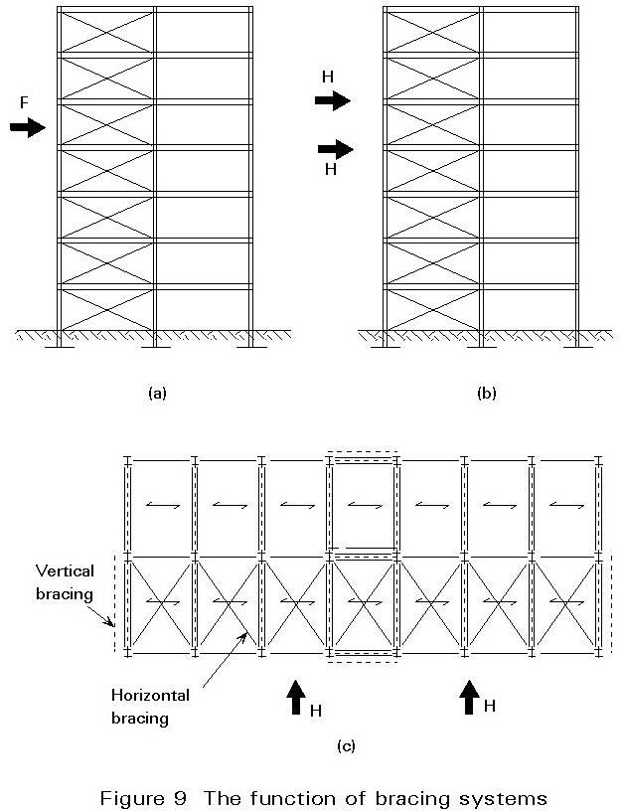
Figure (1) The function of bracing systems

The effects of loads H acting in the floor slab are distributed to the vertical supporting elements which are located in strategic positions of the structural layout by means of an appropriate horizontal resisting element in the floor.
The vertical supporting elements are called vertical bracings; the horizontal resisting element is the horizontal bracing which is located at each floor.
Where horizontal bracings are necessary, they are in the form of diagonal members in the plan of each floor, as shown in Figure 1c).
If steel decking is used, the diagonal bracing can be replaced by diaphragm action of the steel sheeting if it is fixed adequately.
Both horizontal and vertical bracings represent together the global bracing system, which provides the transfer of all horizontal forces to the foundations.
Vertical bracings are characterized by different arrangements of the diagonal members in the steel frame. They are (Figure 2):
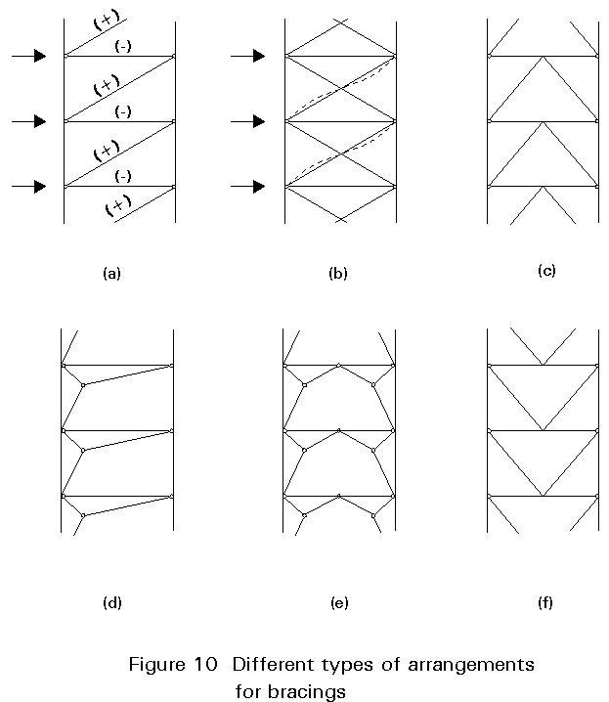
Figure (2) Different types of arrangements for bracings

a. Single diagonal
b. Cross-braced (X-shaped bracing)
c. Inverted V-shaped bracing
d. Unsymmetrical portal
e. Symmetrical portal
f. V-shaped bracing.
An alternative to steel bracings is provided by reinforced concrete walls or cores which are designed to resist the horizontal forces (Figure 3). In these systems, so-called dual systems, the steel skeleton is subjected to vertical forces only. Reinforced concrete cores are usually located around the stairway and elevator zones.
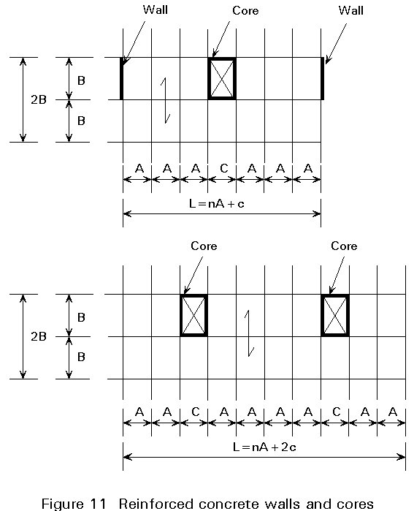
figure (3) reinforced concrete walls and cores
Normally, the floor slab can be designed to resist in-plane forces to avoid the use of horizontal diagonals. This is the case for in-situ reinforced concrete slabs, or composite slabs with appropriate shear connectors.

Chapter Three

Type of loading3.1

DEAD LOADS3.1.1

Dead load consist of the weight of the material of which the building is con-structed such as walls partition, columns, forming floors, roofs and ceilings. The dead load are due to gravity and they result in down word
vertical forces .

LIVE LOADS3.1.2

Live load technically include all the nonpermanent loading that can occurred ,besides dead loads; However the term usually refers only to the vertical gravity loading on a roof and floor surface. Thes loads occure in combination with the dead loads but are generally random in character and must be dealt with as potential contributors to various loading combination.

3.1.3 The lateral load

As used in building design ,the term lateral load is usually applied to the effects of wind and earth quakes as they indues horizontal forces on stationary structure from experience and research design criteria and method in this area are continuously refined, with recommended practices being presented through the various model building codes such as the UBC

THE LATERAL Load applied to effects of:-
- Wind load
- Earth quakes

3.1.4The wind load

Where wind is a major local problem local codes are usually more extensive with regard to design requirement for wind . how ever many codes till contain relatively simple criteria for wind design one to the most up to date and complex standards for wind design is contained in the minimum design loads for building and other structure .
Published by American society of civil engineers (ASCE)
Complete Design of wind effects on buildings includes a large number of
both architectural and structural concerns

Calculate Wind forces3.1.5

For tall buildings the following approximate formula is recommended for the wind pressure

The live load and dead load applied on this building as a plat load in Staad Pro. The approximated formula 1 is recommended for the pressure .
P=0.061V² ……(1)
Where the wind pressure in new tans per square meter on exposed vertical surfaces normal to the wind.
V=the wind velocity in km/hr it depends on geographical location , degree of exposure and height of the stretcher concerted in B.S unit (p=0.003v²)in psf and v in (mile/hr)
Numerical values of table (4-2) are to be accepted for height up to (10)m over the earth surface .
Table (4-2) Linear interpolation can be used
Height over the surface | ≤10 | 20 | 40 | 100 | ≥350
Correction coefficients | 1.0 | 1.162 | 1.342 | 1.483 | 1.732

The velocity in wind forces chosen according to the zone (C) as shown in table (4-2) and we put it in Eq. (1).
Using three equation for the load combination are :
U₁=1.2D + 1.6L +1.6W…….(2)
U₂=1.2D + 1L + 1.6W …….(3)
U₃=0.9D +1.6 W…….(4)

Such as :
U₁ , U₂ , U₃ = load combination 1 , load combination 2,load combination3
D=Dead load .
L=Live load .
W=Wind load .
REF. Building Code Requirements For Structural concrete (ACI 318 – 2008) & Commentary- ACI318 RM-2008 American concrete institute

Chapter Four
4.1 Application
We have designed two multi-Story steel building with different type of bracing .one of them have (6) story and its height (21.5)m ,The height of its first (4.5)m the other five story (3.4)m ,And other have (10) story and its height (35.1)m ,The height of its first (4.5)m and other nine story (3.4)m
Supporting used in Staad Pro. Is fixed .since the base of such building is
design or systematized.
The section of these element shown in the table below.
Table (4-1) Section of buildings element
No. of element | Member | Type of section
1 | BEAM | IPE200
2 | COLUMN | HEA 220
3 | BRACING | L65*65*5

The thickness of the slab is (0.2)m . The loads applied on these buildings are live load =3.5kN/m² and dead load=2.6 k N/m²
- Fire protection&Water proofing =0.025$×$15=0.375 KN/m²
- Tiles & mortar =0.05$×23$=1.15 KN/m²
- F.C &Ducts =0.5 KN/m²
- Juss plasters =0.03$×$20=0.6 KN/m²

6-story V-bracing
Displacement(mm) | height(m)
0 | 0
26.524 | 4.5
43.769 | 7.9
59.758 | 11.3
73.477 | 14.7
84.53 | 18.1
92.354 | 21.5

Displacement(mm) | height(m)
0 | 0
77.477 | 4.5
124.136 | 7.9
161.533 | 11.3
189.138 | 14.7
206.664 | 18.1
214.66 | 21.5
6-story no bracing

6-story X-bracing

Displacement(mm) | height(m)
0 | 0
26.525 | 4.5
43.788 | 7.9
59.817 | 11.3
73.593 | 14.7
84.718 | 18.1
92.615 | 21.5

6-story k-bracing

Displacement(mm) | height(m)
0 | 0
26.543 | 4.5
43.885 | 7.9
60.01 | 11.3
73.922 | 14.7
85.219 | 18.1
93.335 | 21.5

Displacement(mm) | height(m)
0 | 0
53.772 | 4.5
91.493 | 7.9
129.275 | 11.3
166.028 | 14.7
201.064 | 18.1
233.814 | 21.5
262.9 | 24.9
287.951 | 28.3
308.804 | 31.7
324.782 | 35.1
10-story V-bracing

10-story X-bracing

Displacement(mm) | height(m)
0 | 0
53.888 | 4.5
89.162 | 7.9
123.87 | 11.3
156.977 | 14.7
187.969 | 18.1
216.423 | 21.5
241.072 | 24.9
261.651 | 28.3
278.039 | 31.7
289.941 | 35.1

10-story no bracing

Displacement(mm) | height(m)
0 | 0
157.746 | 4.5
260.996 | 7.9
353.913 | 11.3
437.306 | 14.7
510.812 | 18.1
573.913 | 21.5
624.06 | 24.9
660.773 | 28.3
684.053 | 31.7
694.854 | 35.1

10-story K-bracing

Displacement(mm) | height(m)
0 | 0
60.173 | 4.5
99.677 | 7.9
139.191 | 11.3
177.248 | 14.7
213.196 | 18.1
246.507 | 21.5
275.69 | 24.9
300.416 | 28.3
320.623 | 31.7
335.864 | 35.1

Conclusion

Bracing system are used to resist horizontal forces(wind load and earthquake load) and to transmit them to foundations .
In this project take many type of bracing with two height of building (6-story and 10-story) .
After analysis and design the two building with different type of bracing one can see :-
.The X bracing is the best type for resist high lateral load. 1
2.The building without bracing give maximum story drift and the building may be collapse due to unstability because the lateral load (wind load).
3.When use V-bracing give a little different from X-bracing wind low cost and easy for construction from X-bracing.
4.The ratio for maximum displacement in building between no-bracing and X- bracing building equal to 2.317
5.When the building is highest the X-bracing is the beast type for bracing.

References

-Building Code Requirements For Structural concrete (ACI 318 – 2008) & Commentary- ACI318 RM-2008 American concrete institute

Staad pro. 2004-
Copyright 1997-2003 Research engineers . Intl

-Steel construction (introduction to the design of muilti-Story buildings (Lectures from internet)

Manual of Steel-Construction (load and resistance factors design)-

