**List of contents**

**Chapter one**

**Introduction**

1.1 introduction………………………………………….....5

1.2 design basis……………………………………………...6

1.3 design code and specifications………………………….7

1.4 safety provisions of the ACI-Code……………………..8

1.5 reinforced concrete beam behavior……………………10

**Chapter Two**

**Design and analytical theories**

2.1 introductions…………………………………………....14

2.2 design and analytical theories according to ACI-Code..14

2.2.1 Singly reinforced rectangular beams……………..…..14

2.2.2 Doubly reinforced rectangular beams……………..….15

2.2.3 Rectangular beam with tension and compression reinforcement

22.4 shear and diagonal tension in beam……………………21

2.2.5 Shear analysis design of reinforced concrete beam .....22

2.3 design and analytic theories according to B.S………….24

2.3.1 Design beam flexural reinforcement……………..……25

2.3.2 Determine factored moment………..………………….25

2.3.3 Determine required flexural reinforcement……………25

2.3.4 Design of rectangular beam……………………………26

2.3.5 Design beam shear reinforcement……………………..27

**Chapter Three**

Reinforced concrete beam design-numerical examples…………30

**Chapter Four**

Program review and applications

**Chapter Five**

**Comparison**

**Index**

**References**

**LIST OF TABLE**

Table (1.1) Factored load combination for determining required strength U in the ACI_Code

Table (1.2) Strength reduction factor in the ACI-CODE

Table (2.1) minimum beam depth for compression reinforcement to yield

Table (2.2) Values of vc design concrete of shear stress

Table (3.1) Nominal cover (mm) to all reinforcement including links to meet durability requirement

Table (3.2) Nominal cover (mm) to all reinforcement including links to meet specified periods of fire resistance

**LIST OF FIGURES**

Figure (1.1)Behavior of reinforced concrete beam under increasing load

Figure (1.2) Stress distribution at ultimate load

Figure (2.1) doubly reinforced concrete beam

Figure (2.3) Design of a Rectangular Beam Section

**Sympols**

**In ACI-CODE**

a depth equivelant rectangular stress block

As area of tension reinforcement

A's area of compression reinforcement

Asmax maximum amount of flexural reinforcement

Asmin minimum amount of flexural reinforcement

Av area of shear reinforcement

B width of compression face of member

bw web width in mm

c distance from extreme compression fiber to neutral axis

d diameter of bars

d ' distance from extreme compression fiber to centroid of compression reinforcement

d distance from extreme compression fiber to centroid of tension reinforcement

Es modulus of elasticity of reinforcement, Mpa

f'c specific compressive strength of concrete,Mpa

f's stress in compression reinforcemen

fy specific yield strength of reinforcement

min minimum ratio of reinforcementρ

Mn nominal moment strength at section

Mu factored moment at section

Ratio of nonprestressed tension reinforcement ρ

S spacing between bars

Vc nominal shear strength provided by concrete

Vn nominal shear strength

Vs nominal shear strength provided by shear reinforcement

Vu ultimate shear strength

α angle between inclined stirrups and longitudinal axis of member

ρ' ratio of nonprestressed compression reinforcement

ρ max max ratio of tension reinforcement

Єs the strain in the longitudinal reinforcement in acompression zone

Єt net tensile strain in extreme tension steel at nominal strength

Єy yield strain

**Symbols In B.S**

A's area of compression reinforcement

As area of tension reinforcement

Asv total cross section of links at the neutral axis ,at asection

bc is the breadth of the compression face of the beam

bw average web width of aflanged beam

d effective depth of the tension reinforcement

d' depth of the compression reinforcement

d is the effective depth

d' distance from extreme compression fiber to the centroid of compression reinforcement

Fcu cube strength of concrete at 28 days

Fs estimated design service stress in the tension reinforcement

Fyv characteristics strength of links (not to be taken as more than 460mpa)

L the clear span

L0  the distance between supports from center to center

Le the effective span

M design ultimate moment

Md design bending moment modified to account for axial load

Sb spacing of bent-up bars

Sv spacing of links along the member

Vc design concrete shear stress

Vnom shear force capacity of concrete section with minimum vertical length

x depth of the neutral axis

z depth of lever arm

Βb the ratio moment at the section after redistribution /moment at the section before redistribution

ρ' the compression reinforcement

ρ the tension reinforcement

Єh  strain in concrete at depth h

Єmh  strain at depth h correcting for stiffening effect

Єs strain at center of steel reinforcement

**Chapter One**

* 1. **Introduction**

Concrete is a stone like material obtained by permitting a carefully proportioned mixture of cement, sand and gravel or other aggregate, and water to harden in forms of the shape and dimensions of the desired structure. The bulk of the material consists of fine and coarse aggregate. Cement and water interact chemically to bind the aggregate particles into a solid mass. Additional water, over and above that needed for this chemical reaction, is necessary to give the mixture the workability that enables it to full the forms and surround the embedded reinforcing steel prior to hardening. Concretes with a wide range of properties can be obtained by appropriate adjustment of the proportions of the constituent materials.

A special way has been found, however, to use steels and concretes of very high strength in combination. This type of construction is known as prestressed concrete. The steel, in the form of wires, strand, or bars, is embedded in the concrete under high tension that is held in equilibrium by compressive stresses in the concrete after hardening. Because of this precompression, the concrete in a flexural member will crack on the tension side at a much larger load than when not so precompressed. Prestressing greatly reduces both the deflections and the tensile cracks at ordinary loads in such structures, and thereby enables these high-strength materials to be used effectively. prestressed concrete has extended, to a very significant extent, the range of spans of structural concrete and the types of structures for which it is suited.

Advantages of concrete can be summarized as follows:

1. It has a relatively high compressive strength.

2. It has better resistance to fire than steel or wood.

3. It has a long service life with low maintenance cost.

4. In some types of structures, such as dams, piers, and footing, it is the most economical design.

The analysis and design of reinforced concrete structures is based on the concepts of providing sufficient strength to resist hypotheoritical overloads.

The analysis and design of reinforced concrete structural members can be done of the ultimate strength method (USD). This method will predict with satisfactory accuracy the maximum load that the structural member under consideration will carry. The nominal strength of a proposed member calculated, based on the best current knowledge of member and materials behavior. That nominal strength is modified by a strength reduction factor θ less than unity, to obtain the design strength. The required strength, should the hypothetical overload stage actually be realized, is found by applying load factors greater than unity, to the load actually expected, So Strength required to carry factor load ≤ strength provide .

And we can summarize the scope from this project by the following

1-Deal with the theory of analysis and design of rectangular reinforce concrete beams under uniformly distributed load

2-Making acomparesion between the results that obtained from ACI Code (318-02) and the results that obtained from B.S (8110-97)

**1.2 Design basis**

The single most important characteristic of any structural member is its actual strength, which must be large enough to resist, with some margin to spare, all foreseeable loads that may act on it during the life of the structure, without failure or other distress. For reinforced concrete structures at loads close to and at failure, one or both of the materials, concrete and steel, are invariably in their nonlinear inelastic range. That is, concrete in a structural member reaches its maximum strength and subsequent fracture at stresses and strains far beyond the initial elastic range in which stresses and strains are fairly proportional. A member designed by the strength method must also perform in a satisfactory way under normal service loading. For example, beam deflections must be limited to acceptable values, and the number and width of flexural cracks at service loads must be controlled. Serviceability limit conditions are an important part of the total design, although attention is focused initially on strength.

For members proportioned on such a service load basis, the margin of safety was provided by stipulating allowable stresses under service loads that were appropriately small fractions of the compressive concrete strength and the steel yield stress. We now refer to this basis for design as service load design. Allowable stresses, in practice, were set at about one half the concrete compressive strength and one-half the yield stress of the steel.

**1.3 Design code and specifications**

The design of concrete structures is generally done within the framework of codes given specific requirements of materials, structural analysis, member proportion, etc. the international building code is an examples of consensus code governing structural design and is often adopted by local municipalities. The responsibility of preparing material-specific portions of the codes rests with various professional groups, trade associations, and technical institutes. In contrast with many other industrialized nations, the United States does not have an official, government-sanctioned, national code. The American concrete institute (ACI) has long been a leader in such efforts. As one part of its activity, the American concrete institute has published the widely recognized building code requirements for structural concrete which serves as a guide in the design and construction of reinforced concrete buildings. The ACI Code has no official status in itself. However, it is generally regarded as an authoritative statement of current good practice in the field of reinforced concrete. As a result, it has been incorporated into the international building code and similar codes, which in turn are adopted by law into municipal and regional building codes that do have legal status. Its provisions thereby attain, in effect legal standing. Most reinforced concrete buildings and related construction in the United States are designed in accordance with the current ACI Code. The ACI also publishes important journals and standards as well as recommendations for the analysis and design of special types of concrete structures such as tanks.

**1.4 Safety Provisions of the ACI CODE**

The safety provisions of the ACI CODE are given in the form ØSn≥үdD+үLL (1.1a)

ØSn≥ α(үdD+үLL+үWW+………..) (1.1b) in which

Үd is a load factor somewhat greater than one applied to the calculated dead load D

ҮL is a larger load factor applied to the load or code specified live load L

W wind load (additional loads)

In words, the design strength ØSn of a structure or member must be at least equal to the required strength U calculated from the factored load

Design strength ≥ required strength

ØSn ≥U

The nominal strength Sn is computed by accepted methods. The required strength U is calculated by applying appropriate load factors to the respective service loads: dead load D, live load L, wind load w, earthquake E, earth pressure H, fluid pressure F, impact allowance I, and environment effects T that may include settlement, creep, shrinkage, and temperature change.

Loads are defiened in a general sense, to include either loads or the related internal effects such as moment, shears and thrusts. Thus, in specified terms for a member subjected, say to moment, shear, and axial load ØMn≥Mu

ØVn≥Vu

ØPn≥Pu

Where n nominal strength in flexure, shear, and axial load

U factored load moment, shear, and axial load

The load factor specified in the ACI Code, to be applied to calculated dead loads and other live and environment loads specified in the appropriate codes or standards, are summarized in table (1.2)

Table (1.1)Factored load combinations for determining required strength U in the ACI Code

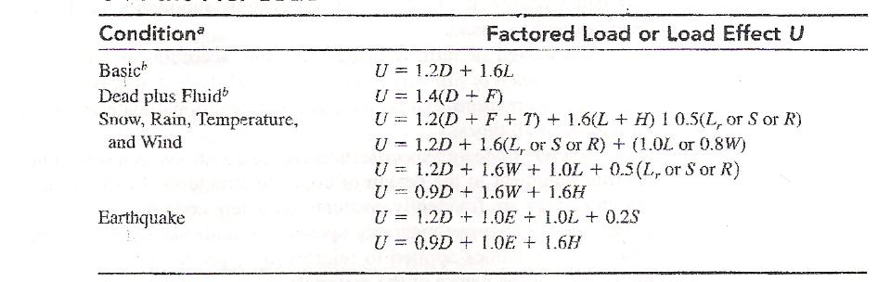

In all cases in table (1.1), the controlling equation is the one that gives the largest factored load effect U.

The strength reduction factor Ø in the ACI Code are given different value depending on the state of knowledge .Also Ø reflects the probable importance, for the survival of the structure , of the sons, alower value is used for columns than for beams . Table (1.2) gives the Ø values specified in the ACI Code

Table(1.2) Strength reduction factor in the ACI Code

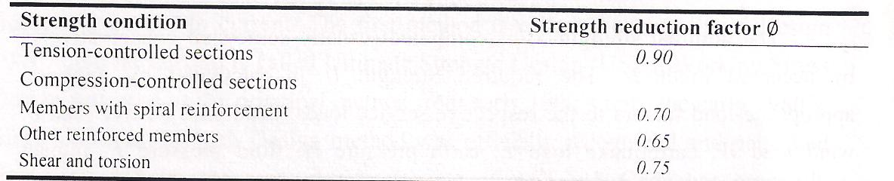

**1.5 REINFORCED CONCRETE BEAM BEHAVIOR**

Plain concrete beams are insufficient as flexural members because the tensile strength in bending is a small fraction of the compressive strength. As a consequence, such beams fail on the tension sides at low loads long before the strength of the concrete on the compression side has been fully utilized. For this reason, steel reinforcing bars are placed on the tension side as close to the extreme tension fiber as is compatible with proper fire and corrosion protection of the steel. In such a reinforced concrete beam, the tension caused by the bending moments is chiefly resisted by the steel reinforcement, while the concrete alone is usually capable of resisting the corresponding compression.

At low loads as, as long as the maximum tensile stress in the concrete is smaller than the modulus of rupture, the entire concrete is effective in resisting stress, in compression on one side and in tension in other side of the neutral axis. In addition, the reinforcement, deforming the same amount as the adjacent concrete, is also subject to tensile stresses. At this stage all stresses in the concrete are of small magnitude and are proportional to strains. The distribution of strains and stresses in concrete and steel over the depth of section is as shown in fig (1.1c).

When the load is further increased, the tensile strength of the concrete is soon reached, and at this stage tension cracks develop. The general shape and distribution of these tension cracks is shown in fig (1.1d).

On the other hand, if large amount of reinforcement or normal amounts of steel of very high strength are employed, the compressive strength of the concrete may be exhausted before the steel starts yielding. Concrete fails by crushing when strains become so large that they disrupt the integrity of the concrete. Exact criteria for this occurrence are not yet known, but it has been observed that rectangular beams fail in compression when the concrete strains reach value of about 0.003 to 0.004.

The analysis of stresses and strength in the different stages just described will be discussed in the next several sections.

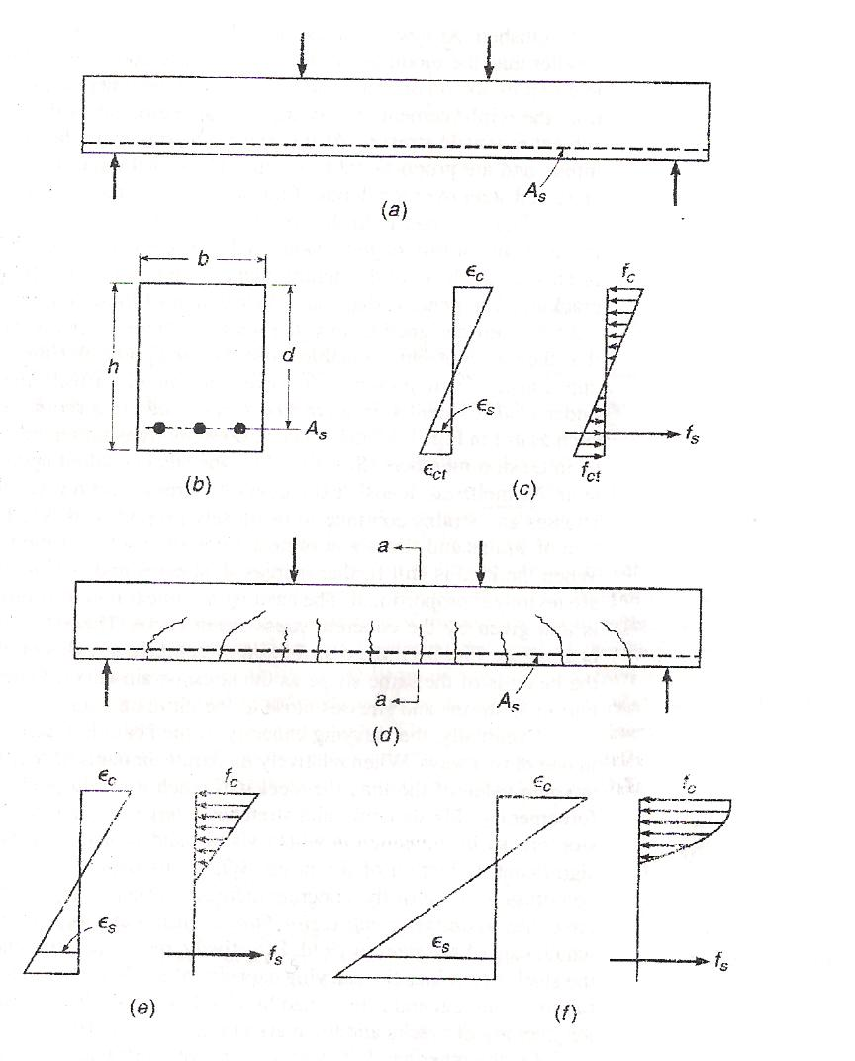

Fig. (1.1) Behavior of reinforced concrete beam under increasing load

A) Stresses elastic and section uncracked

As long as the tensile stress in the concrete is smaller than the modulus of rupture, so that no tension cracks develop, the strain and stress distribution as shown in fig (1.1c) is essentially the same as in n elastic.

b) Stresses elastic and section cracked

When the tensile stresses fct exceeds the modulus of rupture, cracks form, as shown in fig (1.1d). If the concrete compressive stress is less than approximately 0.5 f'c and the steel stress has not reached the yield point , both materials continue behave elastically, or very nearly so this situation generally occurs in structures under normal service conditions and loads, since at these loads the stresses are generally of the order of magnitude just discussed. At this stage, for simplicity and with little of any error , it is assumed that tension cracks have progressed all the way to the neutral axis and that sections plane before bending are plane in the deformed member. The situation with regard to strain and stress distribution is then that shown in fig (1.1e).

c) Flexural strength

It is of interest in structural practice to calculate those stresses and deformations that occur in structure in service under design load. For reinforced concrete beam, this can be done by the methods just presented, which assume elastic behavior of both materials. It is equally, if not more, important that the structural engineer be able to predict with satisfactory accuracy the strength of a structure or structural member. By making this strength larger by an appropriate amount than the largest loads that can be expected during the lifetime of the structure, an adequate margin of safety is assured. In regard to bending, it has been pointed out that at high loads, close to failure; the distribution of stresses and strains is that of figure (1.1f) rather than the elastic distribution of figure (1.1e ). More realistic methods of analysis, based on actual inelastic rather than assumed elastic behavior of the materials and on results of extremely extensive experimental research, have been developed to predict the member strength; they are now used almost exclusively in structural design practice.

Let figure (1.2) represent the distribution of internal stresses and strains when the beam is about to fail. One desires method to calculate that moment Mn (nominal moment) at which the beam will fail either by tension yielding of the steel or by crushing of the concrete in the outer compression fiber.

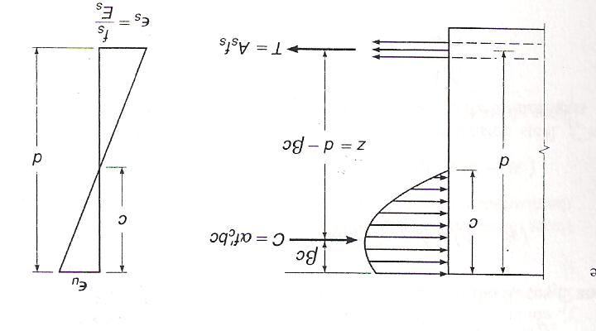

Fig. (1.2) Stress distribution at ultimate load

**Chapter Two**

**Design and Analytical Theories**

**2.1 Introductions**

The analysis and design of reinforced concrete structures is based on the concept of providing sufficient strength to resist hypothetical overloads. The analysis and design of reinforced concrete structural members can be done of the ultimate strength method (USD).this method will predict with satisfactory accuracy the maximum load that the structural member under consideration will carry. The nominal strength of a proposed member is calculated, based on the best current knowledge of member and materials behavior. That nominal strength is modified by a strength reduction factor θ, less than unity, to obtain the design strength. The required strength, should the hypothetical overload stage actually be realized, is found by applying load factors greater than unity, to the load actually expected. So

Strength required to carry factor load ≤ strength provide

**2.2 Design and analytical theories according to ACI Code**

**2.2.1 Singly Reinforced Rectangular Beams**.

As previously stated, the tensile strength of concrete is very low, being about10% of concrete compressive strength .Hence it is assumed in structural design that the tensile strength of the concrete is neglected .Therefore it is necessary to strengthen or reinforce the concrete members where they are subjected to tensile stresses. This strengthening is usually accomplished by the embedment of steel bars or rods which must then resist almost 100% of the tensile forces. The nominal strength of a member can be computed based on principles of mechanics and limits defined by the ACI Code. Using ɣ=0.85, the nominal bending strength is the moment of the internal couple of C and T

Mn=T (d - a/2) (2-1a)

Mn=As fy (d – a/2) (2-1 b)



Fig. (1.2) Stress distribution at ultimate load

The equilibrium of horizontal internal forces in the equivalent stress distribution gives.

a=As fy/0.85 f’c bd (2-2)

substituting equation ( a) in equation Mn

Mn =As fy (d – As fy/ 1.7 f'c b) (2-3)

Equation (2-3) can be written in terms of reinforcement ratio ρ by substituting equation ( T= Asfy) in equation (2-3)

Mn= ρ bd2 fy (1-0.59 ρfy/f'c) (2-4)

ρmax= 0.85 β1 f'c/fy. 0.003/(0.003+0.004) ( 2-5)

**2.2.2 Doubly Reinforced Rectangular Beams**

Doubly reinforced sections contain reinforcement both at the tension and at the compression face, usually at the support section only. They become necessary when either architectural limitations restrict the beam web depth at midspan, or the midspan section dimensions are not adequate to carry the support negative moment even when the tensile steel at the support is sufficiently increased. In such cases, about one-third to one-half of the bottom bars at midspan are extended and well anchored at the supports to act as compression reinforcement. The bar development length has to be well established and the compressive and tensile steel at the support section well tied with closed stirrups to prevent buckling of the compressive bars at the support.

**2-2-3.Rectanguler Beams with tension and compression Reinforcement**

If a beam cross section is limited because of architectural or other considerations, it may happen that the concrete cannot develop the compression force recquired to resist the given bending moment. In this case, reinforcement is added in the compression zone,resulting in a so-called doubly reinforcement beam, i.e., one with compression as well as tension reinforcement see fig (2-1). shown bellow:

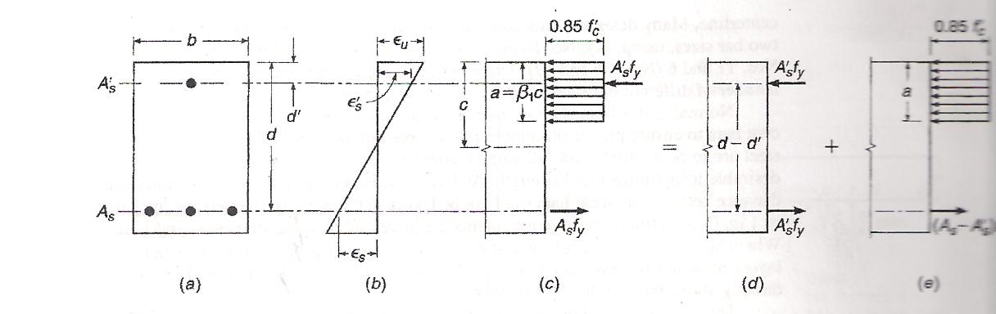

Fig (2-1): Doubly reinforced concrete beam

The use of compression reinforcement has decreased markedly with the use of strength design methods, which account for the full strength potential of the concrete on the compressive side of the neutral axes. However, there are situations in which compressive reinforcement is used for reasonsother than the strength.It has been found that the inclusion of some compression steel will reduce the long term deflections of the members.In addition, in some cases, bars will be placed in the compression zone for minimum-moment loading or as stirrup-support bars continuous throughout the beam span.It may be desirable to account for the presence of such reinforcement in flexural design, although in many cases they are neglected in flexural calculations.

**a.Tension and compression steel both at yield stress**

If, in a doubly reinforced beam, the tensile reinforcement ratio ρ is less than or equal to ρb ,the strength of the beam may be approximated within acceptable limits by disregarding the compression bars. The strength of such a beam will be controlled by tensile yielding, and the lever arm of the resisting moment will ordinarily be but little affected by the presence of the compression bars.

If the tensile reinforcement ratio is larger than ρb, a somewhat more elaborate analysis is required. In Fig. 2.1a, a rectanguler beam cross section is shown with compression steel A's placed a distance d' from the compression face and with tensile steel As at effective depth d. It is assumed initially that both A's and As are stressed to fy at failure. The total resisting moment can be thought of as the sum the compression steel A's and the force in equal area of tension steel.

Mn1=A's fy( d – d') (2-6)

As shown in figure 2.1d. The second part ,Mn2, is the contribution of the remaining tension steel As-A's acting with the compression concrete :

Mn2= (As- A's)fy(d –a/2) (2-7)

As shown in Fig.( 2-1e), where the depth of the stress block is

a= (As-A's)fy/0.85f'c b (2-8)

With the definitions ρ =As/bd and ρ' =A's / bd, this can be written

a=( ρ – ρ')fy d/0.85 f'c (2-9)

The total nominal resisting moment is then

Mn=Mn1 + Mn2 = As fy (d – d' ) + (As – A's) fy(d – a/ 2) (2-10)

In accordance with the safety provisions of the ACI Code, the net tensile strain is checked, and if Єt ≥ 0.005, this nominal capacity is reduced by the factor Ø= 0.9 to obtaine the design strength . for Єt between 0.005 and 0.004, Ø must be adjusted , as discussed earlier.

It is highly desirable, for reasons given earlier, that failure, should it occure, be precipitated by tensile yielding rather than crushing of the concrete . This can be ensured by setting an upper limit on the reinforcement ratio. By setting the tensile steel strain in fig.2.1b equal to Єy to establish the location of the neutral axis for the failure condition and then summing horizontal forces shown in fig.2.1c (still assuming the compressive steel to be at the yield stress at failure), it is easily shown that the balanced reinforcement ratio ρb҄ for a doubly reinforced beam is

ρ 'b = ρb + ρ' (2-11)

Where ρb is the balanced reinforcement ratio for the corresponding singly reinforced beam and is calculated from the equation shown bellow

ρb= 0.85 β1. f'c/fy. Єu/Єu +Єy (2-12)

The ACI Code limits the net tensile strain, not the reinforcement ratio.To provide the same margin against brittle failure as for singly reinforced beams, the maximum reinforcement ratio should be limited to

ρ 'max = ρmax + ρ' (2-13)

Because ρmax establishes the location of the nutral axis, the limitation in Eq.(2-13)

Will provide acceptable net tensile strains. A check of Єt is required to determine the strength reduction factor Ø and verify net tensile strain requirements are satisfied. Substituting ρ for Єt ≥0.005 for ρmax in eq.(2-13) will give Ø =0.9

**b. compression steel below yield stress**

The preceding equations, through which the fundamental analysis of doubly reinfoced beams is developed clearly and concisely, are valid only if the compression steel has yielded when the beam reaches its nominal capacity. In many cases, such as for wide, shallow beams, beams with more than the usual concrete cover over the compression bars, beams with high yield strength steel, or beams with relatively small amounts of tensile reinforcement, the compression bars will be below the yield stress at failure. It is necessary, therefore, to develop more generally applicable equations to account for the possibility that the compression reinforcement has not yielded when the doubly reinforced beam fails in flexure. Whether or not the compression steel with have yielded at failure can be determined as follows.Referring to fig. 2.1b, and taking as the limiting case Є's= Єy , one obtains, from geometry,

C/d' = Єu / Єu – Єy or C =( Єu / Єu – Єy ).d'

Summing forces in the horizontal direction (fig. 2.1c) gives the minimum tensile reinforcement ratio ρ'cy that will ensure yielding of the compression steel failure :

ρ 'cy = 0.85β1 f'c /fy. d'/d. (Єu/ Єu – Єy )+ ρ' (2-14)

If the tensile reinforcement ratio is less than this limiting value, the neutral axis is sufficiently high that the compression steel stress at failure is less than the yield stress. In this case, it can easily be shown on the basis of Fig. 2.1b and c that the balanced reinforcement ratio is

ρ 'b =ρ + ρ' f's/fy (2-15)

Where

f's = EsЄ's = Es {Єu – d'/d (Єu +Єy)} ≤fy (2-15a)

To determine ρmax, Єt = 0.004 is substituted for Єy in Eq. (2-15a), giving

f's = Es {Єu – d'/d (Єu + 0.004)} ≤fy (2-15b)

hence, the maximum reinforcement ratio permitted by the ACI code is

ρ 'max = ρmax + ρ' f's /fy (2-16)

Where f 's is given in Eq.( 2-15b). A simple comparison shows that Eqs. (2-15) and (2-16), with f's given by Eqs.(2-15a) and (2-15b), respectively, are the generalized forms of Eqs.(2-11) and (2-12)

It should be emphasized that Eqs. (2-15a) and (2-15b) for compression steel stress apply only for beams with exact strain values in the extreme tensile steel of Єy or Єt = 0.004.

If the tensile reinforcement ratio is less than ρ 'b, as given by Eq. (2-11)

And less than ρ'cy given by Eq. (2-14) , then the tensile steel is at the yield stress at failure but the compression steel is not, and new equations must be developed for compression steel stress and flexural strength.

The compression steel stress can be expressed in terms of the still-unknown neutral axis depth as:

f's = Єt Es.( c – d' / c) (2-17)

consideration of horizontal force equilibrium (Fig. 2.1c with compression steel stress equal to f's ) then gives

As fy = 0.85β1 f'c bc + A's Єu Es.( c – d '/ c) (2-18)

This is a quadratic equation in c, the only unknown, and is easily solved for c. The nominal flexural strength is found using the value of f's from Eq. (2-17) ,and a = β1c in the expression

Mn = 0.85 f'c ab(d – a/2) + A's f's (d – d') (2-19)

This nominal capacity is reduced by the strength reduction factor Ø to obtain the design strength.

If compression bars will not buckle outward under load, spalling off the outer concrete.ACI Code 7.11.1 imposes the requirement that such bars be anchored in the same way that compression bars in columns are anchored by lateral ties. Such ties must be used throughout the distance where the compression reinforcement is required.

For the compression steel to yield, the reinforcement ratio must lie below ρ'max and above ρ'cy, The ratio between d' and the steel centroidal depth d to allow yielding of the compression reinforcement can found by equating ρ'cy to ρ'max ( or ρ for Єt =0.005) and solving for d' /d. Futhermore, if d' is assumed to be 2.5 in., as is often the case, the minimum depth of beam necessary for the compression steel yield may be found for each grade of steel. The ratios and minimum beam depths are summarized in table 2.1. values are included for Єt = 0.004, the minimum tensile yield strain permitted for flexural members, and Єt = 0.005, the net tensile strain needed to ensure than Ø = 0.90. for beams with less than the minimum depth, the compression reinforcement cannot yield unless the tensile reinforcement exceeds ρmax. The compression reinforcement may yield in beams that exceed the minimum depth in table 2.1, depending on the relative distribution of the tensile and compressive reinforcement.

Table (2.1)

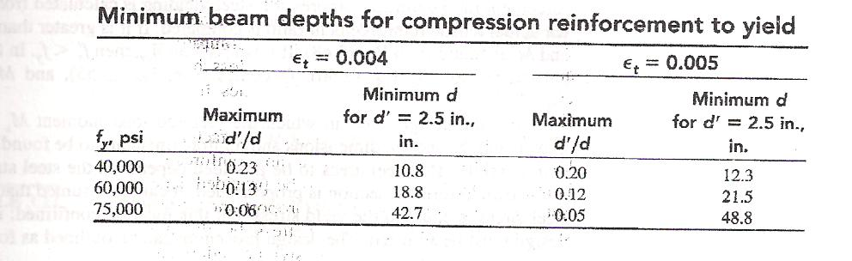

**2.2.4 Shear And Diagonal Tension In Beam**

Beams must also have an adequate safety margin against other types of failure, some of which may be more dangerous than flexural failure. This may be so the catastrophic nature of some other types of failure, should they occur.

Shear failure of reinforced concrete, more properly called diagonal tension failure, is one example. Shear failure is difficult to predict accurately.In spite of many decades of experimental reseach, and the use of highly sophisticated analytical tools.futhermore if a beam without properly designed shear reinforcement is overloaded to failure, shear collapse is likely to occure suddenly, with no advance warning of distress. This is in strong contrast with the nature of flexural failure. For typically underreinforced beams, flexural failure is initiated by gradual yielding of the tension steel, accompanied by obvious cracking of the concrete and large deflections, giving ample warning and providing the opportunity to take corrective measures.Because of these differences in behavior, reinforced concrete beams are generally provided with special shear reinforcement to ensure that flexural failure would occur before shear failure if the member should be severely overloaded.

Figure 2.2 shows a shear-critical beam tested under thirdpoint loading. With no shear reinforcement provided, the member failed immediately upon formation of the critical crack in the high-shear region near the right support.

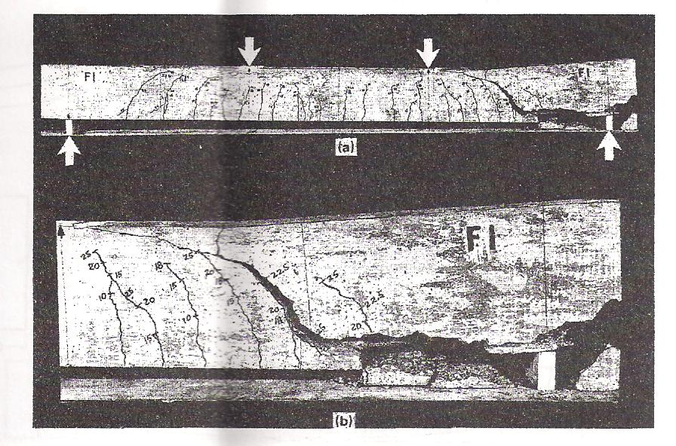

It is important to realize that shear analysis and design are not really concened with shear as such. The shear stresses in most beams are far below the direct shear strength of the concrete. The real concern is with diagonal tension stress. Most of this chapter deals with analysis and design for diagonal tension, and the provides background for understanding and using the shear provisions of 2002 ACI Code. Members without web reinforcement are studied first to establish the location and orientation of cracks and the diagonal carcking load. Methods are then developed for the design of shear reinforcement according to the ACI Code, both in ordinary beams and in special types of members, such as deep beams.

**2.2.5 Shear analysis design for reinforced concrete beam**

According to ACI Code the general equation is

Vu ≤ Ø Vn

Where

Ø: strength reduction factor,=0.75

Vn: Nominal shear strength of the section.

Vn =Vc + Vs

Vc: shear strength provided by concrete.

Vs: shear strength provided by shear reinforcement.

Shear strength provided by concrete (Vc) ….(11.3.ACI-Code)

Shear strength provided by concrete (Vc) for member subjected to shear and flexture only shall be computed by:

Vc= ($√f'c$/6 .bw.d )

Shear strength by shear reinforcement ….(11.6.5 ACI-Code)

If Vc $≥$ Ø Vc ….Ø= 0.45

Then shear reinforcement must be provided, and shear strength (Vs) shall be computed as following:

1. When shear reinforcement perpendicular to axis of member

Vs = Av. fy.d / s ≤ 2/3 $√f'c$. bw .d

Where

Av: Total cross section area of shear reinforcement .

S : spacing of shear reinforcement.

2. When shear reinforcement consist of a single bar or a single group of parallel bars all bent at same point

Vs = Av Fy. Sin≤ ¼ bw .d

3. When Shear reinforcement consist of aserries of parallel bent up bars or groups of parallel bent bars at different points or when inclined stirrups are used as a shear reiforcement.

Vs = Av.fy.d / S .( sinα + cosα) ≤ .bw . d

4. Note: When more than one type of shear reinforcement used to reinforce the same position of a member:

Vs total =

**ACI - Code Limitations**

1. Fy ≤ 420 Mpa.

2. If Vu≤1/2 ØVc.. Then there is no need to use shear reinforcement.

3. If 1/2 Ø Vc <Vu ≤Ø Vc … Then provided minimum shear reinforcement.

As min=  bw.S / 16.Fy

4. spacing limits:

**a.** When shear reinforcement perpendicular to the axis of the member the maximum spacing is the smallest of :

Smax = the smallest of ….. { 16 Av fy $√f'c$\ *.*bw , OR Av.Fy/ 0.33.bw}

And Smax = the smallest of ….. {d /2 ,600} if Vsu≤ 1/3 $√f'c$ .bw. d

Vsu = Vu – ØVc/ Ø

Or

Smax = the smallest {d/4 ,300} if Vsu > 1/3 $√f'c$ bw.d

**b.** For inclined stirrups and bent longitudinal reinforcement to maximum spacing (Smax) is the smallest of….{ 16 Av fy $\sqrt{f}c$\ .bw , OR Av.Fy/0.33.bw}

and Smax= the smallest of ….{3d/8. ( 1+cotα ) , 600} If Vsu ≤1/3 $√f'c$ bw.d

or Smax = the smallest of …..{3d/16. (1+ cotα), 300 }If Vsu > 1/3 $√f'c$ bw.d

**Notes:**

1.partical limit to minimum stirrups spacing to 100 mm

2.Av = n.Asb

Where

N: Number of legs of stirrups.

Asb: cross sectional area of the bars using as a stirrups.

**2.3 Design and analytic theories according to B.S 8110-97**

All beams are designed for major direction flexure and shear only

The beam design procedure involves the following steps:

• Design beam flexural reinforcement

• Design beam shear reinforcement

**2.3.1 Design Beam Flexural Reinforcement**

The beam top and bottom flexural steel areas are designed at a user-defined number of check stations along the beam span. The following steps are involved

In designing the flexural reinforcement for the major moment for a

Particular beam at a particular section:

• Determine the maximum factored moments

• Determine the reinforcing steel

**2.3.2 Determine Factored Moments**

In the design of flexural reinforcement of concrete frame beams, the factored moments for each load combination at a particular beam station are obtained by factoring the corresponding moments for different load cases with the corresponding load factors.

The beam section is then designed for the maximum positive and maximum negative factored moments obtained from all of the load combinations at that section.

Negative beam moments produce top steel. In such cases, the beam is always designed as a rectangular section. Positive beam moments produce bottom steel. In such cases, the beam may be designed as a rectangular section, or T-Beam effects may be included.

**2.3.3 Determine Required Flexural Reinforcement**

In the flexural reinforcement design process, the program calculates both the tension and compression reinforcement. Compression reinforcement is added when the applied design moment exceeds the maximum moment capacity of a singly reinforced section. The user has the option of avoiding the compression reinforcement by increasing the effective depth, the width, or the grade of concrete.

The design procedure is based on the simplified rectangular stress block as shown in Figure (2.3) (BS 3.4.4.1). It is assumed that moment redistribution in the member does not exceed 10% (i.e., βb ≥ 0.9) (BS 3.4.4.4). The code also places a limitation on the neutral axis depth, *x*/*d* ≤ 0.5, to safeguard against non-ductile failures (BS 3.4.4.4). In addition, the area of compression reinforcement is calculated assuming that the neutral axis depth remains at the maximum permitted value.

**2-3-4 Design of a Rectangular beam**

For rectangular beams, the moment capacity as a singly reinforced beam,Msingle, is obtained first for a section. The reinforcing steel area is determined Based on whether M is greater than, less than, or equal to Msingle. See Figure(2.3).



Figure (2.3) : Design of a Rectangular Beam Section

•Calculate the ultimate moment of resistance of the section as a singly reinforced beam.

Msingle = K'fcubd2, where (2-20)

K' = 0.156.

Fcu is the characteristics strength of concrete

d is the effective depth

b width or effective width of the section in the compression zone

• If M ≤ Msingle (k≤k'), no compression reinforcement is required. The area of tension reinforcement, As, is obtained from

As =M/ ((0.95fy) z) or As =M/((0.87fyz)) (2-21)

where

z = d {0.5+√(0.25-k\0.9) ≤0.95d,and  (2-23)

k=M/ (fcubd2)(2-24)

This is the top steel if the section is under negative moment and the bottom steel if the section is under positive moment.

• If M $>$ Msingle,(k >k')the area of compression reinforcement, A's, is given by

A's= (M-Msingle) ⁄ ((f's-0.67fcu/γc) (d-d')) (2-25)

or

A's=(k-k')fcubd2/(0.87fy(d-d')) (2-26)

Where

d'is the depth of the compression steel from the concrete compression face, and

f's=700[1-2d'/d] ≤0.95fy

This is the bottom steel if the section is under negative moment. From

Equilibrium, the area of tension reinforcement is calculated as:

As=Msingle⁄ (0.95fy) + ((M-Msingle) ⁄ (0.95fy) (d-d')), (2-27)

Or

As=(k'fcubd2/(0.87fyz))+A's (2-28)

z =d {0.5+√0.25-k'⁄0.9} =0.88d (2-29)

As is to be placed at the bottom of the beam and *A's* at the top for positive

Bending and vice versa for negative bending.

**2.3.5 Design Beam Shear Reinforcement**

The shear reinforcement is designed for each load combination in the major And minor directions of the column. The following steps are involved in designing The shear reinforcement for a particular beam for a particular load Combination resulting from shears forces in a particular direction (BS 3.4.5):

•Calculate the design shear stress and maximum allowable shear stress as

v =V⁄Acv ,

v=V/bd (2-30)

where

v $≤$ 0.8 RLW √fcu*,* (2-31)

v≤ 5N/mm2 (2-32)

vmax = min {0.8RLW √ fcu , 5.0 MPa}, (2-33)

Acv = bw d, and

RLW is a shear strength reduction factor that applies to light-weight concrete. It is equal to 1 for normal weight concrete. The factor is specified in the concrete material properties.

v is the design shear stress

V is the design shear force due to ultimate loads

If v exceeds 0.8RLW √fcu or 5 MPa, the program reports an overstress. In

that case, the concrete shear area should be increased.

**Note**

The program reports an overstress message when the shear stress exceed 0.8RLW √fcu

Or 5 MPa

•Calculate the design concrete shear stress from

vc = RLW (0.79k1k2⁄γm) (100As⁄bd) 1/3(400⁄d) 1/*4*  (2-34)

Where,

k1 is the enhancement factor for support compression,

And is conservatively taken as 1, (2-35)

k2 = (fcu/25)1⁄3≥1 (2-36)

γm is a partial safety factor for strength of material

γm = 1.25, and (BS 2.4.4.1)

As is the area of tensile steel.

However, the following limitations also apply:

0.15≤ 100As⁄bd ≤3 (BS 3.4.5.4 table 2.2)

400⁄d ≥1,

and (BS 3.4.5.4 table 2.2)

fcu ≤40 N/mm2 (for calculation purpose only). (BS 3.4.5.4 table 2.2)

• If v ≤ vc +0.4, provide minimum links defined by

Asv⁄Sv≥0.4b⁄0.95fyv where (2-37)

Asv is totalcross section of links at the neutral axis at a section,

Sv is the spacing of links along the member

Vc is the shear stress in concrete

Else if vc +0.4 < v < vmax, provide links given by

Asv⁄Sv≥ (v-vc) b⁄0.95fyv (2-38)

Else if v ≥ vmax,

A failure condition is declared. (BS 3.4.5.2, 3.4.5.12)

In shear design, fyv cannot be greater than 460 MPa (BS 3.4.5.1). If fyv is

Defined as greater than 460 MPa, the program designs shear reinforcing assuming that fyv equals 460 Mpa

Table (2.2): values of vc design concrete shear stress

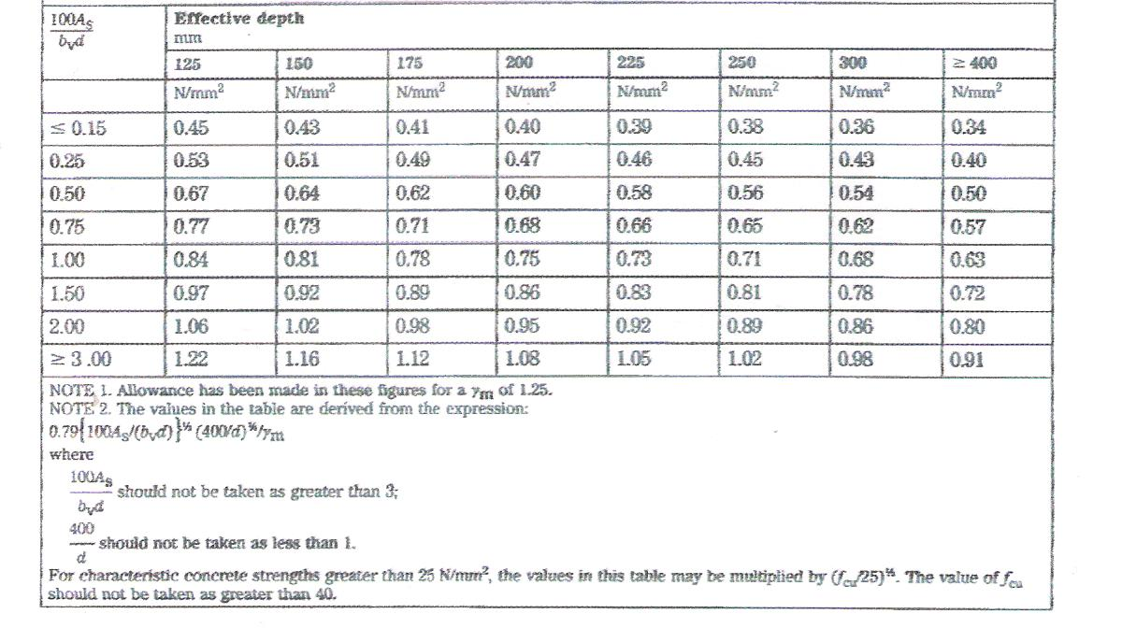

**Chapter three**

**Reinforced concrete beam**

**Numerical examples**

**Solution by ACI-Code 318-02**

**Example1:**

**Find the design strength of the beam shown in figure section if f'c=25 MPa and fy=400 MPa?**

Solution:

Check yield of reinforcement 300mm



For 3 bars 430mm

As=3×π × (12.5)2=1473 mm2

3Ǿ25

ρ=As/bd=1473/ (300×430) =0.01142

Now compare this ρ with ρmax

ρmax=0.85β1× (fc/fy) × (600/ (600+fy))

=0.85×.85× (25/400) × (600/1000)

=0.027

So

ρ<ρmax  OK

steel reinforcement yield

a=As fy/ (0.85 fc b)

=1473×400/ (0.85×25×300) =92.423mm

So nominal strength Mn=As fy(d-a/2)

Mn=1473×400×(430-(92.423/2))×10-6=226.128 kN.m

And the design strength is Mu=θMn

Mu=0.9×226.128=203.52kN.m

**Example2:**

**Calculate the area of steel required for the beam shown in figure below if f'c=25MPa, fy=400MPa, d=500mm,live load=20 kN/m, and dead load=18 kN/m (including self weight)?**

300mm

6m 570mm

Solution:

We will find the ultimate load

Wu=1.2WD+1.6WL=1.2×18+1.6×20=53.6 kN/m

Mu=WuL2/8=53.6×36/8=241.2 kN.m

Mu=θMn=θρbd2fy(1-0.59ρ(fy/fc))

241.6=0.9ρ×300×5002×400× (1-0.59ρ× (400/25))

ρ=0.0098

Now we must compare this ρ with ρmax and ρ minimum

ρmax=0.85×0.85× (25/400) × (600/(600+400))

ρmax=0.027

ρmin=1.4/fy=1.4/400=0.0035

ρ<ρmax  and ρ>ρmin O.K

AS=ρbd=0.0098×300×500=1470 mm2

By using bar diameter 22

No. of bars=1470/380=3.9

So use 4Ø22

**Example3**:

**Rectangular beams that must be carry a service live load of 35kN/m and dead load of 15kN/m (including self weight). 5.5m sample span is limited in cross section 250mm in width and 500mm total depth. If fy=400MPa , f'c=27MPa. What steel must be provided?**

250mm

500mm 5.5m

Solution:

wu=1.2d+1.6l=1.2×15+1.6×35=74kn/m

Mu=WuL2/8= (74) (5.5)2⁄8

=279.8kn.m

Let d=400mm

ρmax=0.85β(f'c⁄fy)(600⁄1400)

=0.85×0.85× (27⁄400) (600⁄1400) =0.0209

Asmax=ρmaxbd=0.0209×250×400=2090mm2

a =Asfy⁄ (0.85f'cb) = (2090×400) ⁄ (0.85×27×250) =145.7mm

Mn=Asfy (d-a⁄2) =2090×400× (400-(145.7⁄2)) ×10-6

=273.494kn.m

Mu>øMn

So it is doubly reinforced beam

Let c⁄d=0.375

C=0.325×400=130mm

Design the beam as asingle reinforced beam

a=βc=0.85×130=110.5mm

As1fy=0.85f'cab

As1=0.85×27×110.5×250⁄400=1584.98mm2

The nominal strength of asingly reinforced beam

Mn1=As1fy (d-a⁄2) =1584.98×400× (400-110.5⁄2)

=218.57kn.m

The reinforce moment Mn'=Mu/ø-Mn1

=279.8/0.9-218.57

=92.318kN.m

Check the section if the compression steel has yield

Let d'=60mm

Έs=(c-d') ×0.003/c= (130-60)×0.003/130=0.0016

Єy =fy/Es=400/200000=0.002

Єs<Єy

the steel has not yield

f's=Єs×Es=0.0016×200000=320MPa<fy

to compute the compression steel area

Mn'=A'sf's(d-d')

A's=92.318/ (320× (400-60)) =848.52mm2

The total steel tension area

As=As1+A's (f's/fy) =1584.98+848.52(320/400)

=2263.79mm2

We will use 2Ǿ25 as compression reinforcement

And 5Ǿ25 as a tension reinforcement

As=no of bars×πd2/4=5×π×252/4=2454.4mm2

A's=2×π×252/4=981.7mm2

ρ =As/ (bd) =2454.4/ (250×400) =0.0245

ρ' =A's/ (bd) =981.7/ (250×400) =0.0098

check to see if the steel compression shall yield

ρlimit =0.85β (f'c/fy) (d'/d) (600/ (600-fy)) +ρ'

=0.85×0.85(27/400) (60/400) (600/ (600-400)) +0.0098

=0.0317

ρ<ρlimit the compression steel shal not yield

check to see if the tension steel shall yield

a = (As-A'sf's/fy) ×fy/ (0.85×f'c×b)

= (2454.4-981.7×320/400)/ (0.85×27×250) =116.36mm

C=a/β=116.36/0.85=136.89

c/d=136.89/400=0.342<0.375

The tension steel shall not yield

Check ρ with ρmin

ρ = (As-A'sf's/fy)/ (bd) =2454.4-981.7×320/400/ (250×400)

=0.0167

ρmin =√f'c/ (4fy) =√27/ (4×400) =0.0032

ρmin =1.4/fy=1.4/400=0.0035

ρmin =0.0035

ρ>ρmin

so the moment capacity of the beam equals

Mn=0.85βab(d-a/2)+A'sf's(d-d')

=0.85×0.85×116.36×250× (400-116.36/2)+981.7×320× (400-60)

=113.99kN.m

The design moment is Mu=øMn=113.99×0.9=102.59kN.m

ØMn>Mu

**Example4:**

**Determine the design strength for the beam shown in figure below if f'c=25MPa, and fy=400MPa@**

300mm

**a) d'=60mm**

**b) d'=50mm**

2Ø20

400mm

Solution:

Check if the compression can be disregarded

6Ø25

AS=no. of bars×πd2/4=6×π×252/4=2945.24mm2

ρ =AS/ (bd) =2945.24/ (300×400) =0.0245

ρmax=0.85β (f'c/fy) × (600/1400) =0.85×0.85× (25/400) × (600/1400)

=0.01935

ρ $>$ ρmax it design as adoubly reinforced concrete beam

check the yield of tension bars

A's=2×π×202/4=628.32mm2

ρ '=A's/ (bd) =628.32/ (300×400) =0.0052

ρ 'max=0.85×β× (f'c/fy) × (600/1400) +ρ'=0.0245

ρ=ρ'max so f's=fy

@d'=60mm

Check the yield of compression bars

ρlimit=0.85β× (f'c/fy) × (d'/d) ×600/ (600-fy) +ρ'=

=0.85×0.85× (25/400) × (60/400) ×600/ (600-400) +0.0052

=0.0255

ρlimit>ρ so fy>f's

T=C

Asfy=0.85f'C× a×b+A'sf's

2945.24×400=0.85×25×a×300+628.32×f's

Where

f 's=Єs×Es

Єs =(c-d') ×0.003/c

a=βc

Asfy=o.85×f'c×βc×b+A's× ((c-d') ×0.003/c) ×Es

2945.24×400=0.85×25×0.85×c×300+ 628.32((c-60) ×0.003/c) ×200000

C=172.16mm

a =βc=0.85×172.16=146.336mm

f's= (172.16-60) ×0.003×200000/172.16=390.89=390.9MPa

Nominal strength

Mn=0.85βf'c×a×b (d-a/2) +A'sf's (d-d')

=342671612.3×1000000=342.672kN.m

Design strength

Mu=ØMn=0.9×342.672=308.4kN.m

@d'=50

ρ limit=0.85×0.85× (25/400) × (50/400) ×600/ (600-400) +0.0052

=0.0221

ρlimit<ρ so f's=fy

a = ((As-A's) fy)/ (0.85f'c b)

= ((2945.24-628.32) ×400)/ (0.85×25×300) =145.38mm

The nominal strength is

Mn=0.85×25×146.336×300× (400-146.336/2) +628.32×400(400-50)

=392.86kN.m

Design strength is Mu=0.9×392.86=353.58kN.m

**Example5:**

**For dead load=15kN\m and live load=20kn\m design the beam for shear reinforcement if f'c=25 MPa, fy=400 MPa, bw=300, d=400 for two layers of steel 5ø29?**

Solution:

Wu=1.2d+1.6L

=1.2×15+1.6×20 8m

=50 kN\m

Vu at the face of support 200

=WuL\2

=50×8\2=200kN

Vu at distance (d) from the face of

Support Vud=Vu-Wud

=200-50×0.4=180kN

Vc= (1/6) √f'cbwd= (1/6) √25×300×400=100000/1000=100kn

So Ø VC=0.75×100=75 kN

Vu= Ø Vc+ Ø Vs

Vsrequired= (Vu- Ø Vc)/ Ø

= (180-75)/0.75=140 kN

Vs max= (2/3) √f'c×bwd = (2/3) √25×300×400=400000/1000=400kN

Vs required<Vsmax OK

Use Ø10 inclined stirrups with two legs and Ø=45degree (assume)

Av=2Ab=2×π×102/4=157mm2

Smax is the smallest of

16 Avfy/ (√f'c×bw) = (16×157×400)/ (√25×300) =669.9mm

Avfy/ (0.33bw) =157×400/ (0.33×300) =634.34mm

Compare Vs with (1/3) √f'cbwd

(1/3)√25×300×400=200000/1000=200kN

Vs< (1/3) VF'c×bwd

Smax=the smallest of

(3d/8)(1+cotØ)= (3×400/8) (1+cot45) =300mm

600mm

Smax=300mm

S required= (Avfyd) (sinØ+cosØ)/Vsrequired

= (157×400×400) (sin45+cos45)/140000

=253.75mm<Smax

Use 5 stirrups at 250mm spacing putting the first at distance 250/2=125mm from face of support

**Example6:**

**Design the beam shown in figure for shear reinforcement if f'c=28MPa , fy=420 MPa , dead load=24 kN\m(including self weight), and live load=48kN\m?**

Solution: 300mm

550mm

6m

Wu=1.2d+1.6L=1.2×24+1.6×48=105.6kN\m

Vu at face of support=WuL/2=105.6×6/2=316.8

Vu at critical section=Vu-Wud=316.8-105.6×0.55=258.72 kN

Vc= (1/6) √f'cbwd= (1/6)√28×300×550=145516.3/1000=145.52 kN

ØVc=0.75×145.52=109.14 kN

Vu>ØVc shear reinforcement required

Vs= (Vu/Ø)-Vc= (258.72/0.75)-145.52=199.44 kN

Vs max= (2/3) √f'cbwd= (2/3)√28×300×550=582065.28/1000=582kN

Vs required<Vsmax OK

By using Ø10 as vertical stirrups

Av=2Ab=2×π×102/4=157mm2

Srequired= (Avfyd)/Vs= (157×420×550)/199.44×1000=181.84mm

Use Srequired=180mm

Smax=the smallest of

16Avfy/ (√f'cbw) =16×157×20/ (√28×300) =664.6mm

Avfy/ (0.33bw) =157×420/ (0.33×300) =666mm

Smax=666mm

ØVs=0.75×199.44=149.58 kN

(1/3)√f'cbwd= (1/3)√28×300×550=291032.6/1000=291kN

Vs< (1/3) √f'cbwd

Smax is the smallest of {d/2 ,600} = {550/2 ,600} =275, 600

Smax=275mm

Smax>Srequired OK

Use 15 stirrups at 180mm putting first one at a distance 90mm from face of support

**Solution by B.S 8110-97**

**Example1:**

**Calculate the area of steel required for the beam shown in figure below if fy=400MPa, d=500mm,live load=20 kN/m, and dead load=18 kN/m (including self weight)?**

300mm

6m

570mm

Solution:

Clear span =6m

Width =300mm

Width of supporting wall =200mm

fy =400 mpa

maximum size of aggregate =20mm

maximum size of bar =32mm

maximum link size =10mm

Exposure condition =severe

Fire resistance required =2 hr

From table (3.1)

Grade of concrete C40 for severe exposure

Nominal cover=40mm

From Index (3.1)

Nominal cover of beams for two hours fire resistance =40mm

For 2hr resistance, minimum width of beam =200mm, from figure (3.2) of B.S 8110

Effective depth d=overall depth-nominal cover-dia of link-half dia of bar

d=570-40-10-16=504mm

the effective span is the smaller of Lо=6+0.20/2+0.2/2=6.2mm

L+d=6+0.504=6.504mm

Le=6.2 therefore

To check slenderness of beam :

60bc=60×0.3=18m

250bc2/d=44.64m

Satisfied L<60bc<250bc2/d

Design for moment- rectangular beam

Wu=1.2d+1.6L=1.2×18+1.6×20=53.6kN\m

Mu=Wul2\8=53.6×36\8=241.2 kN.m

Shear at face of support=Wul\2=160.8kN

Shear at d from face of support =160.8-53.6×0.504=133.78=134kN

Shear at 2d from face of support=160.8-53.6-2×0.504=106.77=107kN

fcu =f'c\0.82=30.5N\mm2

K=M\ (fcu b d2) =241.2×106\ (30.5×300×5042) =0.103<K'=0.156

z=d (0.5+√(0.25-K\0.9))=437.6mm<0.95d

x = (d-z)\0.45=147.5mm<0.5d

As=M\ (0.87fyz) =241.2×106\ (0.87×400×437.6) =1583.8mm2

By using bar 25mm, Ab=491mm2

No. of bars=1583.8\491=3.2 so use 3Ø25mm

As=3×491=1473mm2

Check maximum allowable shear v=V\bd=at face of support

v =160.8\ (300×504)=0.00106=1.06n\mm2<0.8√fcu=4.4N\mm2

Design for shear

V=107 kN at 2d from support

v =107×1000\ (300×504) =0.707kn<0.8√fcu

ρ =100As\bd=100×1473\ (300×504) =0.97%

vc =0.65×1.17=0.7605n\mm2 from fig. (3.1)

Vnom= (vc+0.4) bd= (.76+.4) ×300×504×1000=175.4>v at face of support

Nominal links Asv=0.4bSv\ (0.87fyv)

Assume Sv=300mm

Asv=0.4×300×300\ (0.87×400) =103.4mm2

Minimum tensile reinforcement =0.0013bh=0.0013×300×570=222.3mm2<1473mm2

2 no. 12 diameter provided at top of beam

Minimum reinforcement in side face of beam

Minimum diameter of bar in side face of beam =√(Sbb\fy)

=√ (200×300\400) =12.2mm

As=0.00125bh=0.00125×300×570=213.75mm2

Curtailment of bars=0.08l=0.08×6000=480mm

Spacing of bar clear spacing

Maximum spacing =47000\fs

fs =fy (5\8) (Asrequired\Asprovided) =400(5\8) (1583\1473) =268N\mm2

crack width calculations

As=1473mm2 d=504mm

A's=226mm2 d'=54mm

m =Es\Ec=200\20=10

ρ=As\bd=1473\(300×504)=0.0097

ρ'=A's\bd=226\300×504=0.0015

x=d{(mp+(m-1)ρ')2+2(mp+(m-1)(d'\d)ρ')}1\2-(mρ+(m-1)ρ')

=174mm

K2=x\2d(1-x\3d)=0.153

K3=(m-1) (1-d'\x)=6.2

fc =M\(k2bd2+K3A's(d-d'))=13.9N\mm2

fs =mfc((d\x)-1)=263.6N\mm

Єs=fs\Es=0.0013

Єh=((h-x)\(d-x))Єs=0.00156

Єmh=Єh-(b(h-x2))\(3EsAs(d-x))=0.00156

**Chapter Four**

**Program Review and Application**

Introduction about the program

SAP2000 is agood featured program that can be used for simplest problems and most complex project

Seven example problems have been prepared to demonstrate how to use SAP2000 commands and features

**REFERENCES**

1) Arthur H. Nilson, David Drawin, and Charles W. Dolan, ''Design of Concrete Structures'', 13th Edition

2)Amer M. Ibrahem, Mohammed Sh. Mahmood, and Qussay W. Ahmed, ''Design of Reinforced Concrete Structures

3) American Concrete Institute, Building Code Requirements for Structural Concrete ACI318-02

4) British Standards institution, Structural use of concrete B.S8110-97