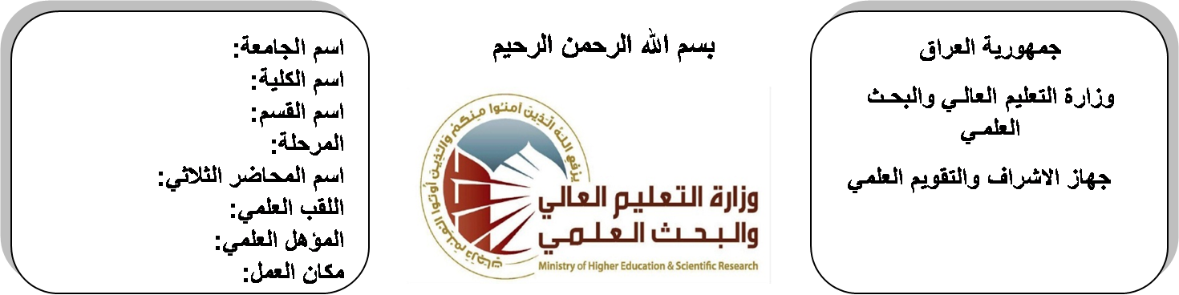
اسم الجامعة:ديالى
اسم الكلية:الهندسة
اسم القسم: الالكترونيك
المرحلة: الاولى
اسم المحاضر الثلاثي: ابراهيم سعدون فتاح
اللقب العلمي: مدرس مساعد
المؤهل العلمي: ماجستير
مكان العمل: كلية الهندسة

(( استمارة الخطة التدريسية السنوية ))

ابراهيم سعدون فتاح |  |  |  | اسم التدريسي:
IBRAHIM1969@YAHOO.COM |  |  |  | البريد الالكتروني:
Mathematics I |  |  |  | اسم المادة:
The aim of this subject is to make the students ready to undestand and comprehend the scientific theories and their applications related to their field of the study. |  |  |  | أهداف المادة:
Calculus by Thomas |  |  |  | الكتب المنهجية:
Calculus by James Stewart ,Barbara Frank. |  |  |  | المصادر الخارجية:
الامتحان النهائي | المختبرات | الفصل  الثاني | الفصل الأول | تقديرات الفصل:
60% | 0% | 20% | 20%
 |  |  |  | معلومات إضافية:

جدول الدروس الأسبوعي – الفصل الدراسي الأول
الملاحظات | المادة العملية | المادة النظرية | التاريخ |  | الأسبوع
 |  | Limit & Inequalities | 27/9/2015 |  | 1
 |  | Trigonometry ,Analytic Geometry | 4/10/2015 |  | 2
 |  | Sets, Relations | 11/10/2015 |  | 3
 |  | Functions (algebraic and trigonometric) | 18/10/2015 |  | 4
 |  | Differentiation and Integration | 24/10/2015 |  | 5
 |  | Transcendental Functions | 1/11/2015 |  | 6
 |  | Inverse Trigonometric | 8/11/2015 |  | 7
 |  | Natural Logarithmic | 15/11/2015 |  | 8
 |  | Exponential and Power | 22/11/2015 |  | 9
 |  | .Graphs , Derivatives and Integrals | 29/11/2015 |  | 10
 |  | Area Between Curves  Volume of Revolution | 6/12/2015 |  | 11
 |  | Length of the Curve  Surface Area of Revolution | 12/12/2015 |  | 12
 |  | Hyperbolic Function  Inverse Hyperbolic | 20/12/2015 |  | 13
 |  | Differentiation and Integration | 27/12/2015 |  | 14
 |  | Method of Integration  Trigonometric Substitutions | 3/1/2016 |  | 15
 |  | Quadratics, Partial fractions, by parts, Further substitutions | 10/1/2016 |  | 16
العطلة الربيعية |  |  |  | 15/1/2016 to  1/2/2016

توقيع الأستاذ: توقيع رئيس القسم توقيع العميد:

جدول الدروس الأسبوعي – الفصل الدراسي الثاني

الملاحظات | المادة العملية | المادة النظرية | التاريخ | الأسبوع
 |  | Representation of vectors in space (i,j,k) unit vectors | 21/2/2016 | 1
 |  | Scalar Product | 28/2/2016 | 2
 |  | Vector Product. | 6/3/2016 | 3
 |  | Complex Numbers  Invented Number System | 13/3/2016 | 4
 |  | The Argent Diagram  Addition, Subtraction | 20/3/2016 | 5
 |  | Product, Quotient, Power and Roots | 27/3/2016 | 6
 |  | Polar Coordinate System | 3/4/2016 | 7
 |  | Polar Coordinate System | 10/4/2016 | 8
 |  | Graphs of Polar Equations | 17/4/2016 | 9
 |  | Graphs of Polar Equations | 24/4/2016 | 10
 |  | Plane Area in Polar coordinates | 1/5/2016 | 11
 |  | Plane Area in Polar coordinates | 8/5/2016 | 12
 |  | Plane Area in Polar coordinates | 15/5/2016 | 13
 |  | Matrices | 22/5/2016 | 14
 |  | Matrices | 29/5/2016 | 15
 |  | Determinants, . Inverse of a Matrix | 2/6/2016 | 16

توقيع الأستاذ: توقيع رئيس القسم توقيع العميد:

