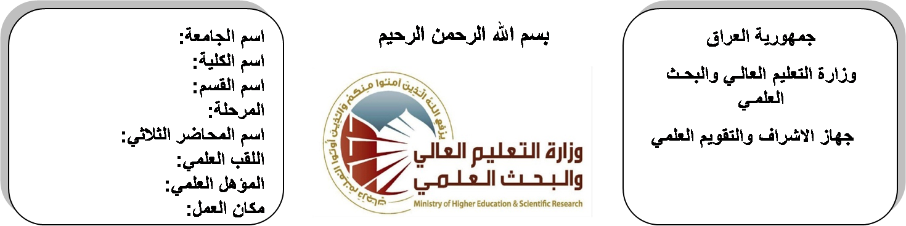
اسم الجامعة:ديالى
اسم الكلية:الهندسة
اسم القسم: الالكترونيك
المرحلة: الاولى
اسم المحاضر الثلاثي: ارشد عبد الحميد محمد
اللقب العلمي: مدرس
المؤهل العلمي: دكتوراه
مكان العمل: كلية الهندسة

(( استمارة الخطة التدريسية السنوية ))

ارشد عبد الحميد محمد |  |  |  | اسم التدريسي:
Arshad.ahd@gmail.com |  |  |  | البريد الالكتروني:
Engineering Mechanics |  |  |  | اسم المادة:
The aim of this subject is to make the students ready to undestand and comprehend the scientific theories and their applications related to their field of the study. |  |  |  | أهداف المادة:
 |  |  |  | الكتب المنهجية:
 |  |  |  | المصادر الخارجية:
الامتحان النهائي | المختبرات | الفصل الثاني | الفصل الأول | تقديرات الفصل:
60% | 0% | 20% | 20%
 |  |  |  | معلومات إضافية:

جدول الدروس الأسبوعي – الفصل الدراسي الأول

الملاحظات | المادة العملية | المادة النظرية | التاريخ |  | الأسبوع
 |  | Force System , units system , parallelogram law, forces + components | 29/9/2015 |  | 1
 |  | resultant of coplanar forces components of force in space | 6/10/2015 |  | 2
 |  | moment of a force. moment of couples equilibrium | 12/10/2015 |  | 3
 |  | Free body diagram , coplanar system | 20/10/2015 |  | 4
 |  | analysis of trusses, friction : Nature of friction , theory of friction | 27/10/2015 |  | 5
 |  | coefficient of friction, centroids & center of gravity centroids | 3/11/2015 |  | 6
 |  | centroids determined by integration | 10/11/2015 |  | 7
 |  | moments of inertia: parallel axes theorem | 17/11/2015 |  | 8
 |  | moment of area by integration , radius of gyration , moment of inertia of composite area | 24/11/2015 |  | 9
 |  | Kinetics of particle | 1/12/2015 |  | 10
 |  | rectilinear motion , curvilinear motion | 8/12/2015 |  | 11
 |  | rectangular components of curvilinear motion | 15/12/2015 |  | 12
 |  | normal and tangential component of acceleration | 22/12/2015 |  | 13
 |  | kinetics : force , mass and acceleration | 29/12/2015 |  | 14
 |  | kinetics of particle Newton's 2nd law. | 5/1/2016 |  | 15
 |  | Thermodynamics | 12/1/2016 |  | 16
عطلة نصف السنة |  |  |  | 15/1/2016 to  1/2/2016

توقيع الأستاذ: توقيع رئيس القسم توقيع العميد:
جدول الدروس الأسبوعي – الفصل الدراسي الثاني

الملاحظات | المادة العملية | المادة النظرية | التاريخ | الأسبوع
 |  | active materials &their specification | 15/2/2016 | 1
 |  | work and heat in ideal gasses and steam fist law of thermodynamics practical law in steam and gasses | 22/2/2016 | 2
 |  | second law f thermodynamics | 1/3/2016 | 3
 |  | practical law in steam and gasses. | 8/3/2016 | 4
 |  | Strength of Materials | 15/3/2016 | 5
 |  | Hooks law | 22/3/2016 | 6
 |  | tension and compression stress | 29/3/2016 | 7
 |  | tension and compression stress | 5/4/2016 | 8
 |  | thin-walled cylinders and spheres | 12/4/2016 | 9
 |  | thin-walled cylinders and spheres | 19/4/2016 | 10
 |  | combined stress (mohrs circle )shear and normal stress | 26/4/2016 | 11
 |  | combined stress | 3/5/2016 | 12
 |  | normal stress | 10/5/2016 | 13
 |  | normal stress | 17/5/2016 | 14
 |  | stresses in beams initial principal. | 24/5/2016 | 15
 |  | stresses in beams initial principal. | 1/6/2016 | 16

توقيع الأستاذ: توقيع رئيس القسم توقيع العميد:

