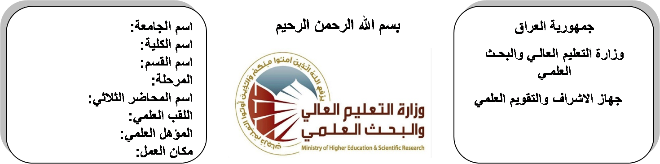
اسم الجامعة:ديالى
اسم الكلية:الهندسة
اسم القسم: الالكترونيك
المرحلة: الاولى
اسم المحاضر الثلاثي: عدنان محمد طه
اللقب العلمي: مدرس مساعد
المؤهل العلمي: ماجستير
مكان العمل: كلية الهندسة

(( استمارة الخطة التدريسية السنوية ))

عدنان محمد طه |  |  |  | اسم التدريسي:
adnanalmamory@gmail.com |  |  |  | البريد الالكتروني:
Electronic Physics |  |  |  | اسم المادة:
The aim of this subject is to make the students ready to undestand and comprehend the scientific theories and their applications related to their field of the study. |  |  |  | أهداف المادة:
Electronic circuits & devices by Millman. |  |  |  | الكتب المنهجية:
Electronic circuits by Schlling. |  |  |  | المصادر الخارجية:
الامتحان النهائي | المختبرات | الفصل الثاني | الفصل الأول | تقديرات الفصل:
60% | 0% | 20% | 20%
 |  |  |  | معلومات إضافية:

جدول الدروس الأسبوعي – الفصل الدراسي الأول

الملاحظات | المادة العملية | المادة النظرية |  | التاريخ | الأسبوع
 |  | Energy Levels and Atomic Structure |  | 27/9/2015 | 1
 |  | The atom, model, wave nature of light |  | 4/10/2015 | 2
 |  | dual nature of matter, wave function |  | 11/10/2015 | 3
 |  | energy – band theory of metals, insulators and semiconductors |  | 18/10/2015 | 4
 |  | crystal structure, ionic, covalent and metallic bonding, energy hand of crystals. |  | 24/10/2015 | 5
 |  | Internal structure of materials cell, packing miller indices |  | 1/11/2015 | 6
 |  | crystal planes and direction , brags law and x- ray diffraction , electronic ballistics |  | 8/11/2015 | 7
 |  | Mobility and conductivity |  | 15/11/2015 | 8
 |  | energy distribution of electrons |  | 22/11/2015 | 9
 |  | Fermi level, work function |  | 29/11/2015 | 10
 |  | Semiconductor materials (SI, GE and compound semiconductors) |  | 6/12/2015 | 11
 |  | extrinsic semiconductors |  | 12/12/2015 | 12
 |  | Fermi – level in semi conductor diffusion and carrier life time |  | 20/12/2015 | 13
 |  | hall effect . |  | 27/12/2015 | 14
 |  | P-N junction in equilibrium, current–voltage characteristics |  | 3/1/2016 | 15
 |  | charge–control description of a diode transition and diffusion capacitances |  | 10/1/2016 | 16
العطلة الربيعية |  |  | 15/1/2016 to  1/2/2016

توقيع الأستاذ: توقيع رئيس القسم توقيع العميد:

جدول الدروس الأسبوعي – الفصل الدراسي الثاني

الملاحظات | المادة العملية | المادة النظرية | التاريخ | الأسبوع
 |  | diode switching times | 21/2/2016 | 1
 |  | diode models | 28/2/2016 | 2
 |  | small- signal model and load line concept | 6/3/2016 | 3
 |  | introduction to heterojuncions and double heterojunctions . | 13/3/2016 | 4
 |  | Rectifiers | 20/3/2016 | 5
 |  | zener diodes voltage regulators | 27/3/2016 | 6
 |  | clipping circuits | 3/4/2016 | 7
 |  | clamping circuits | 10/4/2016 | 8
 |  | wave form generation | 17/4/2016 | 9
 |  | Varactor diode | 24/4/2016 | 10
 |  | tunnel diode | 1/5/2016 | 11
 |  | photodiode | 8/5/2016 | 12
 |  | photovoltaic (solar)cell | 15/5/2016 | 13
 |  | light emitting diode | 22/5/2016 | 14
 |  | principle and operation of semiconductor laser | 29/5/2016 | 15
 |  | metal electronic palasilics semiconductor diode. | 2/6/2016 | 16

توقيع الأستاذ: توقيع رئيس القسم توقيع العميد:

